Curriculum Vitae Guide

Career Connections | Office of Teacher Education
WW Wright Building, Suite 1000
https://education.indiana.edu/students/careers/index.html
Revised Spring 2024
by Jac’lyn Bera, Graduate Assistant

What is a Curriculum Vitae (CV)? Why Does it Matter?
A curriculum vitae, also called a CV or vita, is a summary of your education, accomplishments, and professional experiences (e.g., teaching experience, research, clinical experiences, presentations, publications),. CVs provide foundational information about your academic and professional history that aids in applying for fellowships, jobs, grants, publications, conferences, and internships. Often times, CVs are considered to be exclusively important when applying for jobs within academia, however, this is not always the case. It is a cornerstone to your application materials as a graduate student, whether you are applying to a graduate program or moving forward with your career.

Is a CV really different from a resume?
In short: Yes! It is! For starters, your CV is a living document that goes more in-depth than a standard two-page resume. There is no page limit to a CV, and depending on your field or specialization, that length may be as short as three pages or longer than six pages. The information in your CV is supposed to be relevant to your field; meaning that even though there is no page limit, your CV should still remain concise and to the point. CVs offer a more comprehensive picture of your scholarly identity and training. It should also be tailored to the position or organization that you are applying to. Saving an archival copy that includes EVERYTHING you have done, may be helpful for future applications.

Formatting your CV
While there is no “gold-standard” way to organize your CV, formatting can vary from field to field. Seeking out examples for structure can be incredibly helpful when deciding how you want the document to read. However, there are a few consistent formatting suggestions that will help guide your writing process:
- List everything in reverse chronological order, which highlights your most recent achievements and experiences.
- Check your CV for spelling and typographical errors
- Utilize functions like Bold, Italics, and Underlines to help break up the space and draw attention to different sections. Also use bullet point style descriptions, keeping your information short and concise.
- Font: most commonly used fonts are “Times New Roman” or “Helvetica/Arial” and range between 10-12 points.
- The footer/page number is most appropriately placed in the lower center or right-hand corner of the page and may be in smaller font size
- It is recommended that CV’s be saved in either MS Word or Adobe PDF format. You just want to make sure that your CV can be opened with the majority of the current software systems. Commercial copy stores will take electronic files (via email or USB) and make multiple copies professional quality printers. For most applications, however, an inkjet or home laser printer will produce acceptable copies.
- If you print out your CV: Always use standard white, ivory, or neutral 8.5 x 11-inch heavyweight paper. Keep in mind that colored paper and ink may look hazy after copying
- Don’t double-side print your CV or resume

Information to include in your CV,
- Your name and contact information (Typically permanent email address and professional social media or website handles)
  - You may choose to include your phone number and address if sending your CV in for a job position, but do not include these on publicly accessible CVs
  - This one should be used at your own discretion. Including your pronouns can help reduce the chance of being misgendered, but if you feel cautious of the organizations or positions you are applying for, you may choose to omit them.
- Education including the name, location, and degree obtained or in progress. List in reverse chronological order.
- Licenses and Certifications including the official license name, and date obtained/valid until date.
- Experiences – can include brief (2-3 bullet point descriptions or each experience)
  - Teaching- including the position title, name of course, university/school where you taught, location, and dates
  - Research - including the role you held, research lab name, organization/university, location, and dates
  - Clinical/Practicum - including the role you held, practica/clinic name, supervisor, location, and dates
  - Work history - including the role you held, company/employer name, location, and dates
- Publications and Presentations
- Grants
- Fellowships, Honors, and Awards
- Professional Affiliations and Membership
- Leadership Experiences
- Skills: Languages, Software, Other (optional)
- References (optional)

Information to avoid including on your CV
- Age
- Racial and Ethnic identities
- Political affiliation
- Religious preference or affiliation
- Hobbies
- Marital status
- Sexual orientation
- Gender identity
  - This one should be used at your own discretion. Including your pronouns can help reduce the chance of being misgendered, but if you feel cautious of the organizations or positions you are applying for, you may choose to omit them.
- Place of birth
- Photographs
- Height, Weight, and health status

Additional Academic and Job Search Resources
*IU School of Education Career Connections is not affiliated with, and does not endorse or recommend any of the public or independent organizations listed here. This list is made available as a resource to assist students in their job search.
University Career Centers
Purdue University: https://owl.purdue.edu/owl/job_search_writing/resumes_and_vitas/writing_the_cv.html
Cornell University, Graduate School - https://gradschool.cornell.edu/career-and-professional-development/pathways-to-success/prepare-for-your-career/take-action/resumes-and-cvs/
University of North Carolina at Chapel Hill - https://writingcenter.unc.edu/tips-and-tools/curricula-vitae-cvs-versus-resumes/
Online Help Sites
LiveCareer: https://www.livecareer.com/cv/examples
American Psychological Association: https://www.apa.org/education-career/job-search/cv-resume/vitae-tips
Teaching Philosophies: https://crlt.umich.edu/resources-publications/teaching-philosophies-statements
Books
The Academic Job Search Handbook by Vick and Furlong
Vick, J. M., Furlong, J. S., & Heiberger, M. M. (2008). The academic job search handbook (4th ed.).
How to Write a Lot by Paul J. Silvia
Silvia, P., & Sinclair, C. (2007). How to Write a Lot: Tips for Increasing Writing Productivity. PsycEXTRA Dataset. doi:10.1037/e506102012-202
Your Crystal Clear Career Path by Peter Engle
Engler, P. G. (2014). Your crystal clear career path: Featuring smart, new and effective job search strategies: Find rewarding work, not just a job!

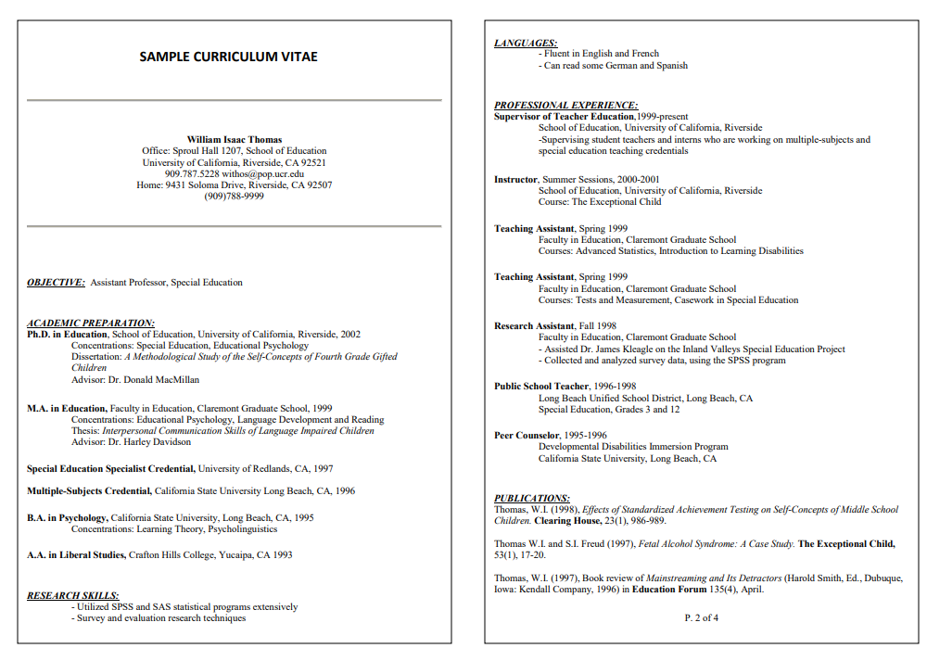

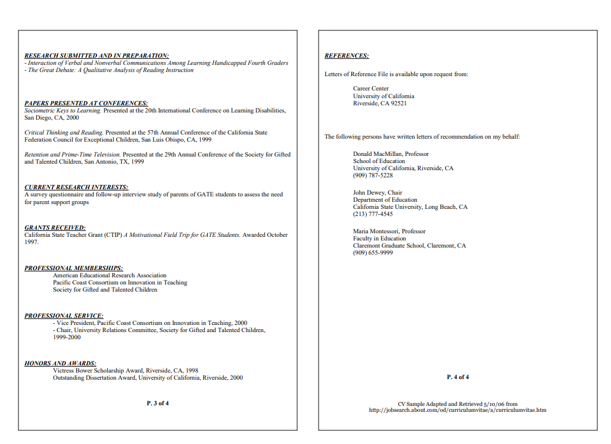

Mary Lou Goodman
1234 Hoosier Dr, Bloomington, IN, 47401| 812-555-5555 | EMAIL@gmail.com

Education
Ph.D., School Psychology, Indiana University, Bloomington, IN Anticipated May 2020

M.S.Ed., School Psychology, Indiana University, Bloomington, IN May 2017

B.A., Psychology, Sociology/Anthropology minor, Indiana University, Bloomington, IN May 2015

Practicum Experience
Academic Interventionist, August 2016 - Present
Grandview Elementary, Bloomington, IN
Supervisors: Rebecca Martinez, Ph.D., Kassie Lowery, B.A.
- Manage a case load of three students struggling with academics
- Assess and track data pertaining to student interventions
- Consult and communicate with teachers and parents regarding students’ progress
- Research and implement evidence based practices

School Psychology Practicum Student, January 2016 - May 2016
College Park Elementary, Lincoln Middle School, Eastbrook Elementary, Indianapolis IN Supervisors: Thomas Huberty, Ph.D
- Performed Psychoeducational evaluations of children elementary age to middle school
- Conducted in-class observations
- Administered, scored, and interpreted cognitive and academic testing for placements
- Conducted an individual behavior plan with a student
- Managed interventions twice a week with students on reading and sight words
- Participated and led Case Conference Committee meetings

Teaching Assistant in Special Education, August 2015 - December 2015
Clear Creek Elementary, Bloomington, IN Supervisors: Scott Bellini, Ph.D
- Incorporated special education students within inclusion setting
- Created small group innovative lessons to encourage active student participation
- Established positive relationships with students, teachers, and school administrators
- Personally requested by special education teachers to take over classrooms
- Advocated for children in the school system

University Teaching Experience
Instructor for EDUC-M202, August 2016-Present
Indiana University, Bloomington, IN Supervisor: Andrew Bosk, M.S.
- Grade assignments, teach lessons pertaining to job search strategies,
- Secure guest speakers, submit end of course grades, and update curriculum/syllabus
- Advise students/alumni regarding resume writing, cover letters, interviewing skills, portfolios, online credentials job search strategies and other career related matters
- Initiate and present multiple workshops for Career Connections

Research Experience
Senior Research Capstone, January 2015 - May 2015
Earlham College, Richmond, IN Supervisor: Rachael Reavis, Ph.D
- Designed and conducted independent research study on ostracism and mood amongst undergraduate students
- Entered and interpreted in SPSS
- Completed an APA write up of the study
- Presented findings at annual undergraduate research conference

Research Assistant, August 2013 - May 2014
Earlham College, Richmond, IN Supervisor: Rachael Reavis, Ph.D
- Assisted in the design and conducted research study with 2nd and 3rd graders on visual spatial abilities
- Conducted research study on peer victimization with participants
- Analyzed peer victimization, executive function, conflict management, and delay of gratification in students
- Organized and lead activities promote physical, mental, and social development
- Recruited parents and children to participate in psychological research
- Assisted with data entry, coding, and data analysis
- Presented findings at an annual undergraduate research conference
- Learned IRB procedure for approval with special attention paid to ethical considerations and other aspects of the research process

Researcher in Child Development, January 2013 – May 2013
Earlham College, Richmond, IN Supervisor: Vincent Punzo, Ph.D
- Researched human and child development
- Undertook a psychological case study of a single child
- Conducted interviews, natural observations, and assessments with families and schools
- Transcribed and recorded findings in a 100-page document

Presentations

Annual Research Conference Journal (Poster Presentations)
Earlham College, Richmond, IN
- Published in 4th, 5th, and 6th annual research journal
- Flores, H. (2015). You Can't Sit With Us: Role of mood on ostracized collegiate students.
Annual Research Conference Journal, 6.
- Flores, H. (2015). The Role of Praise in Fixed and Growth Mindset. Annual Research Conference Journal, 6.
- Flores, H., Webb, A., Galperin, O., & Kasikci, K. (2014). Sibling Relationships and Delay of Gratification. Annual Research Conference Journal, 5.
- Flores, H., Galperin, O., & Kenny, S. (2014). Thoughtful Friends: An examination of executive functioning, theory of mind, and friendship. Annual Research Conference Journal, 5.
- Flores, H., & Donohue, L. (2013). Money Makes all the Difference: The effects of exposure to money on helpfulness. Annual Research Conference Journal, 4.

Work Experience
Job Search Advisor, August 2016 - Present
Indiana University, Bloomington, IN
Supervisor: Andrew Bosk, M.S.
- Advise students/alumni regarding resume writing, cover letters, interviewing skills, portfolios, online credentials job search strategies and other career related matters
- Initiate and present multiple workshops for Career Connections Online
- Respond to résumé referral requests from employers
- Promote and assist with annual Interview Day
Pier 1 Imports Sales Leader, September 2015-Present
Bloomington, IN
Supervisor: Christie Snelling, M.S.
- Maintain daily record of all transactions and generate reports for store manager
- Train staff to deliver outstanding customer service
- Reorganize sales floor to meet company demands
- Assist with recruitment and training of new staff
- Top performing manager three quarters in a row
- Sales Associate of the Region Q2

Resident Assistant, August 2013 - August 2015
Earlham College, Richmond, IN Supervisor: Katie Colip, M.A.
- Coordinated programs essential to the growth of the community
- Independently planned educational and social events for a floor of 40 first-year college students in a co-educational facility
- Collaborated and implemented educational opportunities for a building of 350 residents as part if a resident assistant team
- Responded to and managed emotional, medical, and facilities related problems
- Oversaw an area budget for community programing
- Enforced rules and regulations to ensure the orderly operations of Residence Hall

Teacher Assistant in Counseling and Psychotherapy, January 2014 - May 2014
Earlham College, Richmond, IN Supervisor: Michael Jackson, Ph.D.
- Assisted professor in lectures and coursework
- Educated students with counseling methods and approaches
- Helped students with in-depth therapy session

Communities in Schools Aid, January 2014 - May 2014
Test Intermediate, Richmond, IN Supervisor: Rachel Reavis, Ph.D
- Mentored 5-8 grade students with behavioral and emotional needs
- Worked alongside school psychologist
- Prepared materials for daily group activities
- Helped bridge the gap between English and Spanish speaking students
- Traveled to children’s homes for tutoring
- Assisted in level 1 and level 2 CIS

Live-in Childcare Provider, December 2010 - 2013
Columbus, Ohio Supervisor: Kelly Osborne
- Live-in nanny for three consecutive years over summer
- Committed to taking care of children of all ages
- Skilled in handling crisis situations

Leadership
President of Psychology Club, August 2013 - May 2014
Earlham College, Richmond, IN
- Led and participated in student run meetings
- Contacted professors, alumni, and professionals in psychology fields
- Facilitated intellectual group discussion

Captain of Earlham Field Hockey, August 2013 - 2014
Earlham College, Richmond, IN Supervisor: Heather Moore, B.A.
- Organized all players in daily activities, drills, and leadership roles
- Designed and implemented game initiatives for team-building rooted in theory
- Enforced positive thinking and mentored teammates
- Utilized team’s ability and skill
- First captain in history to receive title as a Junior

Volunteer Experience
Save Our Adolescents from Prostitution, May 2011 – Present
Columbus, OH
Supervisor: Theresa Flores, M.S.W
- Inform and educate communities on human trafficking
- Advocate for the education of trafficking in US
- Train communities and educators of the warnings and red flags
- Call motels and package soap for donation

YWCA Volunteer January 2013 – May 2013
Richmond, IN
Supervisor: Rachel Reavis, Ph.D.
- Assisted battered women and children in residential facility
- Accompanied families on counseling visits
- Filed papers and ran errands

Assessments Administered
WISC – IV WISC – 5
WJ-IV (ACH) WJ-IV (COG)
Conners Conners 3 BASC-2 BASC-3 KABC KTEA
Standford Binet

Sarah R. Wilson
801 N. Pearl St. Bloomington, IN 47401
123-456-7890
sarahwilson@email.com

EDUCATION
2012 – Indiana University School of Education, Bloomington, IN
Program: Developmental and Learning Sciences, Human Development Track Minor concentration: Inquiry Methodology
Degree: Ph.D. (Expected 2017) Advisor: Mary Waldron, Ph.D.
2012-2014 Indiana University School of Education, Bloomington, IN
Program: Developmental and Learning Sciences, Human Development Track Degree: M.S.
Advisor: Mary Waldron, Ph.D.

2005-2006 Indiana Wesleyan University, Indianapolis, IN Program: Transition to Teaching
Licensure: Indiana Teaching Certification in Social Studies, Psychology

1996-2000 Ball State University, Muncie, IN
Major: History (Psychology minor) Degree: B.S.

AWARDS & HONORS
2016 Carole A. Ames Fellowship Award School of Education
Indiana University
2013, 2014, Trentham Travel Award
& 2016 Department of Counseling and Educational Psychology Indiana University
2015 Student Merit Award
Research Society on Alcoholism

2014 Outstanding Associate Instructor Award School of Education
Indiana University

2014 Myrtle M. Scott Research Award
Department of Counseling and Educational Psychology Indiana University

2014 | Adolescence in Diverse Contexts Student Poster Award Society for Research on Adolescence
2014 | Emerging Scholar Student Travel Award Society for Research on Adolescence
2013 | Rise Research Award  Association for Psychological Science
2012 | Student Poster Competition, 3rd place Award Indiana Psychological Association
2005-2006 | Dean’s List  Indiana Wesleyan University
2000 | Cum Laude  Ball State University
2000 | Academic Honors in Writing Ball State University
2000 | Outstanding Senior Award Ball State University
1998-2000 | Golden Key International Honor Society
1996-2000 | Dean’s List  Ball State University

PROFESSIONAL MEMBERSHIPS
Association for Psychological Science Indiana Psychological Association Society for Research on Adolescence Research Society on Alcoholism

RESEARCH INTERESTS
- Substance use and abuse in adolescence and emerging adulthood
- Childhood and adolescent obesity
- Adolescent and emerging adulthood sexual behavior
- Comorbid psychopathology during childhood and adolescence

PUBLICATIONS
Referred Articles (in chronological order)

Wilson, S. R., Doran, K. A., & Waldron, M. (2016). Childhood weight status and timing of first substance use in an ethnically diverse sample. Drug and Alcohol Dependence, 164, 172-78.

Doran, K. A., Sapharas, N. K., Wilson, S. R., Waldron, M. (2016). Timing of first substance use: Risks from parental divorce and paternal death. Manuscript to be submitted.
Wilson, S. R. & Waldron, M. (2016). Childhood weight status predicts timing of first sexual intercourse in an ethnically diverse sample of females. Manuscript in preparation.

Refereed Presentations (in chronological order)

Wilson, S. R. & Waldron, M. (2016, May). Associations among childhood weight status, pubertal timing, and sexual initiation in an ethnically diverse sample of girls. Poster presented at the annual convention of the Association for Psychological Science, Chicago, IL.
Wilson, S. R. . & Waldron, M. (2015, July). Childhood weight status and timing of first alcohol use: The moderating role of pubertal timing. Poster presented at the annual meeting of Research Society on Alcoholism, San Antonio, TX. [published abstract]
Sapharas, N. K., Wilson, S. R., Doran, K. A., & Waldron, M. (2015, March). Timing to first
substance use: Risks from parental divorce and paternal death. Poster presented at the annual meeting of the Society for Research on Child Development, Philadelphia, PA.
Wilson, S. R. ., Doran, K. A., & Waldron, M. (2014, March). Associations between childhood weight status and substance use initiation. Poster presented at the annual meeting of the Society for Research on Adolescence, Austin, TX. [additional presentation at the SRA “Adolescence in Diverse Contexts” reception]
Wilson, S. R., Doran, K. A., Sapharas, N. K., & Waldron, M. (2013, May). Race/ethnicity moderates associations between weight status during childhood and early substance use. Poster presented at the annual meeting of the Association for Psychological Science, Washington, DC. [additional presentation at the APS RISE Award reception]
Wilson, S. R., Sapharas, N. K., Doran, K. A., & Waldron, M. (2012, October). Early Substance Use and Risk of High School Dropout: Differences by Urban Versus Rural Residence. Poster presented at the annual meeting of the Indiana Psychological Association, Indianapolis, IN.

Non-referred Articles, Presentations, and Web Publications
Wilson, S. R., (2014, June 4). Adolescence in Diverse Contexts: Associations between childhood weight status and substance use initiation. [Blog post]. Retrieved from http://www.s-r- a.org/announcements/blog/2014-06-04-adolescence-diverse-contexts-associations-between- childhood-weight-sta

Wilson, S. R., (2013, June 14). Race/ethnicity moderates associations between weight status during childhood and early substance use. [Blog post]. Retrieved from http://www.psychologicalscience.org/index.php/video/apssc-rise-research-award-winner- raceethnicity-moderates-associations-between-childhood-weight-status-and-early-substance- use.html
Wilson, S. R., Doran, K. A., Sapharas, N. K., & Waldron, M. (2013, May). Early substance use and risks from childhood obesity: Preliminary analyses. Paper presented at the monthly meeting of the Human Development program, Indiana University School of Education, Bloomington, IN.

RESEARCH EXPERIENCE
Fall 2012–present Team Member
Adolescent Development Lab
Department of Counseling & Educational Psychology Indiana University School of Education, Bloomington, IN
Member of a research team studying biopsychosocial transitions during adolescence and emerging adulthood. Mary Waldron, Ph.D., Advisor.

Spring 2015 Data Analyst ICARE Data Project
Department of Counseling & Educational Psychology Indiana University School of Education, Bloomington, IN

Conducted and interpreted factor analysis, advised on methodological decisions, and cleaned and coded data examining associations between counselling experiences, HIV education, outlook on life, and social experiences among citizens of the Republic of Botswana infected with HIV. Rex Stockton, Ph. D., Primary Investigator.

TEACHING EXPERIENCE

Postsecondary Teaching
Fall 2013-Spring 2015 Associate Instructor, P313 Adolescents in a Learning Community & Fall 2016-Spring 2017 Department of Counseling and Educational Psychology
Indiana University, Bloomington, IN
Responsible for developing and implementing curriculum, lessons, lectures, and in-class activities, providing student support, and grading exams and final papers.

Fall 2015-Spring 2016 Associate Instructor, M202 Job Search Strategies for Educators
Office of Career Connections
Indiana University School of Education, Bloomington, IN

Responsible for developing and implementing curriculum, lessons, lectures, and in-class activities, providing student support, conducting mock interviews, and grading papers and projects.

Summer 2015 Associate Instructor, S508 Secondary School Curriculum
Department of Curriculum and Instruction Indiana University, Bloomington, IN
Responsible for developing and implementing curriculum, lessons, and in-class activities, providing student writing support, teaching graduate level study skills, and editing master’s theses to a cohort of South Sudanese graduate students. Special course focus: education development and peace education, specific to the South Sudanese context.

Spring 2015 Associate Instructor, P510 Psychology in Teaching Department of Counseling and Educational Psychology Indiana University, Bloomington, IN
Responsible for developing and implementing curriculum, lessons, lectures, and in-class activities, providing student support, teaching graduate level study skills, and grading exams and final papers to a cohort of South Sudanese graduate students. Special course focus: education development and peace education specific to the South Sudanese context.
Summer 2014 Associate Instructor, S503 Secondary School Curriculum
Department of Curriculum and Instruction
Center for International Development, Education, and Research School of Education
Indiana University, Bloomington, IN
Responsible for developing and implementing curriculum, lessons, lectures, in-class activities, and providing student support. Taught course to a cohort of South Sudanese graduate students in Kampala, Uganda.

Fall 2012-Spring 2013 Teaching Assistant, P314 Lifespan Development
Department of Counseling and Educational Psychology Indiana University, Bloomington, IN

Responsible for grading final papers, grading and entering scores into electronic gradebook, student academic support, and assistance with curriculum development/instructional materials. Anne Stright, Ph.D., Instructor.

K-12 Teaching
2011–2012 GED/College Readiness Instructor
Fathers and Families Center, Indianapolis, IN

Developed and implemented GED curriculum in reading, writing, math, science, and social studies. Taught and mentored young adults preparing for GED exam and taking beginning college courses. Teaching methods included lecture, small group instruction/activities, and one-on-one tutoring. Administered, graded, and created Individualized Learning Plans based on Official GED Practice Tests and TABE tests. Assisted employment staff in teaching students job readiness skills, including; resume and cover letter writing, interviewing skills, and job search strategies.

2009–2011 Lead GED/College Readiness Instructor
Marian University College of Education partnering with Youthbuild Indy, Indianapolis, IN
Led a team of trained educators in providing quality GED/College Readiness education. Developed and implemented GED curriculum in reading, writing, math, science, and social studies. Taught and mentored young adults preparing for GED exam and taking beginning college courses. Teaching methods included lecture, small group instruction/activities, and one-on-one tutoring. Administered, graded, and created Individualized Learning Plans based on Official GED Practice Tests, CASAS tests, and TABE tests. Assisted employment staff in teaching students job readiness skills, including; resume and cover letter writing, interviewing skills, and job search strategies.

2007-2009 Secondary Social Studies Teacher
Fountain Square Academy, Indianapolis, IN

Taught middle and high school social studies, serving as the Team Lead. Strong focus on curriculum development and implementation, reading and writing skills development, and remediation. Teaching
methods included lecture, small group instruction/activities, and one-on- one tutoring.
Fall 2006 Student Teacher, Middle School Social Studies Stonybrook Middle School, Indianapolis, IN

Developed and implemented curriculum, taught lessons, administered and graded assignments and tests, provided student academic support. John Barnes, Mentoring Teacher

Spring 2006 Student Teacher, High School Social Studies Broad Ripple High School, Indianapolis, IN

Developed and implemented curriculum, taught lessons, administered and graded assignments and tests, provided student academic support.

Fall 1998-Spring 1999 Teaching Assistant, HIST 198, Non-western Civilization
History Department
Ball State University, Muncie, IN
Responsible for grading final papers, grading and entering scores into course gradebook, student academic support, and assistance with instructional materials.
Fall 1999-Spring 2000 Teaching Assistant, HIST 150, Western Civilization History Department
Ball State University, Muncie, IN
Responsible for grading final papers, grading and entering scores into course gradebook, student academic support, and assistance with instructional materials. John Barber, Ph.D., Instructor

Teaching Workshops
Fall 2015-Spring 2016 Resume Writing Workshops
Office of Career Connections
Indiana University School of Education, Bloomington, IN
Fall 2015-Spring 2016 Interview Skills Workshops
Office of Career Connections
Indiana University School of Education, Bloomington, IN

Spring 2011 Hands’ On Math Workshop
Indiana Department of Education Conference College of Education
Marian University, Indianapolis, IN

Presented to educators at a state conference. Developed and taught curriculum and activities focused on engaging K-12 students in math skills and remediation.

Spring 2011 Hands’ On Math Workshop

College of Education, Summer Learning Institute Marian University, Indianapolis, IN

Presented to educators, instructors, and summer learning providers at a staff development workshop. Developed and taught curriculum and activities focused on engaging K-12 students in math skills and remediation.
Spring 2011 Hands’ On Literacy Workshop
College of Education, Summer Learning Institute Marian University, Indianapolis, IN
Presented to educators, instructors, and summer learning providers at a staff development workshop. Developed and taught curriculum and activities focused on engaging K-12 students in literacy skills and remediation.

Summer 2010 Flo-cabulary Workshop
College of Education, Summer Learning Institute Marian University, Indianapolis, IN

Presented to instructors and summer learning providers
at a staff development workshop. Developed and taught curriculum and activities focused on engaging K-12 students in vocabulary enhancement.

OTHER PROFESSIONAL EXPERIENCE
2016-present Edvance Research, San Antonio, TX AT&T Aspire Proposal Reviewer
Review and rate proposals from a variety of organizations and schools that are applying for grant monies from AT&T for programs that support students at risk of not completing high school and/or not attending college.

2003-2007 Employment Consultant
Noble of Indiana, Indianapolis, IN
Taught individuals with developmental disabilities the skills necessary to obtain and maintain community employment. Wrote monthly and annual reports, provided on-site orientation, training, and follow along support, and trained new staff members.

2000-2002 Case Manager
Center for Mental Health, Anderson, IN

Assisted individuals with severe mental illness in daily living skills,

medication education and compliance, budgeting, obtaining housing needs, and employment skills. Member of Anderson, Indiana’s Homeless Task Force.

COMMUNITY/PROFESSIONAL SERVICE

Fall 2015-present Volunteer
Mother Hubbard’s Cupboard, Bloomington, IN

Fall 2015-Summer 2016 Graduate Student Representative
Committee on Diversity
Indiana University School of Education, Bloomington, IN
Spring 2016 Reviewer
Student Research Award
Association for Psychological Science

Spring 2016 Counseling and Educational Psychology Graduate Student Representative
Award for Excellence in Mentoring Selection Committee Indiana University, School of Education, Bloomington, IN

Adapted from: Writing the curriculum vitae. Writing the Curriculum Vitae - Purdue OWL® - Purdue University. (n.d.). https://owl.purdue.edu/owl/job_search_writing/resumes_and_vitas/writing_the_cv.html
Borsellino, R. (2020, August 6). What is a curriculum vitae, and do you need one?. The Muse. https://www.themuse.com/advice/what-is-curriculum-vitae-example#whoneeds
American Psychological Association. (n.d.). Curriculum vitae dos and don’ts. American Psychological Association. https://www.apa.org/education-career/job-search/cv-resume/vitae-tips#:~:text=In%20the%20academic%20market%2C%20a,an%20application%20to%20an%20interview
GSAS: CVS and cover letters - harvard university. (n.d.). https://hwpi.harvard.edu/files/ocs/files/gsas-cvs-and-cover-letters.pdf
American Psychological Association. (n.d.). Curriculum vitae dos and don’ts. American Psychological Association. https://www.apa.org/education-career/job-search/cv-resume/vitae-tips#:~:text=In%20the%20academic%20market%2C%20a,an%20application%20to%20an%20interview
Writing a CV. Office of Career Services | School of Public Health | Indiana University. (2023, July 24). https://careers.publichealth.iu.edu/resources/writing-a-cv/
Writing the curriculum vitae. Writing the Curriculum Vitae - Purdue OWL® - Purdue University. (n.d.). https://owl.purdue.edu/owl/job_search_writing/resumes_and_vitas/writing_the_cv.html
Doyle, A. (2021, March 20). Curriculum vitae (CV) samples, templates, and writing tips. The Balance. https://www.thebalancemoney.com/cv-samples-and-writing-tips-2060349
Adapted from: Writing the curriculum vitae. Writing the Curriculum Vitae - Purdue OWL® - Purdue University. (n.d.). https://owl.purdue.edu/owl/job_search_writing/resumes_and_vitas/writing_the_cv.html

