Investigating A Student’s Distributive Partitioning Scheme: The Case of Gabriel

Problems

Weight of Candy Bars Problem. Ming has five identical candy bars. Each bar weighs h ounces. Draw a picture of what 1/7 of all the candy bars look like? How much does 1/7 of all the candy weigh? Explain your drawing and your answer.

Data Excerpts

Data Excerpt 1: Gabriel, Martin, and the teacher talk about Weight of Candy Bars Problem.
T: So, this one. Explain this to me again.
G: So, I have no idea [laugh].
T: So, this was 1/7 of 5h. Here is your 5h and…
G: Okay so 1/7 of 5h with. Did we think about it was equal to 5/7 of 1h?
M: Yeah.
T: So, how did you conclude that?
G: We kind of pull out 1/7 from each h. So H#2, H#3 and then.
T: Uh-huh.
G: Uhm. So and that is 5 of 1/7 from each h so that is 5/7…
M: Of 1/7 of 5h. 5/7 of 1h is 1/7 of 5h.
T: If you put this together you were saying you would have 5/7 compare to 1h, right. 5/7 of 1h okay. And that is the same as 1/7 of 5h. So uhm how do you know this is how would you justify that 1/7 when you put those five pieces together?
M: Well, we took out 1/7 from each.
G: Yeah so if we put them all together it will equal 5/7 of it would okay [laugh] So, if you set them all together these are they would line up you know 1,2,3,4,5. It will line up just like that.
T: Right, right. Definitely I agree with you.
Gabriel and Martin’s JavaBars work for Weight of Candy Bars Problem

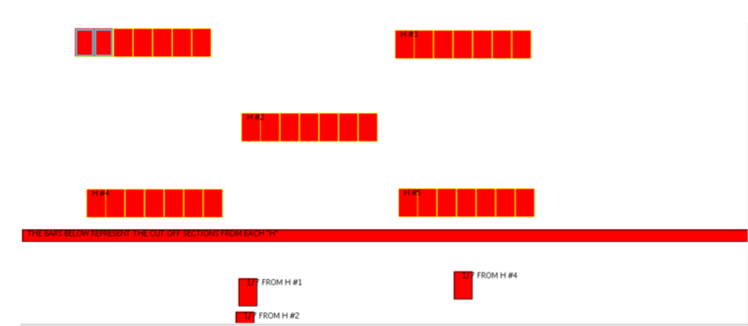

Finding Weights of Multiple Cookie Dough Logs Problem. This morning the bakers have ten cookie dough logs. They want to find the weight of 1/13 of that amount. Draw a picture of what 1/13 of all the dough look like. How much does 1/13 of all the dough weigh? Explain your drawing and your answer. Most likely you’ll want to use JavaBars for this problem.

Data Excerpt 2: Gabriel makes the connection between two problems.
T: So, it looks kind of similar to me because you are taking now you have 10ms, 10 weights and you are taking one of them make it into 13 parts right?
M: Yeah.
T: So now how could you justify [G said oh] you have to have 10/13 in each of those little pieces.
G: So we can like we can pull out this.
T: See if you can label something or write something down [she left].

Data Excerpt 3: Gabriel explains their JavaBars picture for Finding Weights of Multiple Cookie Dough Logs Problem.

T: Okay, can you explain it to me, how did you get?
G: So first we tried to do first we lined up these two bars thirteenths and tenths. So this is 10m and this is 1/13 of all of 10m. So then we were trying to figure out how 1/13 related to 1m. So we lined it up and made put thirteenths in the smaller portions to see what equal 1m and eventually 10/13 equals 1/13 of 10m. So, 10/13 of 1m rather equals 1/13 of 10m. So then we ungrouped them just like we did in our on Tuesday and put them on to show that equals that [laugh].

Gabriel and Martin’s work for Finding Weights of Multiple Cookie Dough Logs Problem
