IU School of Education
Learning and Teaching with Technology (LTT) Committee Report, 2019-2020 Erik Jacobson & Anne Leftwich, LTT Committee co-Chairs
Date: April 20, 2020

SOE Technology Committee Members at IUB:
- Adam Maltese
- Curt Bonk
- Rod Myers
- Anne Leftwich
- Erik Jacobson
- Karen Wohlwend

- Kyungbin Kwon
- Rajagopal Sankaranarayanan
- Amber Hill
- Heather Ormiston
- Ginette Delandshere

Meeting Dates (10): October 17, 2019, December 12, 2019, January 16, 2020, February 26,
2020.
Goals and Charges:
  - This committee shall give advice on priorities, policies, and matters related to learning and teaching with technology, including distance education.
  - Tasks include developing a vision for how technology can be used to enhance learning and teaching across disciplines, support efforts for the School of Education to be a learning laboratory for the efficacy of technology for learning and teaching, promote uses of technology to help build relationships with schools, and develop policies for distance education courses.
  - Policies for distance education courses should address but are not limited to matters of review and assessment of the quality of distance education courses, course loads, instructors’ qualifications, and intellectual property.
  - Create a proposal/plan for SOE library renovation project.

Actions and Outcomes:
  - Library Renovation: Collected information from relevant stakeholders on ways to revision the School of Education library space. See more information in Appendix below.
  - Faculty Technology Showcase: Online by August 1, 2020. Presentations will be made available on Kaltura. The committee awarded 3 Challenge grants and 8 Technology Adoption grants for the 2019-2020 year. Awardees were originally going to present their work at a faculty symposium, but instead we have asked them to submit videos or narrative reports, which we will share broadly with the IU community in early August via the School of Education website. The extended deadlines and shift to online products responds to the current health crisis and to the increased interest in and need for

technology in education. We hope the results of these 11 reports will support faculty who are learning by necessity to include more technology in their instruction.
  - Challenge Grants - $2000 each
    - Gamze Ozogul
    - Kelly Williams
    - Colton Ames & Gustave Weltsek
  - Tech Adoption Awards - $1000 each
    - Jessica Lester
    - Amy Pickard
    - Kyungbin Kwon
    - Curt Bonk
    - Faridah Pawan
    - Mary Beth Hines
    - Bradley Levinson
    - Peg Sutton

Recommendations for Future Action:
      - Find new ways to motivate expanded use of technology in the SOE, for example, by modifying the LTT Technology Challenge Grants program.
      - Try to find ways to support online pedagogical challenges and best practices.
        - Investigate specific ways to engage diverse groups of students with online and technology tools.
We wish to thank to the dean’s office for their continued support of the Faculty Technology Showcase as well as the LTT Challenge Grants. We did not pursue the grants this year due to the disruption of coronavirus. However, this is something we plan on exploring for next year. Please let us know if you require further information.
Erik Jacobson (erdajaco@indiana.edu) & Anne Leftwich (aleftwic@indiana.edu), co-Chairs of LTT Committee.

IU School of Education
Learning and Teaching with Technology (LTT) Committee Report Library Renovation
Erik Jacobson & Anne Leftwich, LTT Committee co-Chairs

Process and Timeline:
We were initially charged with collecting information from stakeholders to make suggestions for the library renovations in the School of Education. Our initial timeline was as follows:

- January/February 2020: Collect input from stakeholders
  - Erik and Anne attended every department faculty meeting to collect feedback
    - Faculty provided input during these meetings OR emailed Erik/Anne directly
  - Distributed an online survey to collect feedback from graduate and undergraduate students
  - Amber attended Staff Council to collect feedback from staff
  - Curt collected feedback from library design/learning spaces experts from around the world
- February 20, 2020: Discussion with Julie Johnston, Director of Learning Spaces at UITS
  - Provided contextual background and potential options to include in redesign
- February 21, 2020: LTT Meeting and presentation
  - Provided a summary of the feedback and input
- April, 2020: Receive feedback on library renovations from SOE community
  - We plan on creating a survey to solicit a final round of feedback focused on commitments to use spaces from graduate students and faculty via tailored surveys.
- May, 2020: Hand off final recommendation to space planning and architects office.

Description of Education Library Renovation Spaces
- Instructional spaces
  - Sandbox or demonstration classroom for trialing new furniture and teaching or learning equipment.
  - Classroom for scheduling one-time or short-term experiences that draw on tech/library resources
  - Classroom for scheduling classes, especially if they have distinctive technological or equipment needs
  - Cannot be used for overflow classes without specific technology/library needs
  - Classroom scheduling for one-time or short-term experiences drawing on tech/library resources
  - Glass/frosted boards on the walls and portable whiteboards everywhere!
  - Potential to host field trips of local K-12 students
  - Questions arose around who would staff this space, including erasing the walls and checking out markers

- Technology-focused resources
  - TTL
    - Laminator, 3D printer, Cricut, paper cutter, di-cut
  - MILL
    - Investigate moving MILL from library
    - Perhaps separate the spaces for traditional making and technical making.
Continue to use the MILL upstairs for more technical making and provide a
maker’s lab downstairs for more low-key, traditional making. May need to sound proof.
    - Craft materials
    - Playdough
    - Construction paper
    - Markers, glue, scissors, tape, and other art supplies
    - Print instructional materials
    - Textbooks and sample curriculum
    - Professional books or journals not electronically available
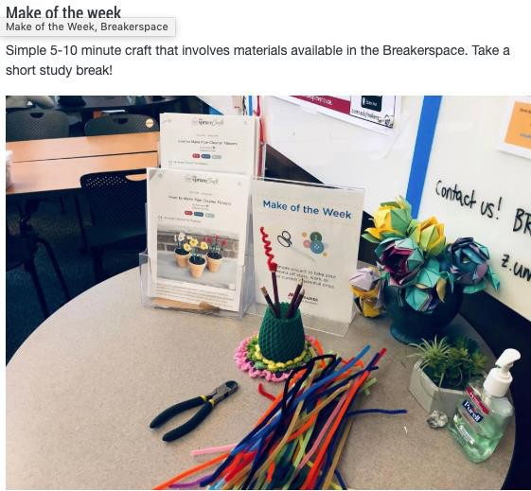

  - One-button recording studio
    - This makes it easy for professors teaching online courses to create quick screencasts in more private environments
    - Provides higher-quality online resources
    - We need someone to assist with set-up and production
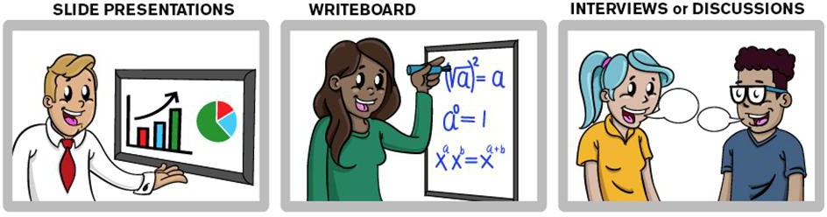

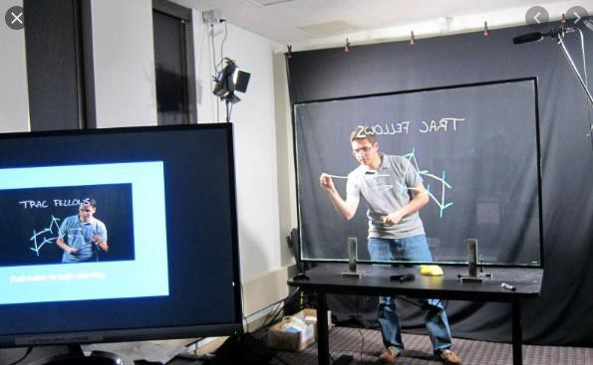

  - Common equipment loan space
    - Serving resources currently managed via separate processes by ETS, TTL, IST Studio students, & MILL.
  - Virtual meeting space
    - Provide spaces where faculty and students can conduct their virtual meetings
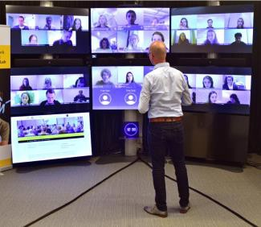

  - Instructional consulting meeting/sandbox space
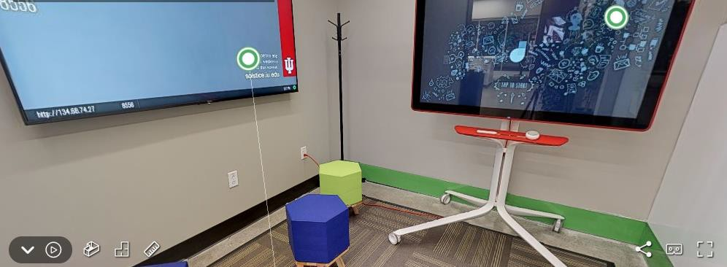

- Children’s Collection & Textbook Materials
  - Ensure to keep and highlight these materials
- Collaborative spaces
  - Informal seating area adjacent to the existing café
  - Glassed-in conference rooms of various sizes from 4 to 10 people
    - Must have projection capabilities.
    - Informatics discovered that even when two people want to collaborate/share slides/practice presentations they use projection capabilities of the room.
  - Brainstorm walls or space throughout
  - Easy to use online reservation site (IUPUI has one)
  - Comfortable seating

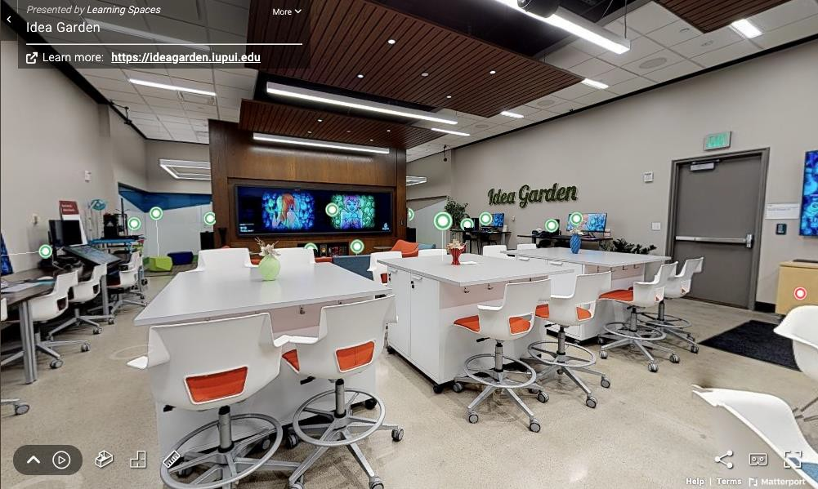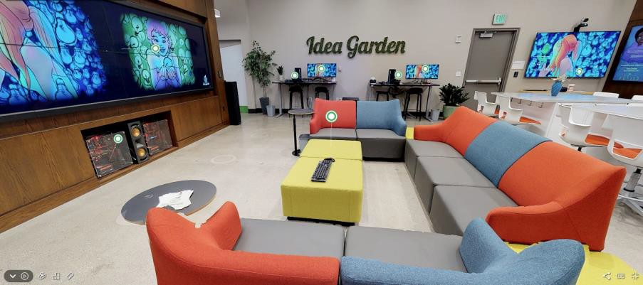

- Large Screen
  - Have a large screen at the entrance, or perhaps even outside the library to encourage people to come in
  - Announcements, info, profiles of technology success stories, perhaps usable for convocations?
- Furniture
  - Tall chairs, stand up desks
  - Flexible seating
  - More comfortable seating
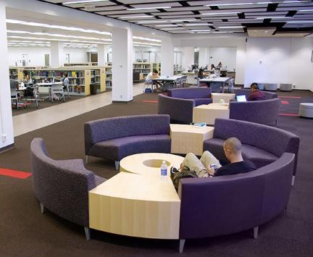
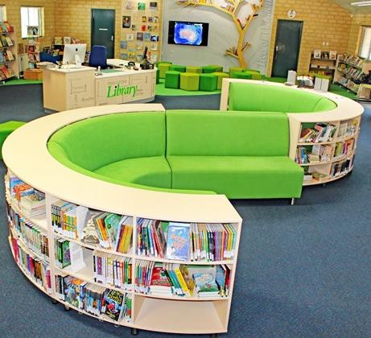

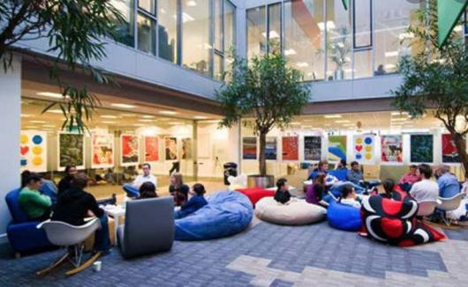

- Office space
  - Instructional Consulting (Staff (Rod) + GA)
  - Librarians
  - ETS Assistance
  - Visiting scholars

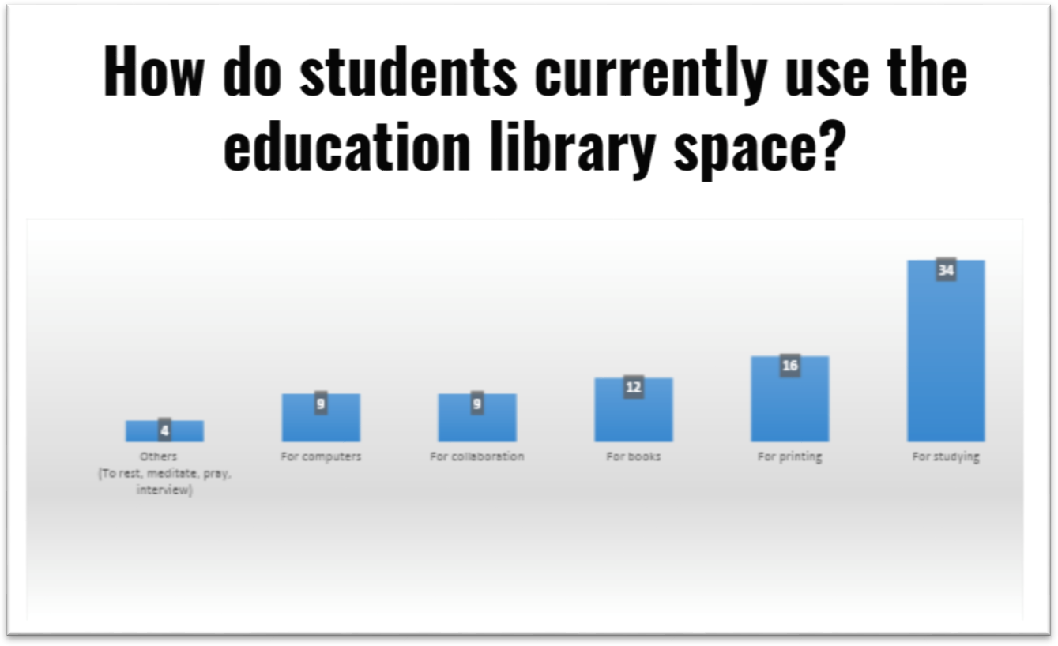
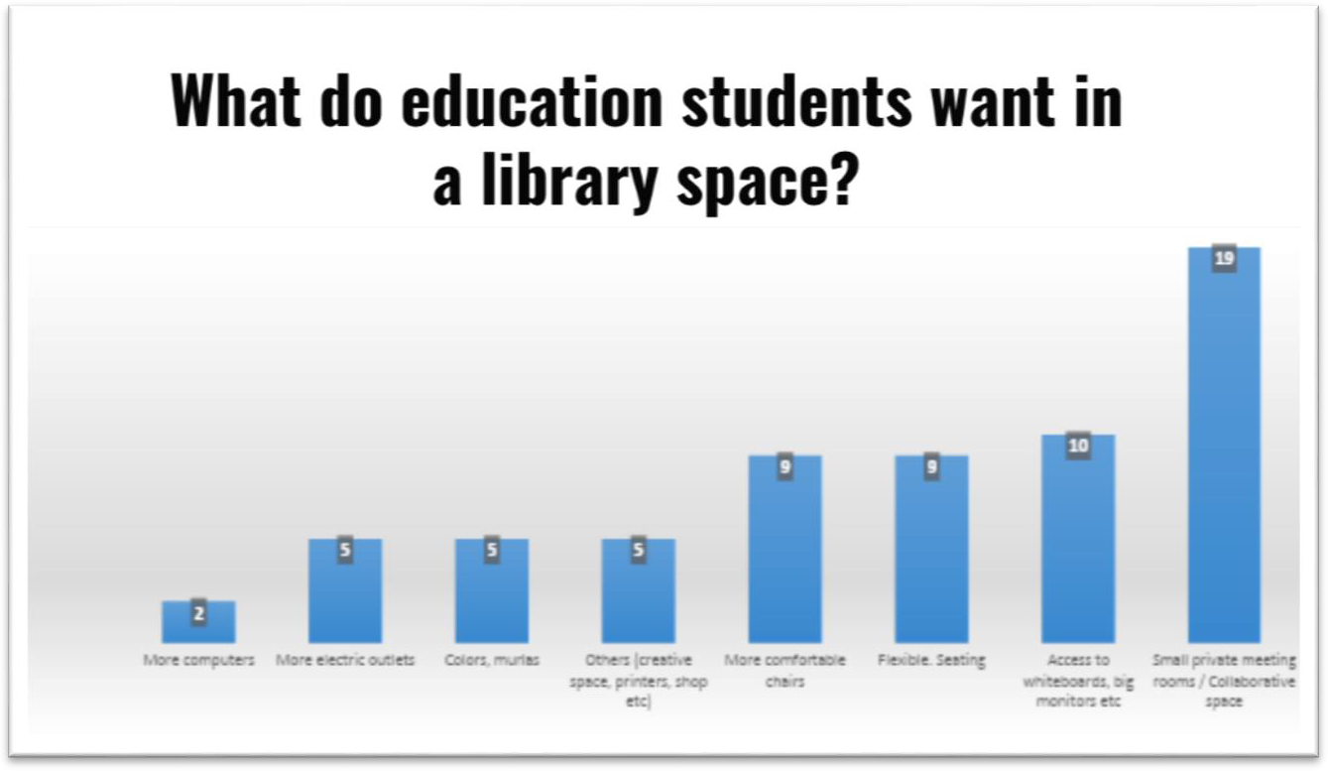
Additional Feedback

What should be included to make the education library
innovative / inspiring teaching / learning space?
- More collaboration spaces, Private rooms
- More comfortable chairs
- More natural light, less yellow lights
- More standing desks, private kiosks
- A mock classroom
- More multimedia resources
- Whiteboards & interactive spaces
- Comfortable space for learning, reading, and writing
- More Biophilic design based on the idea that humans are naturally outdoor species
- More discussion rooms, More outlets
- Some sort of movie/video viewing space
- Private rooms with computers, screens and zoom capabilities.
- Inspiring Art and colorful walls
- 3d printers
- Soundproof/clear glass rooms for holding instructor-student conferences
- Explore, design, and test teaching/learning ideas

Erik Jacobson (erdajaco@indiana.edu)& Anne Leftwich (aleftwic@indiana.edu), co-Chairs of LTT Committee.

