Saturday Science Week 1
Lesson Plan
Lesson Topic: Jack and the Beanstalk (Biology) Grade Level: 3 and 4 Length of Lesson: 2 hours
Desired Results
State Content Standard(s):
- 3.LS.2 Plan and conduct an investigation to determine the basic needs of plants to grow,
develop, and reproduce.
- SEPS.8 Obtaining, evaluating, and communicating information Scientists and engineers need to be communicating clearly and articulating the ideas and methods they generate. Critiquing and communicating ideas individually and in groups is a critical professional activity. Communicating information and ideas can be done in multiple ways: using tables, diagrams, graphs, models, and equations, as well as, orally, in writing, and through extended discussions. Scientists and engineers employ multiple sources to obtain information that is used to evaluate the merit and validity of claims, methods, and designs.
Central Focus (learning goals):  Students will understand:  - that plants need specific things in order to grow and survive  - the plant growth cycle  - that each part of a plant has a vital role  - the importance of sunlight, water, and soil for plants. | Essential Question(s):  - What do plants need in order to grow and survive?  - What are the different parts of a flower and what are their individual purposes?  - What is photosynthesis and how does it work?
Student objectives (outcomes/performance goals):
Students will be able to:
- create a prediction/hypothesis
- describe what a plant needs to survive
- list the different parts of a plant (flower)
- define photosynthesis
Learning Plan
ENGAGE (20 min)

-GETTING TO KNOW “YOU” ACTIVITY! (Human Knot, fun facts, etc)
-TEAM BUILDING ACTIVITY
-HOOK ABOUT PLANTS
-READ / WATCH JACK AND THE BEANSTALK
EXPLORE (30 min)
-ADD WHITE FLOWER TO FOOD COLORING
-go over what a hypothesis is and write hypotheses
-share ideas
-DISSECTION OF A FLOWER
-have students separate the different parts of the flower
-GO OVER THE DIFFERENT PARTS DURING THE DISSECTION
EXPLAIN (30 min)
-GO OVER PHOTOSYNTHESIS, IMPORTANCE OF PLANTS, DIFFERENT PARTS OF PLANTS, AND PLANT GROWTH CYCLE
-plant needs video
-photosynthesis discussion
-students will act out the different parts of the plant growth cycle
-DO PLANT GROWTH CYCLE COLORING SHEET
ELABORATE (20 min)
-PLANT “QUIZ” IN TEAMS
-different plant needs (water, sunlight, etc)
-plant trivia
-different parts of the plant
EVALUATE (10-15 min)
-FINAL DISCUSSION
-EXIT TICKET
-labeling the different parts of a plant
-TAKE HOME ACTIVITY EXPLANATION
-hand out materials with instructions

Performance Task(s):  - During Game: students answer questions correctly with their groups  - Exit Ticket: students will show understanding if they are able to individually label the parts of a plant. | Other Evidence:  - Take Home Activity: students will record observations at each stage of the plant growth cycle. This will show if they can properly identify the different stages of the plant cycle.
Resources and Materials:
- powerpoint for lesson (Linked)
- jack and the beanstalk video (linked)
- 1 flower for each student
- food coloring
- toothpicks
- blank pieces of paper
- plant growth cycle coloring sheet (21 copies) https://superstarworksheets.com/wp-content/uploads/2021/11/PlantLifeCycleBlank.pdf
- green construction paper
- jeopardy (linked)
- note/index cards for exit ticket (21)
- ziploc bags
- beans
- paper towels
- take home activity directions sheet (linked) 21 copies
- observation sheet for take home activity (linked) 21 copies

Required Accommodations/Modifications (IEPs, 504s, ILPs):
- n/a at this point
- possibly preferred seating if the students/parents ask

Extending the Lesson
- We will be giving each student a ziploc bag, 3 beans, 2 paper towels, and a simple instruction sheet. Students will be taking their beans home and following the instructions on the sheet. Beans should begin to sprout after a few days and students are to record their observations and bring them to the next class. 🙂

Saturday Science Week 2
Lesson Plan
Lesson Topic: Egg Drop (Physics) Grade Level: 3 and 4 Length of Lesson: 2 hours
Desired Results
State Content Standard(s):
- 3-5-ETS1-1. Define a simple design problem reflecting a need or a want that includes specified criteria
for success and constraints on materials, time, or cost.
- 4-PS3-3. Ask questions and predict outcomes about the changes in energy that occur when
objects collide.
- 3-5-ETS1-3. Plan and carry out fair tests in which variables are controlled and failure points are
considered to identify aspects of a model or prototype that can be improved.
Central Focus (learning goals):  Students will understand:  - how to draw and implement a design of their own to solve a problem  - that forces and motion are all around us  - the importance of knowing how force impacts motion | Essential Question(s):  - In what ways can an egg be protected from a steep fall?  - How can recyclables be repurposed in science class?  - What are forces and motion?
Student objectives (outcomes/performance goals):
Students will be able to:
- create their own design to save Humpty Dumpty from a fall
- describe what forces and motion are
- use recyclable materials in a different way than intended
Learning Plan
ENGAGE (20 min)

- Humpty Dumpty Video: https://www.youtube.com/watch?v=DIBmxZ5CSJM
- Word Search: printed https://docs.google.com/document/d/1lL4Af10lk6qgkp8yWK15G33Cl9R_RjalciM80VBuBDI/edit?usp=sharing
EXPLORE (30 min)
- Building a Catapult
  - Students will work together to build a catapult out of given materials: rubber bands and spoons to knock down a wall.
- Brain Break
EXPLAIN (15 min)
- We will do a discussion on the physics concepts we are covering through the egg drop (air resistance and force). We will have a video and a powerpoint with talking points.
  - Video: https://www.youtube.com/watch?v=IP9qwbn6lik
  - Explains air resistance, drag, and friction.
  - Powerpoint: https://docs.google.com/presentation/d/1H3fe3XkBG9E3xw83tK-hanrKJ15Gkod9s2tej8EhLYI/edit#slide=id.g1b992763435_0_145
- Then, we will have students answer questions in teams. They will hold up whiteboards with their answers.
- Brain Break
ELABORATE (30 min)
- Egg Drop Eggsperiment (worksheet linked)
-Students will draw a picture of their contraption/structure to protect an egg, Humpty Dumpty, from the fall. They will then get their own materials and build the structure that they drew. We will be going outside and dropping each structure from the top of a ladder. If there is bad weather, we can drop the eggs from the second floor of the Education building. Students will then complete the rest of the worksheet which is asking if the students contraption protected Humpty Dumpty and what they would change if it did not work.
- Brain Break
EVALUATE (10-15 min)
-Trivia Eggstravaganza on PowerPoint
-Students will be working with their groups and using a whiteboard and dry erase marker to answer the questions that pop up on the screen. Students will receive points for their group. The team with the most points wins!

Assessment Evidence
Performance Task(s):  - During worksheets: students answer questions clearly and correctly individually  - During Game: students answer questions correctly with their teams  - During Elaborate/Explore: students will be able to create/draw a design and bring it to life | Other Evidence:  - Take home activity: students can effectively create a parachute and use it to solve a problem
Resources and Materials:
- 2 dozen eggs
- variety of recyclables (empty containers, bottles, boxes, etc.)
- pencils for each child and markers (21 pencils)
- worksheet for each child (linked) (21 copies)
- string for each child, 3 yards (21 pieces of string)
- ladder (for dropping the eggs off of outside)
- tarp (to cover up egg mess)
- bouncy balls (at least 21)
- yard sticks (at least 10)
- little plastic babies https://www.amazon.com/36pcs-plastic-Babies-shower-decorations/dp/B07C556W9H/ref=sr_1_4?crid=V1LIREN25OXB&keywords=little+plastic+figures&qid=1679517044&refinements=p_36%3A-500&rnid=386491011&sprefix=little+plastic+figures%2Caps%2C97&sr=8-4 or you can find at party city for cheap as well (22 babies at least)
- word search (Linked and 21 copies)
- spoons (at least 21)
- rubber bands (at least 21)
- white boards (at least 4)
- dry erase markers (at least 4)

Required Accommodations/Modifications (IEPs, 504s, ILPs):
- n/a at this point
- possibly preferred seating if the students/parents ask

Extending the Lesson
- -students will create parachutes/hot air balloons for them to safely land their “little people”
-”little people” will be the little babies (linked on amazon)
- Students will take home a little baby, string, and a plastic grocery bag. They will construct the parachute at home and use it to protect the baby.

Saturday Science Week 3
Lesson Plan
Lesson Topic: Cinderella (physics) Grade Level: 3 and 4 Length of Lesson: 2 hours
Desired Results
State Content Standard(s):
- 3-PS2-1. Plan and conduct an investigation to provide evidence of the effects of balanced and
unbalanced forces on the motion of an object
- 3-PS2-2. Make observations and/or measurements of an object’s motion to provide
evidence that a pattern can be used to predict future motion.
- 4-PS2-1.* Investigate how multiple simple machines work together to perform everyday tasks
Central Focus (learning goals):  Students will understand:  - the importance of knowing how force impacts motion  - how simple machines, such as a wheel and axle, can be used in our daily lives | Essential Question(s):  - What is Newton’s Third Law of Motion?  - What are forces and motion?
Student objectives (outcomes/performance goals):
Students will be able to:
- Create cars using a variety of objects
- Describe Newton’s Third Law of Motion
Learning Plan
ENGAGE (20 min)
- Watch cinderella clip as as an intro to what we are doing
- Intro/Asking Bonding Questions (i.e. would you rather, this or that, fun facts)
- Brain break

EXPLORE (30 min)
- talk about newton's 3rd law with definitions and visuals
- Demonstration
- brain break

EXPLAIN (10 min)
- Wheels = simple machine connection
- Playing video linked in slideshow
- Referring back to previous definitions
- Have them start their designs for the balloon cars in pairs
- Brain break

ELABORATE (40 min)
- Make balloon cars
- Using recyclables, students will use their design to build a balloon powered car.
- Brain break
EVALUATE (10-15 min)
- trivia
Assessment Evidence
Performance Task(s):  - SWBAT compose a car that is able to move when pushed on the ground  - SWBAT explain Newton’s Third Law of Motion and how it correlates with the balloon cars  - SWBAT answer trivia questions correctly in groups | Other Evidence:  - SWBAT complete the take home Cinderella worksheet correctly
Resources and Materials:
- Balloons (21; or one for each child)
- Powerpoint (linked)
- Video (linked)
- Straws (21; or one for each child)
- Tape
- Bottle caps (or anything round that can be used for wheels) (4 for each child)
- Markers
- Scissors
- small flat pieces of cardboard (we can cut them up out of the boxes) (21; or one for each child)
- Balloon Car Design 23 copies
- Cinderella Maze 23 copies
- Cinderella Word Search 23 copies

Required Accommodations/Modifications (IEPs, 504s, ILPs):
- n/a at this point
- possibly preferred seating if the students/parents ask

Extending the Lesson
- Students will take home a Cinderella maze that we have created for them. This maze includes information from our class this week as well as a few fun, written activities for them to complete. There is no need for them to bring their worksheets back the next week.

Saturday Science Week 4
Lesson Plan
Lesson Topic: Three Little Pigs (engineering) Grade Level: 3 and 4 Length of Lesson: 2 hours
Desired Results
State Content Standard(s):
- 3-5-ETS1-1. Define a simple design problem reflecting a need or a want that includes specified criteria
for success and constraints on materials, time, or cost.
- 3-5-ETS1-2. Generate and compare multiple possible solutions to a problem based on how well each is
likely to meet the criteria and constraints of the problem.
- 3-5-ETS1-3. Plan and carry out fair tests in which variables are controlled and failure points are
considered to identify aspects of a model or prototype that can be improved.

Central Focus (learning goals):  Students will understand:  - how to plan and carry out a building design  - the importance of the foundation of a building | Essential Question(s):  - What does a good building structure need?  - What is needed for a building to withstand weight and wind being put on it?
Student objectives (outcomes/performance goals):
Students will be able to:
- draw a building design
- build a design that withstands heavy mass and wind
Learning Plan
ENGAGE (20 min)

1- Students will complete “morning work” as they are waiting for the other students to arrive.
2- Students will watch a short video about the story of the 3 Little Pigs.
3- Students will have a brain break!

EXPLORE (20 min)
1- Students will learn about all the necessary parts of a building.
2- Students will talk about the cost of building materials; they will use beans as “money” to buy their materials.
3- Students will have a brain break!
EXPLAIN (40 min)
1- Students will draw a blueprint design for their house on the worksheet.
2- Students will use their “money” to buy the materials that they need to make a home safe from the Big Bad Wolf
3- Students will have a brain break!
ELABORATE (20 min)
1- Students will have their houses tested by the “wind” and “weight” of the Big Bad Wolf
2- Students will write about what went well with their design and what they would need to improve.
3- Students will have a brain break!
EVALUATE (10-15 min)
1- Students will complete trivia in groups of 4 regarding the information that they learned during the lesson.
2- Students will receive information/instructions regarding their take home assessment.

Assessment Evidence
Performance Task(s):  - SWBAT draw and build a small “building” out of recyclable materials  - SWBAT explain the different aspects of their buildings  - SWBAT complete trivia correctly with teams | Other Evidence:  - SWBAT complete the take home 3 Little Pigs worksheet correctly
Resources and Materials:
- PowerPoint (linked)
- hair dryer (no need to supply, we can bring)
- recyclables
- before class worksheet (down below) Earth Day
- take home activity worksheet (linked and inserted below) double-sided to save paper! Wolf maze and word search
- during class worksheet (inserted below) “Build That House”
- beans

Required Accommodations/Modifications (IEPs, 504s, ILPs):
- n/a at this point
- possibly preferred seating if the students/parents ask

Extending the Lesson
- Students will get a take home worksheet that works as an “assessment” and fun activity to continue the lesson

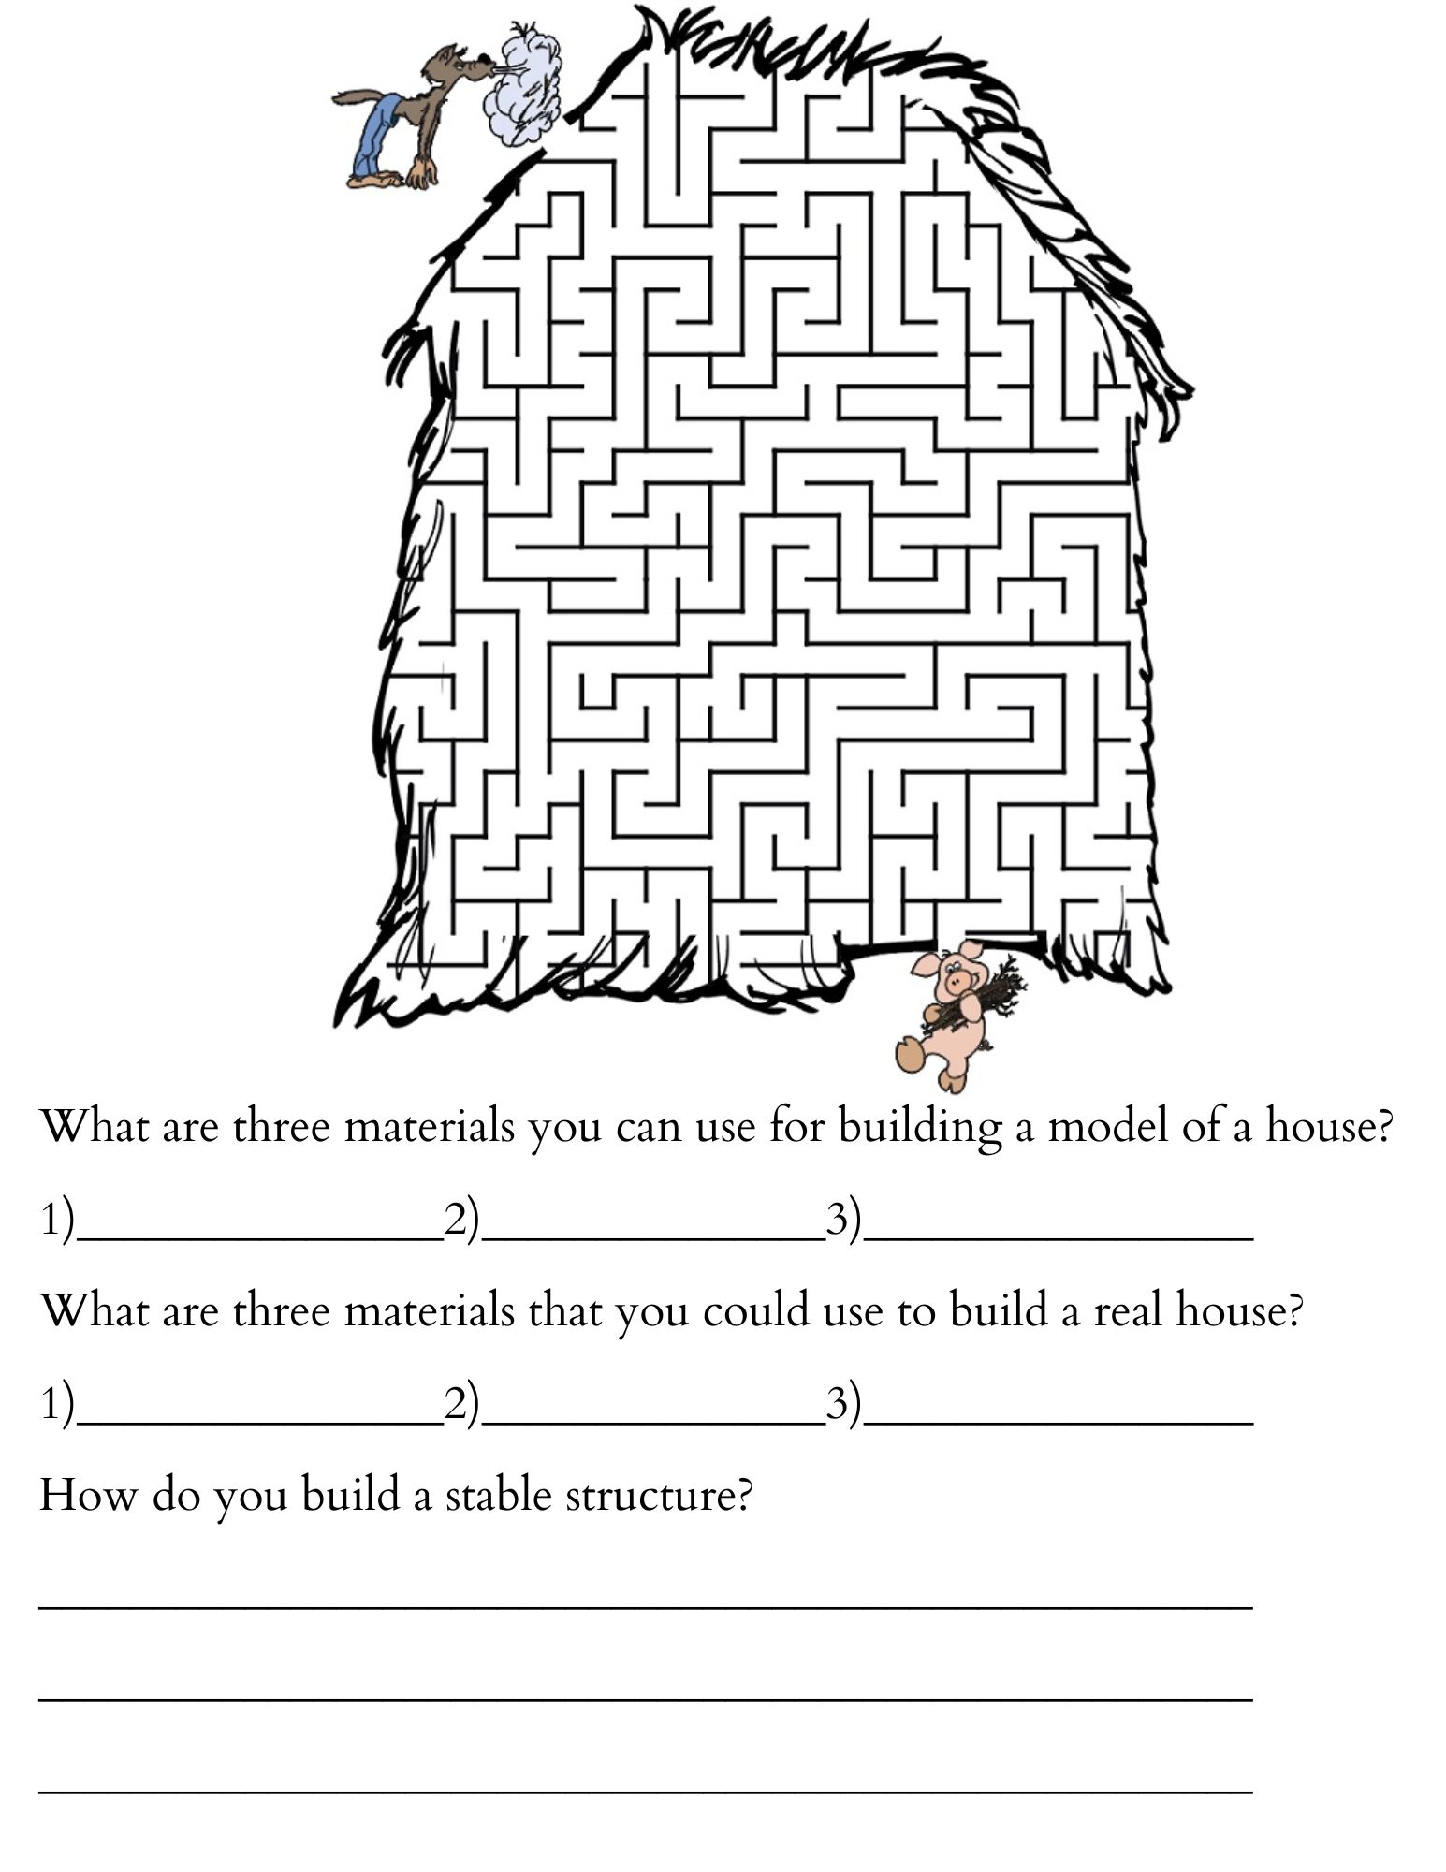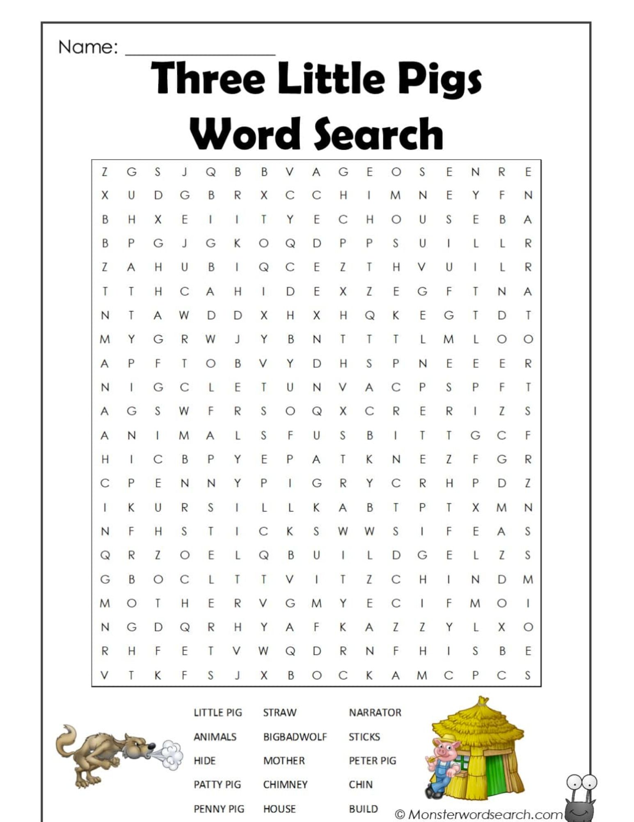

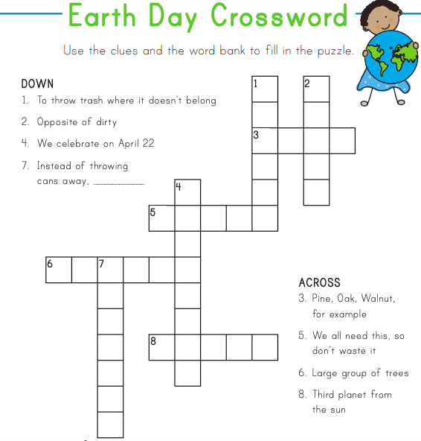
Name:______________________
Build That House!
Directions: List the recyclable materials that you will be using to build your house. Next, write the parts of a house. Then, list the price of each of the different materials that you used. Include a drawing of your structure in the box below. After your house is tested, answer the question below.
Materials:___________________________________________________________________________________________________________________________________________________
Name the parts of a house: ______________________________________________________________________________
List the price each of material that you used: ________________ ___________________ _______________________ ______________________________ _____________________ ________________________ __________________

Question: Did your house survive the wind and weight? If yes, why do you think that it survived? If not, what would you do differently next time?
_______________________________________________________________________________________________________________________________________________________________________________________________________________________________________________________________________________________________________________________

Saturday Science Week 5
Lesson Plan
Lesson Topic: Fairies (Chemistry) Grade Level: 3 and 4 Length of Lesson: 2 hours
Desired Results
State Content Standard(s):
5-PS1-4.Conduct an investigation to determine whether the mixing of two or more substances
2-PS1-4. Construct an argument with evidence to support a claim that some changes caused by heating or cooling can be reversed and some cannot.

Central Focus (learning goals):  Students will understand:  - that is is possible for objects to change into different states of matter  - how the different states of matter are different | Essential Question(s):  - What are the 3 states of matter?  - How do objects go from 1 state of matter to another?
Student objectives (outcomes/performance goals):
Students will be able to:
- list the 3 different states of matter and name real-life objects/occurrences in which all 3 states of matter are present
Learning Plan
ENGAGE (20 min)
-introduction activity and question of the day
-fairy crossword
-watching video about fairies
-brain break

EXPLORE (30 min)
-cloud in a jar activity
-burp in a jar (gas)
-going over 3 states of matter: solid, liquid, and gas
-learning about: sublimation, evaporation, freezing, melting, and condensation
-brain break

EXPLAIN (30 min)
-students make observations about potion and then make their own
-complete worksheet about potion (down below)
-learning about: sublimation, evaporation, freezing, melting, and condensation
-brain break

ELABORATE (20 min)
-making slime for students to observe
-shrek game
-brain break

EVALUATE (10-15 min)
-trivia
-sending students home with slime materials
-saturday science recap with post-it notes

Assessment Evidence
Performance Task(s):  - SWBAT complete trivia with a team  - SWBAT list and describe the properties of the 3 states of matter | Other Evidence:  - SWBAT make slime at home following all of the directions
Resources and Materials:
- fairy crossword (18 copies) down below
- potion worksheet (18 copies) down below
- PowerPoint (linked)
- ziploc bags
- baking soda
- tape
- toilet paper
- vinegar
- food coloring
- cornstarch
- hairspray (I can bring if we are over budget 🙂)
- measuring cups (i can also bring this if we do not have them)
- glass jars/beakers (8) only 1 with a lid
- ice cubes
- water
- post-it notes

Required Accommodations/Modifications (IEPs, 504s, ILPs):
- n/a at this point
- possibly preferred seating if the students/parents ask

Extending the Lesson

Name:_______________________
Magical Potion
Directions: Complete all of the questions below before creating your potion.

Question 1: What is the name of your potion? Be creative.

__________________________________________________________________
Question 2: What are the ingredients that you need for your potion? Make the names up.
__________________________________________________________________
__________________________________________________________________
Question 3: What magical power will your potion have?

__________________________________________________________________
Question 4: What do you think that your potion will look like? Describe it and draw a picture in the box below.

__________________________________________________________________

Question 4 picture- | Question 5 picture-
Question 5: What did your potion actually look like? What state of matter was your potion? Describe and draw a picture below.

__________________________________________________________________

__________________________________________________________________

