Fall 2016
FIRST Lesson Plan: Senses and Observation
GRADE LEVEL: KINDERGARTEN & FIRST

A) LEARNING OBJECTIVES and CRITERIA FOR DETERMINING IF OBJECTIVES ARE MET (minimum of 2/ lesson)
- Students will be able to explain what senses are and demonstrate how to use them with simple objects to increase their observation skills.
B) STANDARDS (see http://www.doe.in.gov/standards/science) )
Science and Engineering Process Standards:

SEPS.8 Obtaining, evaluating, and communicating information
Scientists and engineers need to be communicating clearly and articulating the ideas and methods they generate. Critiquing and communicating ideas individually and in groups is a critical professional activity. Communicating information and ideas can be done in multiple ways: using tables, diagrams, graphs, models, and equations, as well as, orally, in writing, and through extended discussions. Scientists and engineers employ multiple sources to obtain information that is used to evaluate the merit and validity of claims, methods, and designs.

Content and Practice Standards:

K.PS.1 Plan and conduct an investigation using all senses to describe and classify different kinds of objects by their composition and physical properties. Explain these choices to others and generate questions about the objects.
K.PS.4 Analyze data to determine if a design solution works as intended to change the speed or direction of an object with a push or a pull.
1.ESS.2 Observe and compare properties of sand, clay, silt, and organic matter. Look for evidence of sand, clay, silt, and organic matter as components of soil samples.
1.ESS.3 Observe a variety of soil samples and describe in words and pictures the soil properties in terms of color, particle size and shape, texture, and recognizable living and nonliving items.

C) MATERIALS (asterisk (*) = any materials that may be a safety concern)
- plastic cups (10)
- foil
- balloons
- lemons (2)
- (1 bag) of dark chocolate chips (at least 80% cacao)
- (1 bag) of pretzel sticks
- (1 large bag) of skittles
- cotton balls
- play dough
- sandpaper
- Metal
- Flags (paper for brainstorming)
- Clip boards
- Pencils
- Different types of balls (they are in our pile already)
- Alka Seltzer
- Vinegar
- coffee
D) TEACHER CONTENT KNOWLEDGE
- Teachers will know all five senses and how to use them in order to observe objects outside. Teachers will also know how to identify mystery objects using their senses.
E) REFERENCES (list ALL references that you borrowed ideas from to develop this lesson – including any handouts you may distribute)
- None
F) TENTATIVE TIMELINE
- When the students arrive we are going to have coloring pages on the tables and crayons to keep them occupied until the start of the lesson.
- (15 minutes) Introduce Senses
- (30-45 minutes) Scavenger Hunt
- (5 minutes) Discuss their findings.
- (30 minutes) snack & use the bathroom
- (30-45 minutes) Station Senses Activity.
- (5 minutes) Discuss their findings.
- (10 minutes) Designing their own flags. (remaining time)
G) DESCRIPTION OF YOUR LESSON
- Students will come in and we will introduce the senses they will be using in their observations. We will watch a video to introduce the senses. (15 minutes)
- After completing the introduction of senses, we will go outside where the students will be doing a scavenger hunt using their senses. They will receive a chart that is numbered 1-5 and has pictures that represents each of the senses. They will be using drawing or writing in items they find for each of the senses. (30-45 minutes)
- When we come inside students will talk about their findings. (5 minutes)
- After they talk about their findings they will have snack and they will be able to use the bathroom. (30 minutes)
- After that they will be engaging in an activity where balloons and cups will contain objects and they will be observing using their senses to see what they think is in each balloon or cup. These objects will be in different stations that students will rotate through (30-45 minutes)
- After they get through all the stations and collaborate as a group, we will come back to a whole and discuss what they think is inside each of the balloons. (5 minutes)
- With any time left we will talk about creating group flags to represent their group for the olympics. They will work on their flags each week when they come in and if they have any extra time at the end. (10 minutes)

ENGAGE
(5 Senses Video) https://youtu.be/iA1uLc1uEbI
We will be showing an introductory video of the five senses to engage the students and help them understand the five senses. As a class, everyone will understand how to describe their surroundings in a way that makes sense. If a difference is noticed between two things, students can use words and pictures to explain what makes things different from one another by using their best descriptive features, which are smell, sound, taste, see, and feel. What are your five senses and how can you use them?
EXPLORE
After we complete the introduction of senses with the video, the students will go out on a scavenger hunt to find objects outside that they have to use their 5 senses to locate, and then write them on the chart they will receive prior to the exploration.

After their break and snack, they will begin an experiment with 6 different stations, with each station covering a different sense, and another station for a bathroom break. The students will be using their sense of touch to feel balloons filled with different materials to decide what the material is. They will use their sense of smell to smell objects placed in a plastic cup and covered with foil with holes poked on top in order to guess the object they’re smelling. They will use their sense of hearing to guess what sounds are being played. They will use their sense of sight to guess what colors are being shown, and they will use their sense of taste to guess what they are tasting, i.e. salty, sweet, bitter, etc.
EXPLAIN

Claim- My eyes help me see, which can help me describe what something looks like.
My ears help me hear sounds that are high and low in pitch.
My nose helps me smell things that are fresh or spoiled.
My hands help me feel things around me, I can interact with my surroundings.
My tongue helps me taste things that are good to me and might not taste good to others.

Evidence-
After the students complete their scavenger hunt, take a bathroom break, and eat a snack, we will go over what they found in their scavenger hunt and discuss how they used their senses to find these objects.
*Students will be filling out their worksheets deciding what senes help them do. (See worksheet at the bottom.)

After the students go through each station and make their guesses, we will discuss as a whole group what they found and how they used their sense to make these guesses.

Reasoning- Show the youtube video for “My 5 Senses” By Aliki.
https://www.youtube.com/watch?v=YT4nK7bQSmU
Students will be using their senses to observe objects and find out what different senses help them do. They will be able to look at the objects they observed and decide which senses helped them determine that object.
ELABORATION
At the end of class, we will ask the students to go home this week and find something in their room that they can identify by seeing, hearing, touching, smelling, or seeing.
H) EMBEDDED FORMATIVE ASSESSMENT (the 5th “E”)

Evaluate- We will conduct a formative assessment by collecting our students’ five senses worksheets at the end of the day to see how they were able to make observations of different objects by using their five senses.

I) GEARING UP/GEARING DOWN
1. Gearing up:
If this activity is too easy, to gear up students will be asked to use multiple senses on objects, instead of one specific sense we were targeting. Students will also be asked to compare and contrast different objects and the different sense they use to identify objects.

2. Gearing down:
If this activity is too hard, students will be able to work in groups to discuss which sense is emphasized when identifying an object .

Senses Worksheet
Senses: | 1 | 2 | 3 | 4 | 5
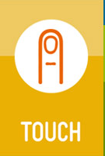
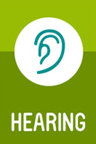

Senses: | 1 | 2 | 3 | 4
Hidden Object’s Activity Worksheet

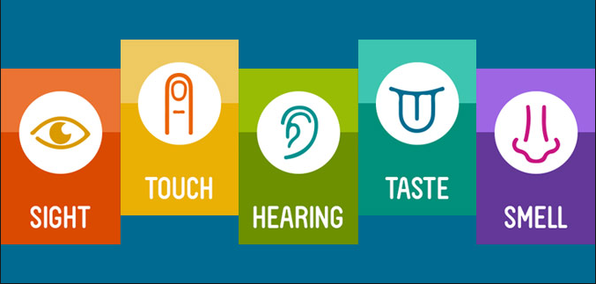
- My _________ help me see, which can help me describe what something looks like.

- My ________ help me hear sounds that are high and low in pitch.

- My _________ helps me smell things that are fresh or spoiled.

- My _________ help me feel things around me, I can interact with my surroundings.

- My ________ helps me taste things that are good to me and might not taste good to others.

Q405 Saturday Science Teaching – Fall 2016 Lesson Plan #2
Second Lesson Plan:
GRADE LEVEL: KINDERGARTEN & FIRST

A) LEARNING OBJECTIVES and CRITERIA FOR DETERMINING IF OBJECTIVES ARE MET(minimum of 2/ lesson)
- Students will build on their prior knowledge of senses, and gain a more complex knowledge of their senses, and how they can use them to compare and contrast complex objects and their properties. This will be connected to then determining soil types.
- Focus Questions:
  - Soil Activity
    - How do scientists use observations to identify soil?
B) STANDARDS (see http://www.doe.in.gov/standards/science)

- 1.ESS.2 Observe and compare properties of sand, clay, silt, and organic matter. Look for evidence of sand, clay, silt, and organic matter as components of soil samples.
- 1.ESS.3 Observe a variety of soil samples and describe in words and pictures the soil properties in terms of color, particle size and shape, texture, and recognizable living and nonliving items.
- 1.PS.2 Predict and experiment with methods (sieving, evaporation) to separate solids and liquids based on their physical properties.

C) MATERIALS (asterisk (*) = any materials that may be a safety concern)
-vinyl tablecloth (6)
-plastic cups (doesn’t matter what size) (26)
-shovels (small or medium sized)
-sand (6 baggies)
-humus (6 baggies)
-clay (6 baggies)
-potting soil (6 baggies)

D) TEACHER CONTENT KNOWLEDGE

To achieve the lesson objectives, the students will need to be able to distinguish the different components of soil. Soil is the scientific term for dirt and is mainly composed of different sources (clay, sand, silt, humus, rocks & pebbles). The basic three components however are clay, sand, and humus (listed below). Thus, for the students to be able to observe and recognize these components in the soil they found around the Education building, we will first have them use some of their 5 senses to observe the components individually before attempting to locate them in the soil they collected. Below is a list of these components, their basic descriptions, and what they often look like or their purpose in the soil. Following the list you will also find what we expect our students to be able to do.

Clay-a stiff, sticky fine-grained earth, typically yellow, red, or bluish-gray in color and often forming an impermeable layer in the soil. It can be molded when wet, and is dried and baked to make bricks, pottery, and ceramics (material deep in the earth that is sticky and easily molded when it’s wet, and will turn hard when it’s baked in an oven.)

Sand-a loose granular substance, typically pale yellowish brown, resulting from the erosion of siliceous and other rocks and forming a major constituent of beaches, riverbeds, the seabed, and deserts. (small, grainy soil you find on the beach or lakes)
Humus- the organic component of soil, formed by the decomposition of leaves and other plant material by soil microorganisms. (dark-brown or black material made from decaying (dead) plants and animal matter. Very healthy for plants because it provides nutrients for them, just like certain foods gives us nutrients to stay healthy).

Potting soil-a mixture of loam, peat, sand, and nutrients, used as a growing medium for plants in containers. (mixture of dirt and other pieces of matter from the earth that helps plants grow).

Observations students should be making about the soil:
- color (if it’s one color, more than one color)
  - Can use sense of sight
- size (of particles)
  - Can use sense of sight, touch
- what’s in the soils samples (rocks, sticks, etc.)
  - Can use sense of sight, touch
- texture (does it feel hard, soft, wet etc.)
  - Can use sense of touch
- What it smells like
  - Can use sense of smell

These observations they make using their five senses are the PROPERTIES of soil.

E) REFERENCES
(handouts at bottom)
- Dirt -The Scoop on Soil by Natalie M. Rosinsky
- Anchor Chart Written Out for Students’ Observations

F) TENTATIVE TIMELINE: (LEAD TEACHERS: Amber/Elisabeth, SUPPORT: Brittany/Brady/Missy/Katie)
    - Class norms and review last week material. (If you hear me put your hands on your head. Hallway expectations. Respect for who has the floor. Raise your hand to speak.) (9:30-9:45am) AMBER
    - Engaging video/ or book explaining what the different types of soil are. (9:45-10:00 am) AMBER
    - Collecting two soil samples from the Jordan River and Woods (10:00-10:20am) ELISABETH-Split into Groups of 3 (1-Brittany, Amber 2-Elisabeth, Brady 3-Katie, Missy)
    - Children will observe four different types of soil that we collected- Sand, Humus, Rocks and Pebbles, and Clay. (10:20-10:40 am) AMBER
    - Wash Hand-Restroom/ Snack- Magic School Bus Video https://youtu.be/WrEgz51xJYM (10:40-11:10am)
    - CER Framework (11:10am-11:20pm) ELISABETH
    - Observing their own soil, and what makes it different from each other. (11:20-11:45 am) AMBER
    - Pick Team Names, Go over flags designs to do next week (11:45am-12:00pm) ALL
    - Pick up/ Go Noodle Time KATIE
      - https://www.youtube.com/watch?v=3bp4LHH1ido
      - https://www.youtube.com/watch?v=3fjdEEl0GjQ

G) DESCRIPTION OF YOUR LESSON

ENGAGE
To begin this Saturday session, we will introduce class norms and rules, so that students know what we expect form them in reference to behavior and classroom etiquette. This will be brief, as we introduce rules on being respectful and quiet, and share our classroom management technique (“If you can hear me put your hands on your head…” After this, we will review with the class about what they learned last week (senses), and how senses relate to how scientists make observations. After the review, one of the lead teacher will instruct the students to come to the floor for a read aloud called “Dirt The Scoop on Soil”. Amber will introduce the read aloud, asking students what they know about soil and address the focus question, “how do scientist use their observation skills to learn about soil.” A couple guided questions that will be asked in the discussion are; What do you think is in soil? What is soil used for? After the read aloud students will return to their seats so that the class can have an open discussion about the book, and what they have learned about soil, as well as what senses might scientist use when observing soil.

EXPLORE
After the read aloud and the class discussion, we will begin with the exploration of different types of components of soil. Students will start out by going outside and collecting soil from two different locations, the Jordan River as well as the other side of the parking garage next to the School of Education. Then we will come back and have the students put their samples to the side of the room to use later in the day. For the next activity, we will give students samples of the three different components of soil to observe using three of their senses, sight, touch, and smell. During this activity we will ask questions like: How would you describe the smell of humus/clay/sand? How you describe what sand/humus/clay feels like? How would you describe what humus/clay/sand looks like? We will then come together after snack to talk about our CER (explained in the explain phase). After we discuss this idea we will go back to the soil samples that they collected at the beginning of the day and use their findings to compare the soil samples with what they found in the different components of soil. Some guided questions we will ask in this part will be; What are some similarities between the soil collections? What are some things that are different? Can you see any of the components that we observed earlier in these soil samples?

EXPLAIN
Claim- The claim that we want students to reach is: scientists make informed observations by using their senses to collect evidence of soil.

Evidence- Students will support their claim with their observations that they make through worksheets #1&2 Getting Down to Earth with Soil activity. Some of the evidence we expect them to collect through their observations is how each of the components (clay, sand, and humus) feel, smell, and see.

Reasoning- Students understand the differences between different types of soil, and can reasonably determine the properties of soil (dryness, thickness, etc) in relation to other soil.

ELABORATION
Students will carry on their knowledge of soil when at home, and will be able to identify the different types of soil when presented. Students will also be able to understand the importance of using their senses to collect evidence in order to strengthen their ideas about their surroundings.

H) EMBEDDED FORMATIVE ASSESSMENT (the 5th “E”)
Evaluate- We will conduct a formative assessment by collecting our students’ Soil identification worksheet at the end of the day to see how they were able to make observations of different types of soil. We will also have one large Anchor Chart that shows what each child came up with for soil observations and compare their results. The anchor chart will cover the questions: How would you describe the smell of humus/clay/sand? How you describe what sand/humus/clay feels like? How would you describe what humus/clay/sand looks like?

I) GEARING UP/GEARING DOWN

1. Gearing up: If this activity is too easy, to gear up students we will have them compare each student’s soil in their group and they will determine what all types of soil they find in each. Then as a whole group we will see what everyone found.

2. Gearing down: If this activity is too hard, or students aren’t understanding we could share a video and/or additional book that pertains to our lesson. This will give them additional opportunities to understanding the different types of soil and why we are using soil to demonstrate the use of senses for observation.

WORKSHEETS USED
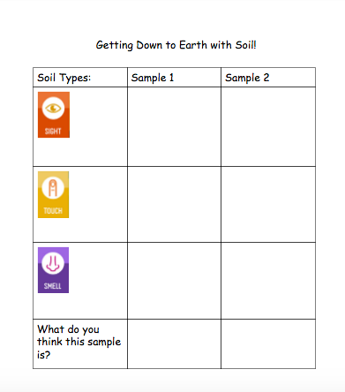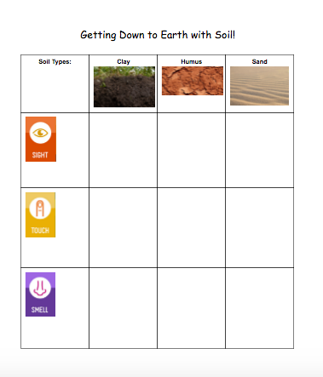

Q405 Saturday Science Teaching – Fall 2016
Third Lesson Plan 3

Boats
Grades K-1

A) LEARNING OBJECTIVES and CRITERIA FOR DETERMINING IF OBJECTIVES ARE MET (minimum of 2/ lesson)
-Students will plan out and design a functioning boat using resources given to them, and collaborating with their team.
-Students will optimize their boat by using certain objects in different shapes and formats in order to move their boat faster down water.

B) STANDARDS
K.PS.2 Identify and explain possible uses for an object based on its properties and compare these uses with other students’ ideas.
K.PS.3 Plan and conduct an investigation to compare the effects of different strengths or different directions of pushes and pulls on the motion of an object.
K.PS.4 Analyze data to determine if a design solution works as intended to change the speed or direction of an object with a push or a pull.
K-2.E.2 Develop a simple sketch, drawing, or physical model to illustrate and investigate how the shape of an object helps it function as needed to solve an identified problem.

C) MATERIALS (asterisk (*) = any materials that may be a safety concern)
- Balances (scales)
- Box fan (teachers bringing two)
- Styrofoam (12)
- Paper clips
- Clay
- Masking tape (6 rolls)
- Straws
- Foil
- Plastic Wrap
- Toothpicks
- Skewers
- Rubberbands
- Paper
- Pencils
- Fabric
- 6 stopwatches

D) TEACHER CONTENT KNOWLEDGE
We, the teachers, conducted the same type of investigation, to see which boat design could move the fastest, in relationship to push and pull, as well as motion. Push and pull are both forces, and force makes an object move or stop moving. Through this activity, students will learn this about motion and forces through trial and error, where they will redesign their boats and variables in order to increase their speed of the boat.
- Push - force to move something away from something else.
- Pull - force to move something toward something else.
- Motion - the process of being moved.
- Force - physical action of moving something.

TENTATIVE TIMELINE: (Lead Teachers: Brittany/Brady, Helpers: Katie, Missy, Amber)
**Everyone will be stationed at a table group for the duration of the activity.
    - Class norms and review last week material. (If you hear me put your hands on your head. Hallway expectations. Respect for who has the floor. Raise your hand to speak.) Go over a brief review of what we learned last week (9:30-9:45am) BRITTANY
    - Go noodle brain break-https://app.gonoodle.com/channels/koo-koo-kanga-roo/pop-see-ko?source=search (9:45-9:48am)
    - Word wall of sailboat parts. Draw design, Creating Boats, Test them (10:00-10:40am) BRADY
    - Wash Hand-Restroom/ Snack- Magic School Bus Video https://youtu.be/yrPK4AUtOpw (10:40-11:10am)
    - Draw re-design, re-design Boat’s (twice) and come up with what works best, what doesn’t work (11:10am-11:45pm) BRITTANY/BRADY
    - Work on Flags (11:45am-12:00pm) ALL
    - Pick up/ Go Noodle Time KATIE
      - https://www.youtube.com/watch?v=LjMffHG1V_Q
      - https://www.youtube.com/watch?v=AH6WDJB5uxg&index=7&list=PLMBmsoTlDdxQxdcs50qKFKgAHov2ec-0K
      - https://www.youtube.com/watch?v=bP_0vet_KFA&list=PLJbDrszTX9P-QnpBwZTwf4E04MBw_KGsQ

G) DESCRIPTION OF YOUR LESSON

ENGAGE
We will begin by introducing the terms push and pull. We will ask the students to identify things that get pushed and pulled. After a short class discussion, we will show the students a Youtube video that discusses what makes boats sink versus what makes them float (Video: https://www.youtube.com/watch?v=tx2pJ1_TYQg ). After the video, we will discuss how it is possible for sailboats to float on water. We will instruct the students that they will be constructing their own boats at their table, and to start to think about their own boat dalesigns, and how they will successfully work their way across the water. If needed, we can brainstorm a word wall of important parts of boats for students who are confused and/or need help labeling. (Making sure that they know that the wind is the source that pushed the boat while on the water.)

Some questions we will be sure to ask are: What is a push? What is a pull? What are some things you can push? What are some of things you can pull?

EXPLORE
During the explore phase, each table will begin creating their team sailboats. While doing so, they will be filling out the guideline packet, to ensure they are on the right track/ considering key ideas that can better help the design of their boat. Students will be asked to first draw their boat structure, labeling important features that can help their boat move faster through the water. After they draw their first model and build it, they will be able to test it on the water. During this portion of the lab, students will each choose jobs to ensure they are correctly racing their boat. Jobs will be, but not limited to, Timer, Boat Pusher, Boat Stopper, Recorder. It is important to note that each boat race is conducted individually, focusing on only one boat at a time. After the boat race is conducted, students will regroup at their tables to determine which features of their boat worked, and which features could be altered in order for their boat to move more swiftly. This step will be repeated at most twice, resulting in at most, three alterations to their boats.
Some questions we will be sure to ask are: Which materials did you use when creating your boat? What helped the boat to go the fastest?

EXPLAIN
While building and trying their models of the boats, they will record and change one feature each round in hopes to make their boats faster. The group will work together to re-sketch their new design, including their improvement and they will logically reason why they made said change. After reconstructing, they will be able to test their boat again. After each group has raced their boats three different times, and have recorded their final observations, the class will gather on the floor in a circle to discuss their findings and their experiences. Each group will have a turn to talk about the changes they made, and if these changes improved their boat’s speed or not. After each group has gone, we will discuss what similar features each group had that helped their boat move swiftly through the water, and how push and pull effected their boat’s overall motion. (Doing a chart of what worked and what didn’t on the board.)

Some questions we will be sure to ask are: Why did you decide to make that change to your boat? How do you think you can change your boat to make it faster?

ELABORATION
While building and testing their boats, the students will record their data and get two opportunities to redo their design to make it more successful, totalling in three races. We will have a discussion with the students to talk about some of the components of push and pull with the sailboats to get the students looking a their data and thinking about what helps boats move the fastest.

Some questions we will be sure to ask the students to think about are: What features are going to make your boat sail without falling at a high speed? Why do you think your boat didn’t move as fast? What can you change?

H) EMBEDDED FORMATIVE ASSESSMENT (the 5th “E”)
Evaluate - We will be giving students a boat packet that they will be drawing their boat designs and recording their data from their races. We will have a discussion talking about the types of materials that allowed the boats to go the fastest.

Some questions we will be sure to ask the students to think about are:
What made the boat successfully move across the container?
What were some things that helped your boat stay stable and not tip over?
What were the things that made your boat sink, or tip over?
How would you have started if you knew the materials that made it successful?

I) GEARING UP/GEARING DOWN
1. Gearing up:
If the lesson is too easy, we will challenge the students to to make their boat a “Double Decker” and add a second piece of styrofoam and attempt to get that one to float across the tub.

2. Gearing down:
If the lesson is too hard, we will allow the students to change more than one feature of their boat at a time and allow the instructors to be more involved in the design process, helping to guide students.

WORKSHEETS USED (be sure to attach full sized copy): BELOW
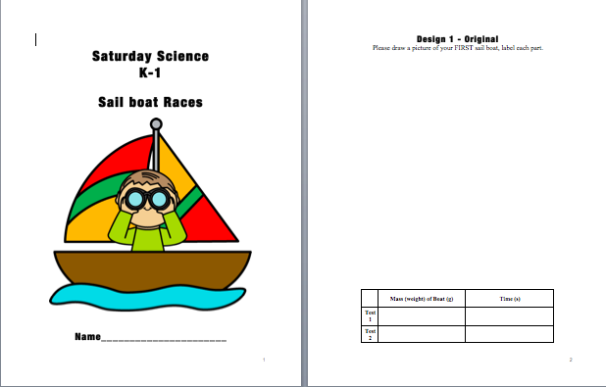
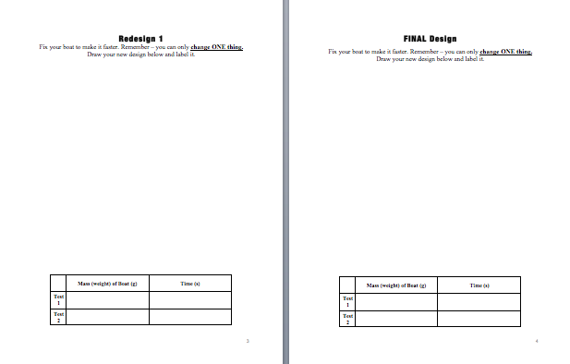
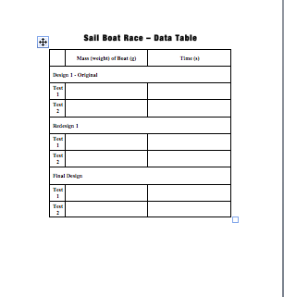
https://www.youtube.com/watch?v=HCvbN2P_MCY&index=4&list=PLxhmD-3PSdNOcs6uP5uJznWToI92MFbh2

Q405 Saturday Science Teaching – Fall 2016
Four Lesson Plan 4

Grades K-1

A) LEARNING OBJECTIVES and CRITERIA FOR DETERMINING IF OBJECTIVES ARE MET (minimum of 2/ lesson)
- Students will be collecting and analyzing data based on the materials provided to determine the best aerodynamic flying object by folding it *things that fly the longest, looking for the best flight time.
  - Focus Questions:
    - Airplane Building
      - What can we do to make the airplane travel the longest?
- Students will compare the materials that they used to build the plane, recognizing key differences in the actual material to determine which one flies the best with their fold pattern.
  - Focus Question: Which material helped your plane fly for the longest time?
B) STANDARDS
- K.PS.2 Identify and explain possible uses for an object based on its properties and compare these uses with other students’ ideas.
- K.PS.3 Plan and conduct an investigation to compare the effects of different strengths or different directions of pushes and pulls on the motion of an object.
- K.PS.4 Analyze data to determine if a design solution works as intended to change the speed or direction of an object with a push or a pull.
- K-2.E.2 Develop a simple sketch, drawing, or physical model to illustrate and investigate how the shape of an object helps it function as needed to solve an identified problem.

C) MATERIALS (asterisk (*) = any materials that may be a safety concern)
- Construction
- Printer Paper
- Cardstock
- Foil
- Tape
- Stopwatch

D) TEACHER CONTENT KNOWLEDGE

We, the teachers, as well as the students, have conducted the same type of investigation, in the previous session. However, now we are focusing on planes and the idea of traveling the longest. Through this activity, students will learn this about motion and forces through trial and error, where they will redesign their planes and variables in order to increase their flight time of the planes.
- Motion - the process of being moved.
- Force - physical action of moving something.
- Push - force to move something away from something else.
- Pull - force to move something toward something else.

TENTATIVE TIMELINE:
    - Class norms and review last week material. (If you hear me put your hands on your head. Hallway expectations. Respect for who has the floor. Raise your hand to speak.) Go over a brief review of what we learned last week.(9:30-9:40am) BRADY
    - Show students a video that introduces planes. https://www.youtube.com/watch?v=6WQ4aOV9aS8 (9:40-9:45am) AMBER
    - Go noodle brain break-https://www.youtube.com/watch?v=5hn61z3FlMQ (9:45-9:48am)
    - Introduce plane activity, discuss rules/procedures for being in the MILL, take students to the MILL to construct planes. (10:00-10:40am) MISSY
    - Wash Hand-Restroom/ Snack- Magic School Bus Video https://www.youtube.com/watch?v=PbvSv6N8PTQ (10:40-11:10am)
    - Test planes, and re-construct as needed. (11:10am-11:45pm) BRADY, AMBER, MISSY
    - Head back to the class, discuss Olympic Games for next week. (11:45-12:00 pm) AMBER
    - Pick up/ Go Noodle Time (12:00 pm) MISSY
      - https://www.youtube.com/watch?v=27Jmi_oPU_w&list=PL2I9fJQlw0SPQ99vmeTuEoU8oEUkA-ckX&index=2
      - https://www.youtube.com/watch?v=PXvh08Mnork
      - https://www.youtube.com/watch?v=39L-M5nhx6Y&list=PLd_c_oI4XQLJnBBms6BLkODsOSRXIYda7

G) DESCRIPTION OF YOUR LESSON

ENGAGE
To engage the students, we will begin by showing them a short video about planes. The video talks about all the different kinds of planes, and how their different designs/structures vary. This will introduce students to the learning objective for the day of making a plane in the MILL and start to make planes with the longest flight time. We will review what the terms motion, force, and push and pull are. We will also introduce the term flight time, and ask the students what they think flight time is. After creating a class definition, we will tell them that flight time is “the time from when the plane takes off to when it lands.”
Some questions we will be sure to ask the students to think about are:

What is motion? What is force? What happens when we push something? What happens when we pull something? What is flight time?

EXPLORE
During the explore phase, each student will be creating their own plane that is designed to have the longest flight time. While doing so, they will be filling out the guideline packet, to ensure they are on the right track/ considering key ideas that can better help the design of their plane. Students will be assigned a plane design to fold each plane with the particular type of material, labeling which plane design they make and the type of material they are using. After they build their first model, they will be able to test it. They will be testing the flight time (how long they stay in the air). After they test their first model they will be able to discuss within their group which model traveled the longest with that material. Then they will move onto a different material and each student will create the same design that they were assigned to with the new material. Then they will test again and find which plane had the longest flight time in that material. Students will repeat this for four materials.
Some questions we will be sure to ask are: Which materials/design traveled the longest? What helped the plane to have the longest flight time?

EXPLAIN
While building and trying their models of the planes, they will record and change one feature (the material) each round in hopes to make their flight time longer. The group will work together to make their new planes with their new materials. After reconstructing, they will be able to test their plane again. After each group has tried their planes four different times, and have recorded their final observations, the class will gather on the floor in a circle to discuss their findings and their experiences. Each group will have a turn to talk about the changes they made, and if these changes improved their plane’s flight time or not. After each group has gone, we will discuss what similar features each group had that helped their plane increase its flight time, and how push and pull effected their plane’s overall motion. (Doing a chart of what worked and what didn’t on the board.)

Some questions we will be sure to ask are: Why did you decide to make that change to your plane? How do you think you can change your plane to make it go longer?

ELABORATION
While building and testing their planes, the students will record their data and get two opportunities to change their materials of their planes to make it more successful, totalling in three races. We will have a discussion with the students to talk about some of the components of push and pull with the planes to get the students looking a their data and thinking about what helps planes move the farthest, and what their flight time was.

Some questions we will be sure to ask the students to think about are: What features are going to make your plane fly the longest? Why do you think your plane didn’t fly as long? What can you change?

H) EMBEDDED FORMATIVE ASSESSMENT (the 5th “E”)
Evaluate - We will be giving students a plane packet that they will be recording their data from their flights. We will have a discussion talking about the types of materials and folds that allowed the planes to go the longest in the flight.

Some questions we will be sure to ask the students to think about are:
What made them travel the longest?
What stopped them from flying?
What would you have started with if you were to know what made the plane successful to begin with?

I) GEARING UP/GEARING DOWN
1. Gearing up: If this lesson is too easy for the students, they can start trying other types of folds. (ex: 10 different objects).

2. Gearing down: The students could do more than one adaption to their models if they are not figuring out what their plane needs in order to travel.

WORKSHEETS USED (be sure to attach full sized copy):
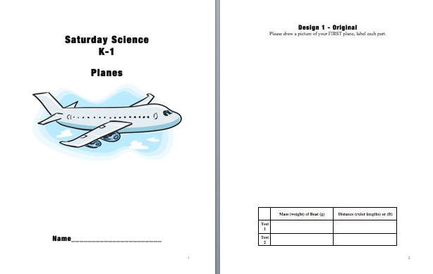
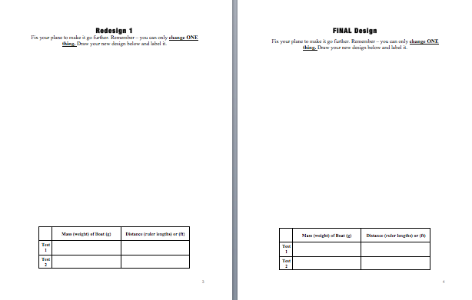
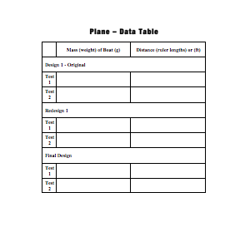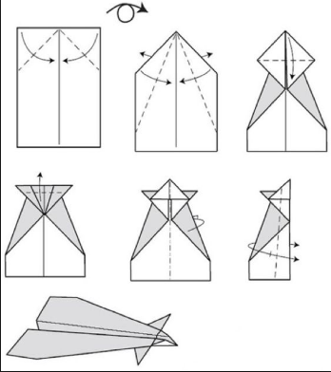

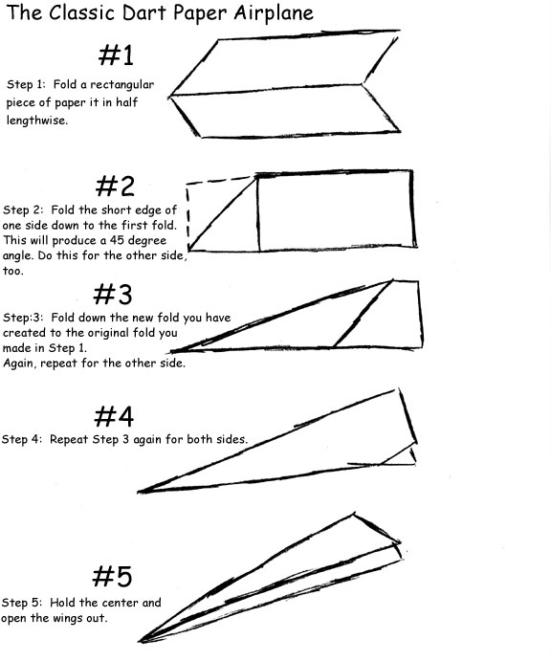
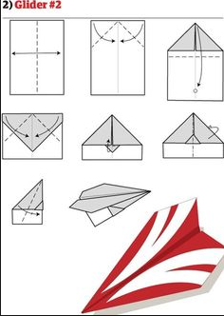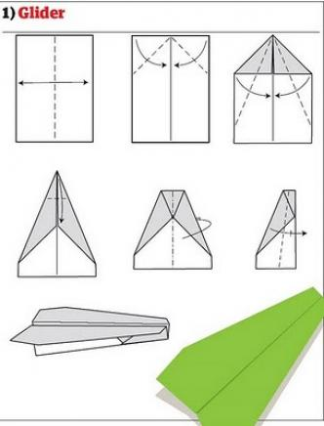

Saturday Science Teaching – Fall 2016
Fifth Lesson Plan (5)
Grades K-1

A) LEARNING OBJECTIVES and CRITERIA FOR DETERMINING IF OBJECTIVES ARE MET (minimum of 2/ lesson)
- Senses
  - Students will be able to explain what senses are and demonstrate how to use them with simple objects to increase their observation skills.
- Soil
  - Students will build on their prior knowledge of senses, and gain a more complex knowledge of their senses, and how they can use them to compare and contrast complex objects and their properties. This will be connected to then determining soil types.
- Force and Motion: Boats
  - Students will plan out and design a functioning boat using resources given to them, and collaborating with their team.
  - Students will optimize their boat by using certain objects in different shapes and formats in order to move their boat faster down water.
- Force and Motion: Planes
  - Students will be collecting and analyzing data based on the materials provided to determine the best aerodynamic flying object by folding it *things that fly the longest, looking for the best flight time.
  - Students will compare the materials that they used to build the plane, recognizing key differences in the actual material to determine which one flies the best with their fold pattern.
- FOCUS QUESTION:
  - How can you use the knowledge you’ve gained about senses, soil, and force & motion to compete in various competitions?

B) STANDARDS (see http://www.doe.in.gov/standards/science) )
Senses Standards
Science and Engineering Process Standards:
SEPS.8 Obtaining, evaluating, and communicating information
Scientists and engineers need to be communicating clearly and articulating the ideas and methods they generate. Critiquing and communicating ideas individually and in groups is a critical professional activity. Communicating information and ideas can be done in multiple ways: using tables, diagrams, graphs, models, and equations, as well as, orally, in writing, and through extended discussions. Scientists and engineers employ multiple sources to obtain information that is used to evaluate the merit and validity of claims, methods, and designs.
Content and Practice Standards:
K.PS.1 Plan and conduct an investigation using all senses to describe and classify different kinds of objects by their composition and physical properties. Explain these choices to others and generate questions about the objects.
K.PS.4 Analyze data to determine if a design solution works as intended to change the speed or direction of an object with a push or a pull.
1.ESS.2 Observe and compare properties of sand, clay, silt, and organic matter. Look for evidence of sand, clay, silt, and organic matter as components of soil samples.
1.ESS.3 Observe a variety of soil samples and describe in words and pictures the soil properties in terms of color, particle size and shape, texture, and recognizable living and nonliving items.
Soil Standards
1.ESS.2 Observe and compare properties of sand, clay, silt, and organic matter. Look for evidence of sand, clay, silt, and organic matter as components of soil samples.
1.ESS.3 Observe a variety of soil samples and describe in words and pictures the soil properties in terms of color, particle size and shape, texture, and recognizable living and nonliving items.
1.PS.2 Predict and experiment with methods (sieving, evaporation) to separate solids and liquids based on their physical properties.
Boat & Airplane Standards
K.PS.2 Identify and explain possible uses for an object based on its properties and compare these uses with other students’ ideas.
K.PS.3 Plan and conduct an investigation to compare the effects of different strengths or different directions of pushes and pulls on the motion of an object.
K.PS.4 Analyze data to determine if a design solution works as intended to change the speed or direction of an object with a push or a pull.
K-2.E.2 Develop a simple sketch, drawing, or physical model to illustrate and investigate how the shape of an object helps it function as needed to solve an identified problem.

C) MATERIALS (asterisk (*) = any materials that may be a safety concern)
- Foil (one roll)
- Coffee
- lemon
- Metal
- Clip boards
- Pencils
- Paper plates
- Paper cups
- Cardstock (6 pieces)
- Construction paper (6 pieces)
- Printer paper (6 pieces)
- Box fan (two)
- Styrofoam (12)
- Paper clips
- Clay (molding clay)
- Masking tape
- Straws
- Plastic Wrap
- Toothpicks
- Skewers
- Rubberbands
- Pencils
- Fabric
- 6 stopwatches

D) TEACHER CONTENT KNOWLEDGE
- Knowledge of Senses/Observation: Teachers will know all five senses and how to use them in order to observe objects outside. Teachers will also know how to identify mystery objects using their senses.
- Knowledge of Soil: To achieve the lesson objectives, the students will need to be able to distinguish the different components of soil. Soil is the scientific term for dirt and is mainly composed of different sources (clay, sand, silt, humus, rocks & pebbles). The basic three components however are clay, sand, and humus (listed below). Thus, for the students to be able to observe and recognize these components in the soil they found around the Education building, we will first have them use some of their 5 senses to observe the components individually before attempting to locate them in the soil they collected. Below is a list of these components, their basic descriptions, and what they often look like or their purpose in the soil. Following the list you will also find what we expect our students to be able to do.
  - Clay-a stiff, sticky fine-grained earth, typically yellow, red, or bluish-gray in color and often forming an impermeable layer in the soil. It can be molded when wet, and is dried and baked to make bricks, pottery, and ceramics (material deep in the earth that is sticky and easily molded when it’s wet, and will turn hard when it’s baked in an oven.)
  - Sand-a loose granular substance, typically pale yellowish brown, resulting from the erosion of siliceous and other rocks and forming a major constituent of beaches, riverbeds, the seabed, and deserts. (small, grainy soil you find on the beach or lakes)
  - Humus- the organic component of soil, formed by the decomposition of leaves and other plant material by soil microorganisms. (dark-brown or black material made from decaying (dead) plants and animal matter. Very healthy for plants because it provides nutrients for them, just like certain foods gives us nutrients to stay healthy).
  - Potting soil-a mixture of loam, peat, sand, and nutrients, used as a growing medium for plants in containers. (mixture of dirt and other pieces of matter from the earth that helps plants grow).
- Knowledge for Boats: We, the teachers, conducted the same type of investigation, to see which boat design could move the fastest, in relationship to push and pull, as well as motion. Push and pull are both forces, and force makes an object move or stop moving. Through this activity, students will learn this about motion and forces through trial and error, where they will redesign their boats and variables in order to increase their speed of the boat.
  - Push - force to move something away from something else.
  - Pull - force to move something toward something else.
  - Motion - the process of being moved.
  - Force - physical action of moving something.
- Knowledge for Planes: We, the teachers, as well as the students, have conducted the same type of investigation, in the previous session. However, now we are focusing on planes and the idea of distance. Distance measures the amount of space between two objects. Through this activity, students will learn this about motion and forces through trial and error, where they will redesign their planes and variables in order to increase their distance their planes can go.
  - Distance- the amount of space between two locations or objects.
  - Motion - the process of being moved.
  - Force - physical action of moving something.
  - Push - force to move something away from something else.
  - Pull - force to move something toward something else.

Students will be investigating different topics that we have talked about the first four weeks of Saturday Science. They will be using what they have learned to compete in the olympics. They will be using their data, that they have collected over the weeks, as a team to create the best boat, paper airplane, and to identify different objects using senses. For example they will be making a verbal claim to our focus question about the airplane that has the longest flight time. They will be looking at their data and determining the best model and material to use for their final airplane and creating this product. They will do this for the boat as well. Then they will compete in the Olympic games at every station (4 total= boat, planes, senses, and tug a rope) and we will determine an overall Saturday Science Champion team.

TENTATIVE TIMELINE:
    - Wrap up and discuss the airplane lab (9:30 - 9:50) AMBER / BRADY / MISSY
      - Record data on big data chart / decide BEST plane to use
    - Discuss each competition for the Olympic Games and rules/procedures. (9:50-10:05) KATIE AND BRITTANY
    - Compete in games (10:10-10:40) ALL TEACHERS
    - Snack/Break (10:40-11:00)
    - Compete in games (11:05-11:35) ALL TEACHERS
    - Medal Distribution (11:40-12:00) ELISABETH
      - https://www.youtube.com/watch?v=ckGB_mLrheM

G) DESCRIPTION OF YOUR LESSON

ENGAGE
When the students walk into the classroom, we will be playing an olympic song (https://www.youtube.com/watch?v=ckGB_mLrheM) for them to get into the mood of what we’re doing for the day! We will start off with a conclusion from last week. We will go over the group data and have the students decide on the plane that they will make for the Olympics. They will be choosing the plane that has the longest flight time based on their data from the previous weeks. The IU teachers will each be at one table group helping to facilitate. Then one of the lead teachers will introduce each game of the Olympics, and the other teacher will discuss the rules/procedures for the day. Since our explore phase takes up most of the day, our explanation of the games and playing of the song will be how we engage the students into our activities for the day.

Some questions we will be sure to ask are: What are the topics that we have talked about over the past weeks in Saturday Science? What are the five senses scientists use? What was the idea we talked about with our boats and planes?

EXPLORE
During the explore phase, the students will compete in the olympic games. The games will be played in stations, where the students are either timed on speed or tested by distance/ability. Each game will test the knowledge they’ve learned from the previous lessons.
Games:
    - Airplane Toss
      - Students will apply their previous knowledge of what they have learned through the unit and apply it to the Olympics games. For the airplane test, students will have designed an airplane that they think will travel the furthest, this ties into what they have been learning about motion.
      - Some questions we will be sure ask are: Which materials/design traveled the longest? What helped the plane to have the longest flight time?
    - Sense/ Relay Race
      - For the Sense/Relay race, students will be placed in teams and have to identify a mystery object by using their sense. Once the child has uncovered what the object was, they will be able to tag the next teammate and then it’ll be their teammate’s turn, etc.
      - Some questions we will be sure ask are: How do you use your senses to identify objects? Which sense helps the most to identify objects?
        - Smell: coffee, vanilla, cinnamon
        - Taste: chocolate, lemon, salt
        - Touch: cotton ball, play doh, sandpaper
        - Hearing: duck, cricket, bell
    - Tug Of War
      - Students will participate in a Tug of War competition, this game applies what students have learned about push and pull
      - Some questions we will be sure ask are: “Are you using push or pull force? How can you tell?”
    - Boat Race
      - Students will use the boat they created in Week 3 to race against the other boats. Students will be competing for fastest boat time. This game will apply to what they learned about force and motion
      - Some questions we will be sure ask are: “Is the wind a push or pull force on the boat? How can you tell?” “What factors make your boat go faster?”

The first 2 stations will take place before snack, and the next two will take place after snack.

EXPLAIN
Students will come back to the classroom to discuss their experiences during the olympic games, and determine which games communicated and put into practice the standards we had set for the students to learn. Students will have a class discussion about which events their team excelled in, and which event their teams did not, and why. During this time, supporting instructors will tally up each team's points to determine a first, second, and third place team. Then, as a class, we will have a closing ceremony, where the winning teams receive medals and will stand on the “podium.”

Possible questions to ask students:
“Which event was the most challenging? Why? Which event was the least challenging? Why?”
“Which event used the idea of push and pull?” (This can be changed to senses, force, motion, flight time, etc)

ELABORATION
For the elaboration phase, our discussion with the students about their experiences during the games will be discussed and written down on the board. Students can refer to this in order to reflect back on what they learned. Elaboration will also come during the games, when the students talk to each other about what will work/not work in the activity they’re doing.

Possible questions to ask students:
“Which fold will make/did make this (plane) travel farther?”
“How can/did you make the boat travel faster?”
“How can/did you use your senses to identify the type of soil?”

H) EMBEDDED FORMATIVE ASSESSMENT (the 5th “E”)
Since the students will not have a tangible assessment for the olympic games, i.e. a packet or worksheet, the assessment will come from the discussion we have with them after the games about what worked, what didn’t work, what they excelled in, and what they may not have done so well in, and why. This assessment will essentially be their reflection back on what they’ve learned during Saturday Science and what they’ll take away.

I) GEARING UP/GEARING DOWN
1. Gearing up:
If the activities are too easy, students will have to depend more on each other to complete the games, rather than help guidance from the instructor. This includes designing and making their boats and planes. This also will force them to communicate without the instructor monitoring, or translating the students’ ideas.
2. Gearing down:
If these activities are too hard for the students, instructors will step in to help guide students while designing and building their boats and planes, as well as work as a translator to help students express and formula their ideas, and communicate them to the other members of their teams.

Handout for Teacher:

Boat Race (s) | Plane Race (s) | Tug of War  (circle one) | Senses Relay  (Tally)
Time: | Time: | Win Lose | Smell:
Time: | Time: | Win Lose | Taste:
Time: | Time: | Win Lose | Touch:
 |  |  | Hear:
Average Time:___ | Average Time:___ | Total:___/3 | Total:___/16

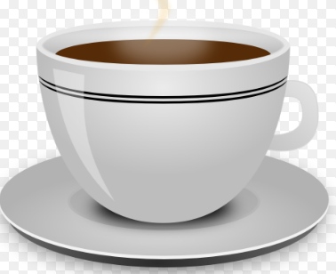 | 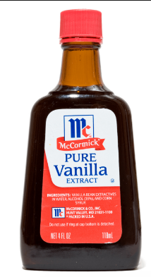 | 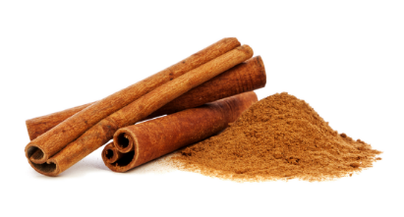
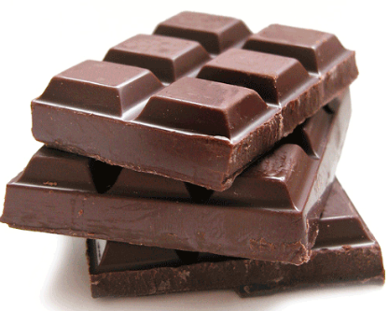 | 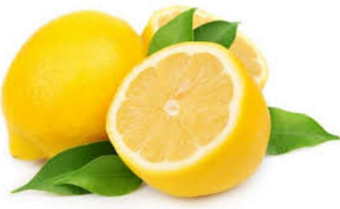 | 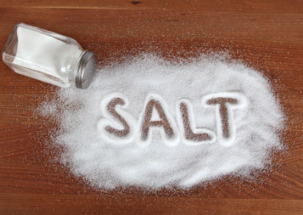
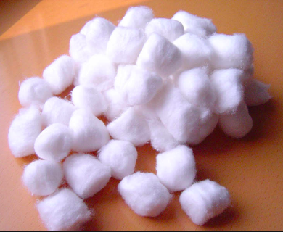 | 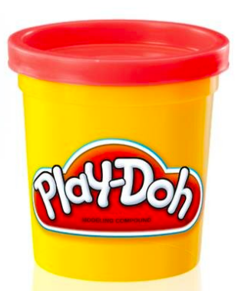 | 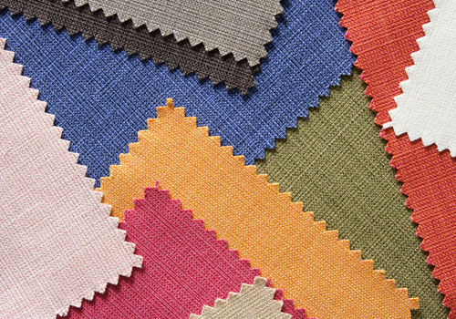
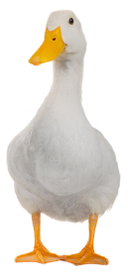 | 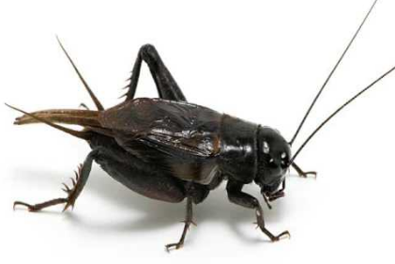 | 