Q405 Saturday Science Teaching – Fall 2016
Lesson Plan Week One

Natural Disasters
Thunderstorms
4th and 5th Grade

A) LEARNING OBJECTIVES and CRITERIA FOR DETERMINING IF OBJECTIVES ARE MET
- Learning Objectives
- Students will learn about the aspects that are involved with the formation of thunderstorms.
  - Students will observe wind patterns and explain how wind is an important indicator of thunderstorms.
  - Students will learn about warm and cold weather fronts and how they contribute to the development of thunderstorms.
  - Students will explore what causes lightning. (and understand how the relationship between thunder and lightning can help them predict the distance of a storm.) ---- potential gear up
- We will be determining if objectives are met through group discussion and the execution of each activity.

B) STANDARDS (see http://www.doe.in.gov/standards/science)
- Science and Engineering Process Standards
- SEPS2. Developing and using models and tools
  - Students will be fulfilling this process standard during the first activity. They will be making model wind socks and using them to observe and describe different wind patterns and the level of the severity.
- Content Standards
- 2.ESS.2 Investigate the severe weather of the region and its impact on the community, looking at forecasting to prepare for, and respond to, severe weather.
  - Students will be executing this standard when learning about thunderstorms and how severe weather can impact a community.

C) MATERIALS
- Hot/Cold Fronts Activity
- 5 Clear plastic containers (about the size of a shoebox)
- Red and blue food coloring
- Ice tray (larger ice cubes are better)
- Lightning and Static Electricity activity
- 26 rubber balloons (any color)
- 5 Fluorescent light bulbs
- Wind Sock Activity
- Larger Construction Paper 11x12 ish (30ish)
- Crepe Paper (Birthday streamer stuff, 2-3 rolls)
- Tape
- Glue
- Yarn
- Hole Punches (3-4)

D) TEACHER CONTENT KNOWLEDGE
- Teachers must understand basic content knowledge about weather, including the definitions of wind, fronts, lightning, thunder, and storm.
- Teachers must understand the concept of static electricity and how it works to create lightning.
- Teachers must understand the relationship between lightning and thunder and be able to use the relationship to calculate the distance of a thunderstorm (count how many seconds pass between the thunder and the lightning and divide by 5 to find the distance from the lightning strike).
- Teachers must understand how warm and cold fronts work together to form thunderstorms through convection and lift.

E) REFERENCES (list ALL references that you borrowed ideas from to develop this lesson – including any handouts you may distribute)

http://www.weatherwizkids.com/weather-thunderstorms.htm

http://www.weatherwizkids.com/experiments-make-thunderstorm.htm

http://www.weatherwizkids.com/experiments-lightning.htm

http://www.wikihow.com/Make-a-Windsock-for-Children

http://www.weatherwizkids.com/experiments-lightning-mouth.htm

F) TENTATIVE TIMELINE

9:30 Welcome ---- Rules and Expectations
9:35-9:40 Engage- What do we know about thunderstorms?
9:40-10:30 Hot/Cold Fronts Activity
10:30-11:10 Static Electricity and Lightning
11:10-11:20 Break/Snack Time (Bill Nye Video)
11:20-12:00 Wind-Sock Activity and Testing

G) DESCRIPTION OF YOUR LESSON

ENGAGE: What do we know about thunderstorms?

To engage the students and get a feel for their prior knowledge about thunderstorms we will ask them to think about their own experiences with thunderstorms. We will ask them to brainstorm what comes to mind when they think about a thunderstorm. In other words, what are the most important “parts” of a thunderstorm. Through this conversation, we will generate a class list of student ideas. Hopefully, the students will generate answers like “thunder, lightning, rain, wind, clouds, etc.” Ideas that are shared more than once will be starred on the board. After this discussion, we will explain to students that we will be focusing on three specific components of thunderstorms. Hopefully, even if it requires some prompting, we will be able to pull these three main ideas from the list that we created with the students. When we pull them out, we will underline them and write each of them on the board as a sort of “plan for the day.” We will explain that we will first explore how thunderstorms are formed, then discuss lightning and thunder, and finally wind. We will leave the list that we created on the board for them to reference throughout the rest of the lesson.

EXPLORE
ACTIVITY 1: HOT/COLD FRONT LAB
FQ: “HOW ARE THUNDERSTORMS FORMED?”

EXPLORE: We will begin our exploration into thunderstorms with an activity meant to help students answer the focus question “How are thunderstorms formed?” To begin the activity, we will pass out pre-prepared pans of warm water with red food coloring to students and ask the students to observe what is in the pan. When we pass out the pans of warm water, we will also pass out the worksheet included below as well as a package of colored pencils. We will begin by asking the students to draw what they see in the pan initially, with only the warm red water and write a sentence or two about what they see. We will then explain to the students that the warm red water represents an unstable warm front, or movement of warm air in the sky, and have the students label their picture accordingly. Then, we will provide the students with blue ice cubes to represent cold fronts and ask the students to draw and label the ice separate from the warm pan of water to represent the two separate fronts, or variables before the experiment. Then, we will ask the students to add the ice to the warm water and ask them to observe what happens carefully. While they observe the experiment, they will be asked to record what they see on the worksheet. They will be asked to draw a picture and write notes individually. Then, they will work together in their small table groups to develop two to three sentences to explain what they observed using the terms “warm front and cold front” or “warm air and cold air”. EXPLAIN: Once the students are finished, we will come back together as a whole group and share our observations. From there, we will explain to students that the observation that they made that the cold air sunk below the warm air is caused by something scientists call convection. We will add this word to a sheet of chart paper that we have available that will serve as our word wall. We will then explain that the process that the students observed is the same process that leads to the formation of thunderstorms. ELABORATE: To elaborate, we will ask our students to use the information that they learned in the lab to discuss how meteorologists (or the scientists that predict the weather) use weather fronts to predict when thunderstorms will occur. To do this, we will show the students a video of a meteorologist using information on cold and warm fronts to show an oncoming potential thunderstorm. After we show the video, we will discuss as a class how information about warm and cold fronts can be used to predict an oncoming thunderstorm. We will use the student’s observations from the lab as the basis of our discussion.
Video: https://www.youtube.com/watch?v=SsgfikHfkaY (last two minutes)

ACTIVITY 2: STATIC ELECTRICITY AND LIGHTNING
FQ: “HOW IS LIGHTNING FORMED?”

EXPLORE: For the second activity we will move on to learning about how lightning is formed. We will go back to our original list from the morning and remind students that they identified lightning as one of the most important parts of a thunderstorm. We will begin the activity by splitting the class in half and providing one half with 6 balloons and 6 light bulbs. Prior to handing out these items we will have a brief conversation about responsibility with lab materials. Once we hand out the items we will ask the students to rub the balloons on their heads and then touch the balloons onto the light bulb. The students will be asked to discuss and record what happens when each student completes the activity (The balloon and the lightbulb create a lightning bolt between them/ briefly light the bulb). The students in the other half of the class will each be given an icebreakers mint. For this activity, we will begin by asking the students to stand in front of one of the full length mirrors provided. We will ask students to suck in air to dry out their mouths and explain that excess saliva interferes with the results. We will then have the students put the ice breakers into their mouths and have them bite into it with their mouths open so that they can see. The students will be asked to record what they observe happen when they bite into the ice breaker. (They should see a flash/spark when the ice breaker breaks apart). A hand out will be provided for students to record their results. Once each student has had an opportunity to try the activity, we will switch and they will get an opportunity to try the second. When the students finish both activities we will come together as a class and share our observations for each activity.
EXPLAIN: Using the data they collected, we will ask the students to discuss why this happened. While they are discussing in their groups, we will go around and guide the conversations. Then we will share out as a class. We will use the student ideas as a jumping point to explain the idea of static electricity and how it caused the energy in the balloon to transfer to the light bulb, similar to how energy from the air connects to the ground to make lightning. to guide their thinking toward the concept of static electricity we will ask them guiding questions in their table groups including “what happened to the balloon/ your hair when you rubbed it on your hair?” “why was it important to rub the balloon on your head before touching the lightbulb?” and “what factors worked together to cause the spark in your mouth?” “why did we dry out our mouths?” “how did breaking the mint contribute to the spark?” we would also want to gear them toward thinking about the importance of the bolts connector or receiver by asking questions like “in each situation, what did the bolt or spark occur between or connect to?” and “do you think that the lightbulb/mouth played an important role in creating the spark?” ELABORATE: Ask students to draw a picture of the process that creates lightning. Have them write a couple of sentences to explain their ideas.

***10 minute break/snack time (show bill nye video)*******
Video: http://www.dailymotion.com/video/x3kgpbm

ACTIVITY 3: WINDSOCK ACTIVITY
FQ: “How can you observe wind patterns and how is that important in predicting thunderstorms?”

EXPLORE: For this activity, students will be creating windsocks, with which they will be able to observe wind patterns. We will begin by referring students back to the activity (list) from the beginning of the day and remind them that they recognized wind as being an important aspect of thunderstorms. Explain to students that meteorologists and other scientists use something called a wind sock so observe the speed of the wind. We will begin the activity by showing the students a pre-made example of a windsock and passing out all of the materials, including construction paper, scissors, tissue paper, markers, colored pencils, and a stapler. Rather than providing students with exact instructions for how to create a windsock, we will ask the students to brainstorm and create their own version of the windsock shown. Reiterate that the purpose of the windsock is to help us recognize the speed of the wind and tell students that they are more than welcome to make changes or improvements to the original design.

For this portion of the activity we will encourage students to get creative and think about functionality. When the students are finished making their windsocks, we will go outside and use them to observe patterns in the wind outside. We will have groups of three or four spread out around the the outside of the school of education to test their creations. Students will use their windsock to observe windspeed.
EXPLAIN: When the students finish testing their creations we will come back together in the classroom and share our observations. We will ask the students to share what they observed about the speed of the wind outside. We will then invite students to share what aspects of their creations were helpful or worked will when they went outside to observe the wind and what aspects did not work or what they might want to change or improve on in the future. We will explain to students that good scientists are always looking for new and better ways to do things and that everyday items as well as huge scientific experiments only improve and become famous if someone is willing to look for ways to improve the world around them and test their ideas.

ELABORATE: We will then discuss in small groups, and then together as a class, how people might use windsocks to predict an oncoming thunderstorm. Draw students’ attention to wind speed and how increased speed might indicate an oncoming storm.

H) EMBEDDED FORMATIVE ASSESSMENT (the 5th “E”)

- The worksheet included with activity one asks students to explain what they observed in terms of “hot and cold fronts” this will help us know if they understood the concept.
- For the lightning activity, the student discussion as well as the picture and sentences serve as assessment of their understanding.
- For the third activity, the small group and whole group conversations will be observed and guided as a teacher. The student responses in these discussions will serve as assessment.

I) GEARING UP/GEARING DOWN
1. Gearing up: If the students move through the activities too quickly, we will add a lesson and discussion about the relationship between thunder and lightning and how they can be used to judge the distance of a storm. We will include an additional activity with this in which they will practice using their math skills to estimate the distance of a storm. If the students can handle it, we will ask them to create the windsock without an example to look at.

2. Gearing down: If the activities seem to be too difficult for the students or they can not seem to handle the materials responsibly, we will shift to using whole group demonstrations where the materials and the lesson is more controlled and directed by the teachers rather than by individual student exploration. Have videos on deck to help clarify certain information that 4th graders might not understand.

Additional Handouts:
- Parent note and permission slip

Q405 Saturday Science Teaching – Fall 2016
Lesson Plan #2

Natural Disasters
Earthquakes
4th and 5th grade

A) LEARNING OBJECTIVES and CRITERIA FOR DETERMINING IF OBJECTIVES ARE MET (minimum of 2/ lesson)
- Students will take a field trip to the science fest and ride the Quake Cottage
- Students will learn about tectonic plates - what they are, how they move - and how they cause earthquakes and tsunamis.

B) STANDARDS (see http://www.doe.in.gov/standards/science)
● Science and Engineering Process Standards:
SEPS.2 Developing and using models and tools
- Students will be planning and building structures out of miscellaneous materials in order to create a structure that they believe will withstand an earthquake. They will be testing and retesting their structures to ensure their durability.
- Students will be observing how the tectonic plates of the Earth move under water and cause vibrations through different activities

● Content Standards:
3-5.E.1 Identify a simple problem with the design of an object that reflects a need or a want. Include criteria for success and constraints on materials, time, or cost.
- The students will be planning, designing, and creating structures that can withstand an earthquake. Those successful will find that their structures withstand the three different “earthquake” stations; gravel, dirt, and sand.

C) MATERIALS (asterisk (*) = any materials that may be a safety concern)
Materials for 4-5 Group
Role of paper towels
spaghetti noodles uncooked (3 boxes)
Mini marshmallows (3 bags)
play dough
sugar cubes
popsicle sticks
pipe cleaners
glue
construction paper
toothpicks
safety goggles
aluminum pans of sand, gravel and soil (enough to fill a big aluminum pan) 3-4
pencils

D) TEACHER CONTENT KNOWLEDGE
- Teachers need to understand that earthquakes are caused by tectonic plate movement.
- Teachers need to know that tectonic plates are the individual pieces of the earth’s crust that move slowly above the upper mantle. The upper mantle is the hot liquid layer below the earth’s crust.
- Teachers need to understand how different foundation substances will hold a structure up during an earthquake. Softer, looser soils will not hold up a structure as well as solidified substance.
- Teachers should have a relative understanding of what materials would be successful when tested against an earthquake scenario, in order to guide students who may be struggling with the activity.
- Definitions
  - Tectonic plates: the two sub-layers of the earth's crust (lithosphere) that move, float, and sometimes fracture and whose interaction causes continental drift, earthquakes, volcanoes, mountains, and oceanic trenches
  - fault line: a line on a rock surface or the ground that traces a geological fault
  - Seismic waves: an elastic wave in the earth produced by an earthquake or other means
  - Ripple effect: the continuing and spreading results of an event or action
  - Epicenter: the point on the earth's surface vertically above the focus of an earthquake

E) REFERENCES (list ALL references that you borrowed ideas from to develop this lesson – including any handouts you may distribute)
http://www.sciencebuddies.org/science-fair-projects/project_ideas/CE_p023.shtml#procedure
http://content.teachengineering.org/content/cub_/activities/cub_natdis/cub_natdis_lesson03_activity1_journal.pdf

F) TENTATIVE TIMELINE

9:00-9:30 Students arrive
9:30-9:40 Group Students and go over behavioral expectations and teachers explain theme of the day (Lauren/Danny)
9:40-10:40- Science fair
10:40-10:50 Snack time
10:50 -11:20 Paper towel/Tectonic plate (Lauren)
11:20-11:50 Introduce “Designing a Building” Engineering Activity (Danny)
11:50-12:00 Debrief Discussion (Danny)

G) DESCRIPTION OF YOUR LESSON

ENGAGE
To begin the day, we will start by asking the class “What do you think we mean by natural disasters?” “How do natural disasters affect our lives?” (Responses will be like Earthquakes, Thunderstorms, Tornadoes, Fires etc…) To recap from last week, we will review terms and ideas that were taught and recall the activities we did. Once the students come to a conclusion, introduce the earthquake theme. As “What do you think happens in the areas affected by an earthquake?” Create a list describing some of the events surrounding an earthquake.
EXPLORE
To further explore how earthquakes affect the land, the students will participate in an activity where they take on the job of an engineer. To tap into the students’ critical thinking skills, we will pose the question
- “Can you make a structure that will withstand an earthquake?”
- “How did you create your structure in such a way that it was or was not able to withstand the earthquake?”
- “Did your structure withstand one surface but not another? If so, why did you think so?”
Through light instruction and guidance, the students will start by drawing their initial plan in the handout provided. Using miscellaneous materials, they will convert their 2D drawings into 3D structures. With careful building, measuring, and trial and error, the students will be building structures and testing them at our three “earthquake stations”. These stations will be large pans each filled with one of the following items: dirt, sand, and gravel. The students will bring their structures to the stations and test their structures’ durability. If their structures failed to stay standing, they will have the opportunity to go back to their tables and rethink their design plan and test a second time.
EXPLAIN
Students will learn about the basic concepts of earthquakes. This will begin with a teacher lead discussion about tectonic plates. To start, the teacher will ask “What is an earthquake”, “How is it formed?” and “What are some other components to earthquakes”. The goal of this discussion is to lead into the terms and definitions of the parts of an earthquakes. These include terms such as tectonic plates, fault lines, seismic waves, ripple effects, epicenter, etc. Once the concepts have been discussed and heard aloud, the students will observe a model of an earthquake. The model will demonstrate how tectonic plate movements along a fault cause the crust to shake and destruction to communities. To show this, a teacher at each table will have two paper towels covered in dirt (to represent the ground) and marshmallows (to represent buildings) the teacher will pull the two paper towels away from each other to represent tectonic plate movement. The students will observe how the movement causes the ground to shake and the houses to fall (an earthquake). The students will be observing how the two mock plates move in different directions and cause the land to be discombobulated and destroyed. As a transition into the final activity, we will explain how the friction of the rubbing plates causes seismic waves to ripple away from the fault line, thus causing the shaking-motion on land and the destruction of buildings. We will show a video of this event to ensure the students fully grasp this concept.
ELABORATION
Students, lead by the teacher, will discuss their structures. They should include information on what structures are more likely to survive an earthquake. IE: Height, Width, Materials, Surface Materials. Ask students the following questions and record student responses in a graphic organizer on the board “Working Designs” and “Design Did Not Work.” Talk about how changing designs helped or hindered their second design. A suggestion of the claim should be “We know that shorter, wider buildings made of stronger materials like popsicle sticks withstand earthquakes better.”

H) EMBEDDED FORMATIVE ASSESSMENT (the 5th “E”)

For the quake cottage portion of our day (the science fair), we will have each teacher lead a discussion on the way back to the school. Each teacher will have 4-5 students so they will be small groups. Questions they will ask are “How did you feel while in the cottage?” “How do you think you could better prepare after this simulation?” “How do you think structures withstand earthquakes?” “Does the intensity of the earthquake matter?”

For the tectonic plate activity, we will be demonstrating how tectonic plates shift causing buildings and surface materials (dirt/bedrock) to shift. We will be leading a discussion based on the students observations. The discussion will involve the following questions: “What did you observe in this experiment?” “How did the surface move?’ “How did the structures react?” “What do the paper towels represent?” “How does the earth move in reality?” “How do tectonic plates create earthquakes?” These questions will be asked in small groups while we come back from the field trip. These questions will lead into the tectonic activity that will be conducted once we come back to whole group instruction.

For our designing activity, we have a handout for students to draw their designs and observe how their structures react in different materials. After TWO designs and TWO handouts we will begin to discuss what makes the best structure. Ask students the following questions and record student responses in a graphic organizer on the board “Working Designs” and “Design Did Not Work.” The questions will be “How did the height of your structure change its ability to withstand an earthquake?” “How does the width of your structure change its ability to withstand an earthquake?” “How do the materials of your structure change its ability to withstand an earthquake?” “What shapes helped create a good structure?”
Here are the video links- http://nationalgeographic.org/media/plate-tectonics/

http://www.discovery.com/tv-shows/discovery-presents/videos/understanding-volcanoes-plate-tectonics/ ( start at 2.56 sec.)

I) GEARING UP/GEARING DOWN
1. Gearing up:
To gear up the activity involving the students building a structure that will withstand the effects of an earthquake you can challenge the students, who are able to successfully make a structure to withstand the elements, to create a structure that is made of only a limited set of supplies.

2. Gearing down:
To gear down the activity involving the students building a structure that will withstand the effects of an earthquake you can pair students who are struggling with other students who are struggling so they are able to share their ideas with one another.

(Insert any handouts here)
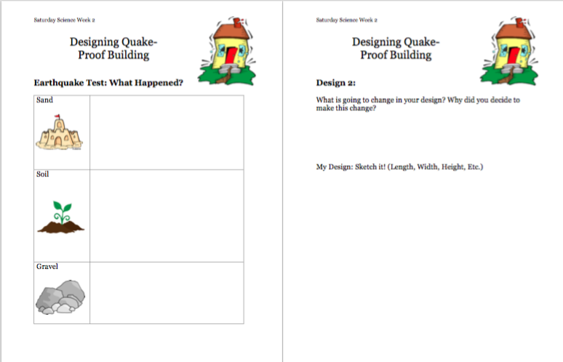

Q405 Saturday Science Teaching – Fall 2016
Lesson Plan #3

Natural Disasters
Tornados
4th and 5th grade

A) LEARNING OBJECTIVES and CRITERIA FOR DETERMINING IF OBJECTIVES ARE MET (minimum of 2/ lesson)
- Students will explore wind patterns and causes for tornados
- Students will learn about safety procedures during tornados and the differences between tornado watch and tornado warning
- Students will create their own tornados
- Students explore how pressure in air forms tornados

B) STANDARDS (see http://www.doe.in.gov/standards/science)
● Science and Engineering Process Standards:

SEPS.1 Posing questions (for science) and defining problems (for engineering)

SEPS.2 Developing and using models and tools
- Students will be planning and building structures out of miscellaneous materials in order to create a structure that they believe will withstand an earthquake. They will be testing and retesting their structures to ensure their durability.
- Students will be observing how the tectonic plates of the Earth move under water and cause vibrations through different activities

● Content Standards:

3-5.E.1 Identify a simple problem with the design of an object that reflects a need or a want. Include criteria for success and constraints on materials, time, or cost.
- The students will be planning, designing, and creating structures that can withstand an earthquake. Those successful will find that their structures withstand the three different “earthquake” stations; gravel, dirt, and sand.

5.ESS.4 Develop a model using an example to describe ways the geosphere, biosphere, hydrosphere, and/or atmosphere interact.

C) MATERIALS (asterisk (*) = any materials that may be a safety concern)
Materials for 4-5 Group

26 Mason jars or plastic bottles
Vinegar
Dish soap
Glitter
5 Glass Jars
5 hard boiled eggs
A box of matches
Newspaper/Tablecloths
Scissors
26 Round Balloons
26 Metal Cans (soup cans or wider)
9 Rubber Bands
26 Thin Straws
Tape
26 Rulers
4 Big Containers to hold water for cold front and hot fronts
Ice

D) TEACHER CONTENT KNOWLEDGE
- Teachers need to understand the three things that are involved with the formation of a tornado
  - There needs to be a layer of warm humid air and strong south winds close to the ground. The upper atmosphere has colder, dryer air and strong winds to the west or southwest. This air is called instability.
  - Wind shear - a change in wind direction with height and speed.
  - A layer of hot dry air in between the upper and lower layers.
- Teachers need to understand how those three elements work with a thunderstorm to create a tornado.
- Teachers need to understand a barometer; how it works, what it looks like, and how to make one.
- Teachers need to understand how air pressure is involved with the formation of a tornado.
- Teachers need to know the difference between a tornado watch and a tornado warning.
- Teachers need to know what the Fujita Tornado Damage Scale is and how it works with rating the severity of tornadoes.
- Definitions
  - Instability: when the air near the surface is much more dense than the dry aloft air. If the warm, moist air can be given an initial push to move upwards, the air will keep on rising, sending moisture and energy to form a tornado's parent thunderstorm.
  - Wind Shear: variation in wind velocity occurring along a direction at right angles to the wind's direction and tending to exert a turning force.
  - Tornado Alley: the states with the highest risk of getting a tornado Arkansas, Iowa, Kansas, Louisiana, Minnesota, Nebraska, North Dakota, Ohio, Oklahoma, South Dakota, and Texas.
  - Fujita Tornado Damage Scale: a scale ranging from F0 - F12 categorizing the damage caused by a tornado.
  - Tornado Watch: Tornado watches are put in place by the Storm Prediction Center, for counties in which a tornado may occur.
  - Tornado Warning: there has been a tornado spotted and people in the designated areas should seek shelter immediately.

E) REFERENCES (list ALL references that you borrowed ideas from to develop this lesson – including any handouts you may distribute)
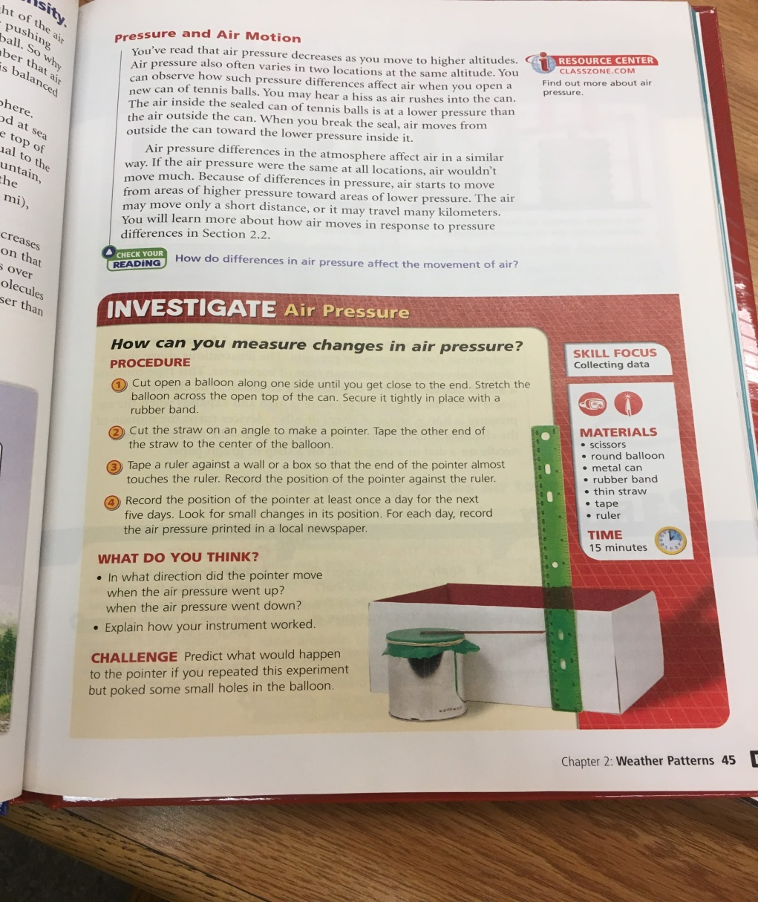
‘
“Severe Weather and Natural Disasters.” Scholastic.com | Online Activities: Weather Watch, Scholastic, http://teacher.scholastic.com/activities/wwatch/tornadoes/index.htm.
http://www.weatherwizkids.com/experiments-tornado-jar.htm
https://www.teachengineering.org/activities/view/cub_natdis_lesson08_activity1
http://www.weatherwizkids.com/experiments-egg-bottle.htm
http://video.nationalgeographic.com/video/101-videos/tornadoes-101

F) TENTATIVE TIMELINE

9:00-9:30 Students arrive
9:30 - 9:40 Discuss Air Pressure (Andie)
9:40 - 10:30 Make Barometers (Table groups)
10:30-10:50 Explain Egg Activity, do activity (Jessy/Table Groups)
10:50-11:10 Snack Time
11:10-11:25 Connect Air Pressure to How Tornadoes are Formed (Jessy)
11:25-11:40 - Safety information Tornados/Warnings/Watch (Andie)
11:40-12:00: Make tornadoes (Table Groups)
https://www.teachengineering.org/activities/view/cub_natdis_lesson08_activity1

G) DESCRIPTION OF YOUR LESSON

ENGAGE
To begin the day we will start the conversation by recapping what a natural disaster is and what the students have learned about thunderstorms and earthquakes. We will then open a discussion about tornadoes by asking the students, “Have you ever heard of tornadoes? If so, what have you already learned about tornadoes? Is there anything you want to know about tornadoes?” This will open a discussion for the teachers to get an understanding of the students’ prior knowledge of tornadoes. We will continue to talk with the students about tornadoes and begin to introduce the concept of air pressure and the high and low pressure mixing contributes to the formation of the tornadoes. The teacher will then introduce a barometer as something that meteorologists use those to measure air pressure.
EXPLORE
To explore the idea of air pressure the students will have the opportunity to create their own barometer after they have learned about air pressure and what a barometer is. After the students have created their barometers the students will have the opportunity to explore how they work and take different measurements of air pressure in different temperatures of water. The students will also be able to see how air pressure works through the egg activity and have the opportunity to talk with their IU teacher about why they believe the egg was able to squeeze through the small opening of the bottle. Finally the students will have the chance to explore the tornado in a bottle activity to be able to observe what a tornado looks like by working with the bottles.
EXPLAIN
There will be several parts to explaining each of the activities and why they are important. The first part of our day is exploring air pressure. We will make sure that their understanding of air pressure and how meteorologist measure it is accurate. hey use a tool, called a barometer, a tool to measure air pressure. This will be the basis for how the students make their barometer on their own. We will test warm and cold water using buckets of water. This will show how the pressure inside the can changing during warm and cold fronts. Next, we will have students make their own barometer. We will each be at a table and the students will explain how their barometer will work. Then, we are talking about air pressure and the egg. We will explain the activity: The lit match heats the air inside the bottle. When air is heated it expands and takes up more room. As the heated air expands, some of it escapes out of the bottle. When the matches go out, the air inside the bottle cools and contracts, which takes up less room. This creates a lower pressure inside the bottle than outside the bottle. The greater pressure outside the bottle forces the egg to get sucked into the bottle. We will have a worksheet to record their observation with the barometer and the egg over the bottle. These observation will help them to find answer to their focus question.
ELABORATION
The students will be able to talk about the different parts of a tornado when they are working with the tornadoes in a bottle ( will be demonstrated by the teachers), this will allow for the IU teacher to talk about the different parts of a tornado that show when the tornado forms. The final explanation will be focused towards connecting the idea of air pressure and what we learned to how tornadoes are formed. National Geographic has a great video that connects all the ideas to how tornadoes are formed. This will tie what the students are learning about air pressure to the idea of tornados. Each student will have their own handout to draw the tornado visuals we are presenting from the powerpoint in whatever way they want. They will be able to show what they are observing for both the visuals shown and the tornado demonstration given by teachers. The students will then make their own tornados in water bottles for the ending activity demonstrating a vortex being made.

H) EMBEDDED FORMATIVE ASSESSMENT (the 5th “E”)

After students make their own barometers they will have a worksheet with barometer measurements for warm and cold water. They will explain where the straw was pointing and why. They will be prompted. It should change with warm and cold water. The students will also be explaining their understandings in their worksheet of how and why the egg was pulled into the glass bottle when matches were dropped.

Students will be drawing their own tornados based off the video and visuals and demonstrations by the teachers. The teachers will also be demonstrating a tornado using 2 liters so that the whole class can see a vortex and a real-life visual of a tornado. They will be doing this prior to making their own tornado in a bottle.

I) GEARING UP/GEARING DOWN
1. Gearing up: If the barometer experiment is too fast or easy for students, we can have them predict how they will work in different environments. IE: On the top of a mountain, in a desert, in a rain forest, and in a blizzard. We will explain how we can know what the general air pressure in each place will be.

2. Gearing up: During the barometer experiment, students may struggle when grasping the idea of hot and cold air pressures. If we notice that students are not understanding even with our barometer activity, we would stop to explain how air can have different pressures. Take time from the later tornado activity to explain how air expands and contracts depending on the atmospheric temperature or density. Further explanation could be: Use mountain climbers as an example. Draw air molecules on the board in a high and low pressure system.

(Insert any handouts here)

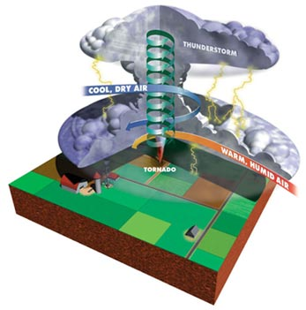

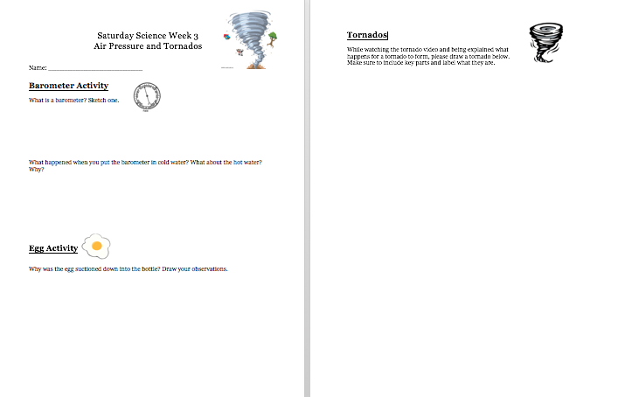

Q405 Saturday Science Teaching – Fall 2016
Lesson Plan- Week 4

Natural Disasters
Volcanoes
GRADES 4-5

A) LEARNING OBJECTIVES and CRITERIA FOR DETERMINING IF OBJECTIVES ARE MET (minimum of 2/ lesson)
- Students will describe how converging plate boundaries form volcanoes. To show that this objective was met, students will explain the connection orally during small group and large group discussion about plate tectonic and volcanoes.
- Students will explain how heat and pressure factor into volcanic eruption. To show that this objective was met, students will describe the relationship between pressure, heat and volcanic eruption on their worksheets for each activity, we will also discuss this concept orally as a class.

B) STANDARDS (see http://www.doe.in.gov/standards/science)
● Science and Engineering Process Standards:
SEPS.6 Constructing explanations (for science) and designing solutions (for engineering)
- Scientists and engineers use their results from the investigation in constructing descriptions and explanations, citing the interpretation of data, connecting the investigation to how the natural and designed world(s) work. They construct or design logical coherent explanations or solutions of phenomena that incorporate their understanding of science and/or engineering or a model that represents it, and are consistent with the available evidence.
● Content Standards:
4.ESS.3 Describe how geological forces change the shape of the land suddenly and over time.
- Throughout this lesson, students will describe how plate tectonics, specifically convergent plate boundaries form volcanoes.

C) MATERIALS (asterisk (*) = any materials that may be a safety concern)
- red wax candles (enough to fill the bottom of 5 jars)
- 5 glass jars
- 5 hot plates
- Sand (enough to fill the bottom of 5 jars)
- 14 film canisters
- 14 Alka Seltzer tablets
- Box Graham Crackers
- 4 containers cool whip
- 6 paper plates

D) TEACHER CONTENT KNOWLEDGE
- Teachers need to have an understanding that a volcano is volcano is a mountain that opens downward to a pool of molten rock (magma) below the surface of the earth. It is a hole in the Earth from which molten rock and gas erupt.
- Teachers need to know that volcanoes are formed when magma from within the Earth's upper mantle works its way to the surface. At the surface, it erupts to form lava flows and ash deposits. Over time as the volcano continues to erupt, it will get bigger and bigger.
- Teachers need to know the vocabulary for volcanos and their parts
  - Active volcano: a volcano that has erupted in the past 10,000 years, may be currently erupting, and is expected to erupt again.
  - Caldera: a large, cauldron-shaped depression caused by the collapse of the ground when the magma chamber is empty.
  - Cinder cone volcano: the most common and smallest type of volcano, usually not more than 300 m (1000 ft) tall, produced by pyroclastic flows. An example of a cinder cone volcano is Paricutin in Mexico.
  - Composite volcano: also known as stratovolcano, formed by a combination of lava flows and pyroclastic explosions that form alternating layers. Composite volcanoes are steep and often very tall. Examples of composite volcanoes are Mt. Fuji in Japan, Mt. Kilimanjaro in Tanzania, and Mt. Rainier in Washington.
  - Crater: an indentation at the top of a volcano.
  - Dormant volcano: a volcano that is not currently erupting, but is expected to erupt again.
  - Extinct volcano: a volcano that has not erupted in the past 10,000 years, and is not expected to erupt again.
  - Hot spots: volcanically active places that lie above mantle plumes.
  - Island arc: a chain of volcanic islands created when a tectonic plate passes over a hot spot. The Hawaiian Islands are an example of an island arc.
  - Lahar: a fast-moving volcanic mudflow composed of ash and water.
  - Lapilli: intermediate-sized fragments of material (2-64 mm, or 0.08-2.5 in) that are ejected in a pyroclastic explosion.
  - Lava: magma that reaches Earth's surface.
  - Magma: molten rock below Earth's surface.
  - Magma chamber: a large area deep underground filled with magma.

  - plume: a column of hot rock that rises up to the surface from Earth's interior.
  - Pahoehoe: (pronounced pah-hoy-hoy) a type of lava that forms a thin, ropy crust when it hardens.
  - Pillow lava: a smooth, rounded type of lava flow that erupts underwater.
  - Pyroclastic flow: a high-temperature mixture of hot ash and fragments of lava that erupts with great force and speed. Pyroclastic flows are the most dangerous type of volcanic eruptions, traveling at speeds of up to 200 km/hr (125 mph) with temperatures of up to 700 degrees C (1300 degrees F).
  - Shield volcanoes: volcanoes that form from fluid lava that builds up slowly over time, creating a wide, gently-sloping mountain shaped like a warrior's shield. Examples of shield volcanoes are Kilauea and Mauna Kea in Hawaii.
  - Tephra: any material ejected during a pyroclastic explosion, regardless of size.
  - Vent: an opening at the top or side of a volcano where lava erupts.
  - Volcanic ash: very small (less than 2 mm, or 0.08 in) fragments of material that are ejected in a pyroclastic explosion.
  - Volcanic bomb: a mass of molten lava that is ejected during a pyroclastic explosion and hardens in the air. Volcanic bombs range in size from 2.5 in (64 mm) to several yards (meters) in diameter, and can weigh several tons.

E) REFERENCES (list ALL references that you borrowed ideas from to develop this lesson – including any handouts you may distribute)

https://www.stevespanglerscience.com/lab/experiments/volcano-in-a-cup-erupting-wax/
http://www.playdoughtoplato.com/graham-cracker-plate-tectonics/
https://sciencebob.com/build-a-film-canister-rocket/
http://primaryhomeworkhelp.co.uk/mountains/volcanoes.htm

F) TENTATIVE TIMELINE

9:00 - 9:30: Volcano videos
9:30-9:40: Tectonic Plate activity, prediction activity (Megan)
9:40-9:55: Tectonic plate demonstration and vocab (Jessy)
9:55-10:30: Pressure activity (Megan)
10:30-10:40: Discussion (Jessy)
10:40-11:00: Snack
11:00-11:40: Final Demonstration Jar Volcanos (Megan and Jessy)
11:40-12:00: Work with groups, pick natural disaster

G) DESCRIPTION OF YOUR LESSON

ENGAGE
We will begin our lesson by showing the following graphic up on the board:
http://indiana.pbslearningmedia.org/resource/ess05.sci.ess.earthsys.tectonic/tectonic-plates-earthquakes-and-volcanoes/
We will ask students to recall how we learned that earthquakes are formed by the movement of tectonic plates and therefore, they are located along tectonic fault lines. Then, we will ask students to predict where volcanoes would be located on the map. Show the students that volcanoes are located along fault lines as well. Explain that unlike earthquakes, which are formed when tectonic plates move apart or past each other, volcanoes are formed along convergent plate boundaries where tectonic plates push up against each-other, causing the earth to rise up. We will demonstrate this concept using graham crackers to show convergent plate boundaries. Then, we will show students the following graphic:
Insert volcano graphic.
We will use this graphic to explain to students that in order for a volcano to form and not just a mountain, the crust must leave an opening for molten magma below the earth’s crust to rise above the crust into the volcano. We will write the new vocabs on the board.

EXPLORE

To explore the topic of volcanos, the students will have previous learned about the tectonic plates and the different parts of volcanos from the engagement activity. We will be splitting the class into 2 groups. One will be moving into the explore phase of why a volcano erupts involving pressure. We will go over briefly the topic of air pressure that we discussed last week and how high pressure expands. Before we start the experiment, we will be having the students predict what they think will happen with the film canisters on the worksheet given. They will then explore how a volcano erupts by working with film canisters and antacid outside. The students will then be making their film canisters by putting a teaspoon of water inside the canister. They will then quickly drop half an antacid tablet and shut the lid. Quickly the students will back away to see what happens.

The other activity will be happening inside of the classroom. This activity will explore how heat impacts a volcano erupting. We will be using wax, a jar, sand, and a hot plate. We will have the student predict how the materials will be used to form a volcano in a jar. After the teachers put the wax, sand, and water into the jar, we will have the students make predictions about what will happen when the heat is turned on. Why do you think we need the wax at the bottom of the jar? What do each individual material items represent in a volcano?
EXPLAIN
Once students finish the activities we will have a class discussion in which we will ask students to explain what they observed during the activities. For the film cannister activity, we will ask the students what they observed. To guide students’ understanding for this activity, we will ask: “What happened when you added the alka seltzer tablet to the cannister?” “Why did the film cannister explode?” “How did pressure relate to the explosion?” “Does this experiment represent a high pressure or low pressure situation?” “What happened when pressure built up inside the cannister?” Hopefully, these questions would help guide students to understand that adding an alkaseltzer to the water in the film cannister caused the tablet to release gas that took up space in the cannister. The space that the gas took up caused a high pressure environment to form within the film cannister because there was not enough room for all of the gas. When the pressure got too high it caused the canister to explode open, releasing the gas.
For the second activity we will ask students to consider what happened when they heated the jar: “What happened to the wax when you heated the jar, did it match your prediction?” “What did the wax represent in the experiment?” “Did the wax (or magma) break through the sand immediately or did it take some time?” “How did pressure influence the activity?” “What would happen if there were more pressure or more heat ?” “How does this activity relate to the formation of volcanoes?” These questions will guide students to understand that when the wax was heated, it caused it to float up causing more and more pressure until the magma broke through the sand. Students should also understand that with more heat or pressure, the volcano would erupt more quickly and be more damaging or volatile. We will explain to students that scientists refer to these areas as “hotspots.” By the end of the activity, students will understand that volcanoes erupt as a result of a combination of heat and high pressure.

ELABORATION

We will wrap up the lesson by connecting how the two activities that were just done relate to why volcanoes erupt. Then, we will ask students to consider what might happen to an environment that is exposed to a volcanic eruption. Students will discuss the potential effects of a volcanic eruption and the damage that could occur. We will show the students a clip about Mount Vesuvius. This will help students understand why volcanoes are seen as a natural “disaster” and help them understand the danger of these events. This will serve as a segway into next week's lesson in which we will learn about disaster preparedness.

Finally, we will be introducing the next week’s activities. We will be grouping students (below) and explaining our next lesson. Students will be working in groups and creating a 15-18 minutes presentation as a meteorologist or natural disaster scientists. They will be describing, and demonstrating what each of our natural disasters are as well as the safety recommendations for each disaster. Each member in the group will be responsible for one natural disaster from research to presentation. We will prompt our students to think about and research each disaster.

H) EMBEDDED FORMATIVE ASSESSMENT (the 5th “E”)

We will be using a worksheet for our formative assessment of the students’ learning. One section of the worksheet will be focusing on the Film Cannister Activity. We will have the students predict what they believe will happen with these materials. We will ask them what their predictions are for when the antacid is mixed with the water and the lid is shut? After they make predictions, they will then do the experiment and explain what happened. The worksheet will prompt them to answer why the canister exploded from the pressure. Is there anything else we could have used to explore eruption and pressure?
The second part of the worksheet will be exploring how the heat creates a volcanic eruption. Students will have predicted what each of the materials for the beaker wax activity are used for. After they perform the activity, they will then describe on their paper what happened and why they think it happened that way. Why did we use wax and sand? Could we have used other materials?
There will be a final part to the handout that will connect the activities of heat and pressure to the formation and eruption of volcanos.

I) GEARING UP/GEARING DOWN
1. Gearing up:
If the students get through the activity quickly we will conduct a mini lesson about historical volcanoes from around the world and the places that are most at risk for a volcanic eruption. During this mini lesson we will also discuss the difference between active and dormant volcanoes.

2. Gearing down:
For students who are not able to follow directions or perform all of the tasks involved with the canister activity these students will move into a teacher lead instruction and they will be in charge of taking observations of what is happening during the activity.

(Insert any handouts here)

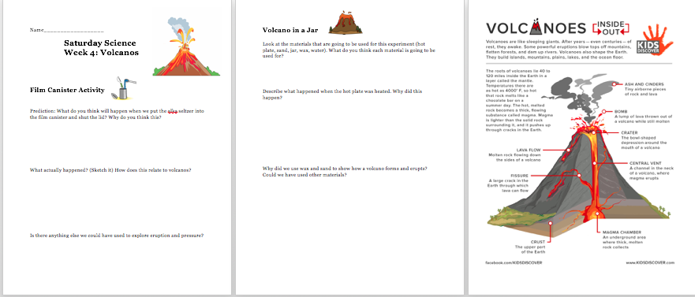

Q405 Saturday Science Teaching – Fall 2016
Lesson Plan Week Five

Natural Disasters

A) LEARNING OBJECTIVES and CRITERIA FOR DETERMINING IF OBJECTIVES ARE MET
- Students will demonstrate knowledge on one of the following natural disasters (tornadoes, hurricanes, flooding, earthquakes). To show this objective was met, students in groups will present information about natural disaster by sharing out to the class the information that they have learned about in these four weeks. We will also assess their learning by showing them a demonstration of a disaster we have previously talked about and asking them to fill out a worksheet.
- Students will understand how to put together a disaster kit as well as what certain materials to include. They will be able to reason which materials are most important to include.
- Students will understand safety information on what to do during natural disasters and how to prepare for one if it occurred. They will show this by making their own survival kits and prioritizing what they would put into their personal kit.

B) STANDARDS (see http://www.doe.in.gov/standards/science)
- Env.1.7 Identify tools and technologies used to adapt and alter environments and natural resources in order to meet human physical and cultural needs.
- Env.3.4 Identify natural Earth hazards, such as earthquakes and hurricanes, and identify the regions in which they occur as well as the short-term and long-term effects on the environment and on people.
- SEPS.8 Obtaining, evaluating, and communicating information:
  - Students will be communicating the information they are learning about their natural disaster to their classmates by using information they obtained and evaluated.

C) MATERIALS
- 1 Cardboard Box
- 5 Poster Boards
- Coloring Materials; markers, crayons, colored pencils
- Clear plastic bucket
- Sand
- Popsicle sticks
- String
- Paper clips
- ALOT of playdough (3 different colors)
- 5 Rulers

D) TEACHER CONTENT KNOWLEDGE
- Monsoon, flood, disaster supply kits, earthquakes, hurricanes, tornadoes
- Teachers need to understand that earthquakes are caused by tectonic plate movement.
- Teachers need to know that tectonic plates are the individual pieces of the earth’s crust that move slowly above the upper mantle. The upper mantle is the hot liquid layer below the earth’s crust.
- Teachers need to understand the three things that are involved with the formation of a tornado:
  - There needs to be a layer of warm humid air and strong south winds close to the ground. The upper atmosphere has colder, dryer air and strong winds to the west or southwest. This air is called instability.
  - Wind shear - a change in wind direction with height and speed.
  - A layer of hot dry air in between the upper and lower layers.
-Teachers need to know basic information about how to survive various natural disasters. For example, during a tornado, go to a room on the bottom floor with no windows, during a flood move toward higher ground, during an earthquake duck and cover heads.
- Teachers need to know what materials are important for building an effective disaster supply kit. These materials should include bottled water, canned goods, can opener, contact list, copies of important documents, dried snack foods, emergency cash, first aid kit, flashlight, medicines, radio, toiletries, whistle, emergency blanket.
- Teachers should know that monsoons are formed by changes in wind direction and air pressure.
- Teachers should know that floods are caused by excessive rainfall.

E) REFERENCES (list ALL references that you borrowed ideas from to develop this lesson – including any handouts you may distribute)

- http://www.shakeout.org/downloads/ShakeOut_P3_DisasterSuppliesKit.pdf
- National Geographic Textbook. 2010. Gr. 4. Earth Science.

F) TENTATIVE TIMELINE

9:30-10:00: Plate tectonic demonstration
10:00-10:25: Survival Kits
10:25-10:55: Presentation Preparation
10:55-11:15: Snack
11:15-12:00: Presentations!

G) DESCRIPTION OF YOUR LESSON

ENGAGE
Students will investigate how the movement of plate tectonics not only causes natural disasters, but also land masses. They will be observing an activity involving clay/play dough by creating a model to learn about the process of the changes in the tectonic plates. Through molding and manipulating play dough, the students will be observing how the play dough changes based on how/when the teacher pushes and pulls the ends of the clay. As the students observe the demonstration, the idea is that they will be able to see how mountains are formed from the pressure of two tectonic plates being pushed together. The students will be predicting and drawing what they see and observe so that they can put their ideas on paper in front of them. It will be the job of the teachers to guide the students thinking in seeing that the thickness of the clay affects the mold, as well as the amount of force applied to the ends. This relates to the previous weeks because tectonic plates relate to earthquakes and volcanoes; including mountains.

EXPLORE
http://www.shakeout.org/downloads/ShakeOut_P3_DisasterSuppliesKit.pdf

Students will be choosing and assembling a survival kit. We will have students identify useful disasters supplies. They will be creating a kit by finding and reasoning about different materials they would use. Each table group will be choosing from limited resources to find the best materials to include. After they are walking around and finding supplies, they will reconvene and have a small group discussion on their chosen material. After they explain which supplies are more important than other, we will create a quick class list on the board. This activity ties into our later presentation when students will be explaining safety procedures.

EXPLAIN
Our final culminating project will have students acting as meteorologists / seismologists or other natural disaster specialists and explain their said natural disaster. Our two main objectives with this activity are to 1) present to the class how a natural disaster is formed and 2) to explain basic safety survival tips related to said disaster. All four teams will be covering a natural disaster. Their goals is to present their disaster using a poster, a quick demonstration, and/or a powerpoint. Students used about thirty minutes in the previous lesson to choose their disaster and begin planning. Our groups are tornadoes, hurricanes, earthquakes, and floods. Our goal is to have 5-10 minute presentations where each student presents some piece of information. Our explanation phase is meant for each group to find, recall, and organize information into a presentation. Each group is presenting in a different format. As long as each group can meet our two objective of natural disaster formation as well as safety tips we want to leave flexibility in presentation format. Students are working together to pool information and research more on the disaster. This activity works as a culminating assessment and makes sure to share the information with their classmates.
Our overall objectives for each group are:
- Every student is involved in planning/research/creation
- Every student contributes in the project
- Presentations address how disaster is formed
- Presentations address safety concerns of disaster
- Presentation address safety tips

Since this whole lesson is assessment based, we are using the explain phase to dig deeper and plan how to present their learned information.

ELABORATION
As a final stage of the project, the students will work together in teams to present a newscast of a natural disaster of their choice. This presentation will be entirely student lead as well as student planned, therefore the entire project will be a formative assessment of student learning. Based on the cooperation of the student teams, the content they include in their newscast, and the context in which they can explain their disaster will allow us as teachers to identify if there was student learning. The idea is that the students will be using terms and concepts that were learned in the previous weeks and incorporate them into their newscast. That way, the student will be discussing the content in a new and innovative way, as opposed to worksheets and demonstrations. Having the students get up and present their findings also gives some students the chance to deliver the information to their peers as a leader and expert in the topic. This helps build student confidence and builds community in the classroom.

H) EMBEDDED FORMATIVE ASSESSMENT (the 5th “E”)

- For this lesson, all of our activities are going to give some type of formative as well as summative assessment for the students to demonstrate what they have learned. The second activity will allow the students to demonstrate their knowledge on what they believe are important to include in an emergency kit. There will be a discussion allowing us to make sure that the students have an understanding of a safety kit.
- The first activity is meant to assess their understanding of the shifting of plate tectonics.
- The end of the class the groups are giving presentations on a specific natural disaster (hurricane, tornadoes, flooding, earthquakes). What they are presenting to us will determine their depth of knowledge.

I) GEARING UP/GEARING DOWN
1. Gearing up: For the presentations, if students need additional learning experiences, groups will add in experiments and visuals to demonstrate their natural disaster. They can use science books and the computers in the classroom to find activities that will help demonstrate the disasters during their presentations.

2. Gearing down: If students are struggling with their presentations, teachers will help make up their scripts for what they will say. Each student has their own role, so the teacher assigned to the group can help the students to create an idea of what they are going to say.

Additional Handouts:
- Parent note and permission slip

Plate Tectonic Worksheet:
