Saturday Science Teaching – Fall 2018
Lesson Plan #1

Lesson #1 and Chemists Exploring Physical Properties
Grade 5-8

A) LEARNING OBJECTIVES and CRITERIA FOR DETERMINING IF OBJECTIVES ARE MET (minimum of 2/ lesson)

- Students will be able to explain why solids react with liquids because of their specific properties.
- Students will be able to identify similarities and differences between types of liquids.
- Students will be able to explain what density is and how you can accurately measure it.

Criteria:
- Students will demonstrate mastery of the above topics by speaking in whole group discussion about their findings. Students will demonstrate density knowledge by applying the concept to an experiment. Lastly, students will come to know the difference between solids and liquids through experimentation. A worksheet that is to be filled out will also showcase student knowledge on the above objectives.

B) TEACHER CONTENT KNOWLEDGE (Describe what your teams needs to know regarding the science concepts you’ve identified for each learning objective above)

- Extensive knowledge of solids and liquids along with their properties and characteristics
- Why certain solids react with liquids
- Density and measuring density

C) MATERIALS (asterisk (*) = any materials that may be a safety concern)

Chemical Analysis Activity
- Sugar (1 bag)
- Baking Soda (1 container)
- Baking Powder (1 container)
- Cornstarch (1 container)
- Baby Powder (1 container)
- Flour (1 bag)
- Salt (1 container)
- Water
- Vinegar (1 container)
- Iodine (1 container)
- 75 Small clear cups
- 10 Tablespoons

6 Layers Activity
- Large glass containers
- Plastic cups x6
- Masking tape x1 roll-
- Pens x6
- Food coloring x4 bottles-
- Honey x1 bottle
- Light corn syrup x1 bottle-
- Dish soap x1 bottle -
- Water
- Vegetable oil x1 bottle-
- Rubbing alcohol x1 small bottle -
- Pipette x2
- Measuring cups-
- Various objects (pennies, paperclips, pin)-

D) REFERENCES (list ALL references that you borrowed ideas from to develop this lesson – including any handouts you may distribute)

Chemical Analysis Activity: https://www.brighthubeducation.com/middle-school-science-lessons/80194-three-forensic-science-activity-ideas/

Weird Science Lesson: https://drive.google.com/drive/folders/0Bzkd4jzZvL-VfkQxblh1WEdNLVFVWFVzTUY3VTJTSGliVTk5Y2JyZi1IQWtNUTFybkhBYlk

HANDOUTS:
- https://docs.google.com/document/d/1YGzglpRymn3-OiQtt5x9HQaHU2OgR0s4azJKMBVzRnw/edit?usp=sharing

E) TENTATIVE TIMELINE (Keep brief—tables work well for this!)

TIME | ACTIVITY
8:30-9:30 | Setting up materials and double checking activity plans
9:30-9:45 | Icebreaker of choice with students (adjective with name)
9:50-10:00 | Explain the day and activity that we will be doing/show materials if possible
10:00-10:45 | 6 layers of liquids activity and inquiry
10:50-11:00 | Snack and cleanup
11:00-12:50 | Chemical Analysis activity
11:50-12:00 | Clean up

F) DESCRIPTION OF YOUR LESSON:
Following a learning cycle approach explain how:
·You will ENGAGE the students into the activities for the day
·The students will EXPLORE the concept through gathering data/investigating/experimenting
·You will support students in making sense of the concepts through forming EXPLANATIONS
·Students will have an opportunity to ELABORATE on what they’ve learned this week

Engage: | We will get the kids excited by using great introductions, hooks, and doing an icebreaker. As an icebreaker we will toss a beach ball around and say our name and other facts. As this is the first class session, we find it important to spend a lot of time on introductions and getting to know one another first. Then, we will then transition into our engage phase of the lesson. We plan to open up the lesson by starting with a video briefly introducing the topics of liquids. We will ask questions like: What are your experiences with liquids? Can anyone find a liquid in the room? What do you think happens to a liquid when its put in a freezer? Focus Question: What are properties of liquids?  Explain to the students that we are doing these experiments for our final crime scene activity on the last week. Students will need to use all of these things they are learning in the first 4 weeks, to decode a crime scene in the final week.
Explore: | Activity 1: We will have one cup per partner for the 6 layer cup activity. For this, students will be given different liquids that range from honey to water and dish soap. Students will first discover these materials and see how they relate to each other. For this, students will experiment with the unknown and figure out how to layer the liquids without having them mix together. To do this, students will have to record which layers interfere with the others and write down their combinations on paper. In this experiment, the partners will work together to understand the concept of density and the relationships between the liquids and their density in relation to the layers.  - Before adding items on top of liquids…  - What do you think will happen to the item?  - Why is there a difference?  Activity 2: We will have 7 clear cups setup with each substance measured out the same in each cup. These will use the alphabet to label them. Each table will have all 7 cups at it. Also at each table, there will be 3 cups for the three according liquids too, labeled using numbers. Each person will have a chart that they can fill out before observations of each substance and be able to draw for reactions. We will instruct the students to NOT test the substance! For observations, we will test each substance for texture first. Students will write what they think each solid would be. Then we will test for a reaction to the liquids. For each testing, students will measure 1 tablespoon of the alphabet and 3 tablespoons of each liquid number. Students will then observe the reactions that take place. Together as a table, students will work together to observe and see what takes place. They will talk about it and discuss what is happening at their table. At the end, students will then write again what they think the solid is at the end and if their observation changed.
Explanations: | We will explain and review large concepts with the students upon experimenting with them. Per finishing each activity, we will gather the students and discuss the following questions. We will all gather around the front area of the classroom and talk about the experiments to start, slowly making our way into creating working definitions and explanations after each activity.  For the first activity, we will discuss…  - Why did specific liquids sink to the bottom? Or top?  - Why do you think these substances do this?  - Some of the items will stay on or near the top stack of the liquids and other items will sink part or all of the way down to the bottom of the cylinder. Why is there a difference?  - Discuss density.  For the second activity, we will discuss...  - Why did some substances bubble and some did not?  - Why did different materials create layers rather than a mixture?  For all activities we will discuss…  - What was challenging about the activities?  - What did you notice that was similar about these activities? What was different?  - Which activity was your favorite, and why?  - Were your predictions correct or incorrect?
Elaborate: | Upon finishing an explanation discussion, we will briefly survey that the students are understanding the big picture. We will allow students the opportunity to extend their learning and explore their curiosities in this phase of the lesson. We will anticipate questions and new ideas from students providing them with information to go home and think about more. We will get students excited about the upcoming lesson as well. Lastly, students will have an opportunity to journal their thoughts on the day’s lesson. In this, we will ask students what part of a crime scene they think this experiment will be useful for.

G) How will you determine if your students achieve the objectives for this week?

- Students will achieve these goals by making observations and drawing/writing on their given worksheets throughout the activities.
- We will make sure students have achieved these objectives through discussions throughout and after the activities.
- We will also have a journaling activity for students to do at the end of the lesson. This way students can right down what they have learned as well as their experience from today.
  - What did you learn about today?
  - What can you tell me about liquids and the properties of liquids?
  - Did you enjoy the activities today?

H) PEDAGOGICAL FOCUS:
-State the focus for the week (Productive discussions, Science for all etc),
-Explain how you are trying to incorporate this into your practice in this week’s lesson

- Productive Discussions
- We plan to incorporate this into our lesson by allowing students to be creative, imaginative, and investigative. Students will have many opportunities to talk with a partner, in small group, and in whole group. Students will learn collaborative skills and communication skills. Discussions will be centered around high level questioning and creating explanations and definitions as a whole group.
Saturday Science Teaching – Fall 2018
Lesson Plan #2

Lesson #2 Forensics
Grade 5-8

A) LEARNING OBJECTIVES and CRITERIA FOR DETERMINING IF OBJECTIVES ARE MET (minimum of 2/ lesson)

- Students will be able to identify the basics properties of an acid.
- Students will be able to explain that fingerprints are unique to each individual and that there are three basic shape categories that all fingerprints fall into.
- Students will be able to explain that fingerprinting and invisible ink are tools and techniques used in forensic sciences.

Criteria:
- Students will demonstrate mastery of the above topics by speaking in whole group discussion about their findings as well as in small groups in their pods. Teachers will monitor that students understand these concepts my asking guiding questions to each group. We will also review their journal entries to see what concepts they grasped and which they perhaps did not. Students will demonstrate acid knowledge by applying the concept to an experiment. Students will use the fingerprint worksheet to demonstrate their understanding of each fingerprint type.

B) TEACHER CONTENT KNOWLEDGE (Describe what your teams needs to know regarding the science concepts you’ve identified for each learning objective above)

- Teachers will have a solid foundation regarding the explanation for why the chemical reaction between the lemon juice and the ink occurs that results from the heat (lemon juice is acidic and it weakens the paper after the juice dries from the heat, resulting in the ink). Teachers will need to have a good enough understanding of why this acid reacts in this manner in order to properly communicate it to students. It would be good for teachers to understand that bases have higher PH’s than acids in the event that a student wants to compare acids to bases.
- Teachers need to know about oxidation. Lemon juice—and the juice of most fruits, for that matter—contains carbon compounds. These compounds are pretty much colorless at room temperature. But heat can break down these compounds, releasing the carbon. If the carbon comes in contact with the air, a process called oxidation occurs, and the substance turns light or dark brown.
- Teachers must have a strong grasp on the concept that every person has a different fingertip that is especially unique to them. The palmar surfaces of the hand have papillary ridges in patterns unique to each person that does not change over time. Teachers need to be aware of this terminology in order to properly communicate this concept to students.
- There are different types of fingerprint styles (arches, loops, and whorls). Arches look like small mountains in the middle of the fingerprint and it looks like it is risen. Loops are just what they sound like and loop around the finger and get smaller as they get to the middle. The whorls look like straight loops that get smaller around the middle, but they are straight instead of angled like loop fingerprints.

C) MATERIALS (asterisk (*) = any materials that may be a safety concern)

Invisible Ink:
- Lemon (1/2 lemon per student) = 12 Lemons
- Bowl (1 per student) = 12 Bowls
- Spoon (1 per student) = 12 Spoons
- Water
- Paint brush, small (1 per student) = 24 Paint Brushes
- White Cardstock paper (1 piece per student) = 24 Pieces of White Cardstock
- Hair Dryer = We will bring 3
- Knife to cut lemons
Fingerprints:
- Clear Glasses = 30 Glasses
- Cocoa Powder = One Container
- Small Soft Brushes = 30 Brushes
- Packing Tape = 6 Rolls
- Light Colored Construction Paper = 30 sheets of Light Colored Construction Paper
- Cooking oil spray
Passports - In Material Room

D) REFERENCES (list ALL references that you borrowed ideas from to develop this lesson – including any handouts you may distribute)

- Invisible Ink:
  - https://www.education.com/science-fair/article/invisible-ink-oxidation/Invisibleink
- Fingerprints:
  - http://stem-works.com/external/activity/561

- Handouts:
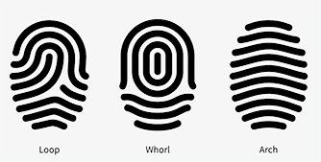

E) TENTATIVE TIMELINE (Keep brief—tables work well for this!)

TIME | ACTIVITY
8:30-9:30 (ALL) | SET UP
9:30-9:45 (Led by Abby C.) | Ice Breaker - Beach Ball questions
9:50-10:00 (Led by Jackie and Abby C.) | Engage: Explain the day and activity that we will be doing  Introduce Forensics Connection
10:00-10:45 (Led by Abby M. and Riley) | Explore: Experiment 1: Invisible Ink
10:50-11:00  (Distributed by Eric while others set up for fingerprints) | SNACK - Bill Nye Video  https://www.youtube.com/watch?v=49Qj8bSpN7c
11:00-12:50 (Led by Eric) | Explore: Experiment 2: Fingerprints
11:50-12:00 (ALL) | Elaborate and Clean Up

F) DESCRIPTION OF YOUR LESSON:
Following a learning cycle approach explain how:
·You will ENGAGE the students into the activities for the day
·The students will EXPLORE the concept through gathering data/investigating/experimenting
·You will support students in making sense of the concepts through forming EXPLANATIONS
·Students will have an opportunity to ELABORATE on what they’ve learned this week

Engage: | We will get the kids excited by using great introductions, hooks, and doing an icebreaker. As an icebreaker we will toss a beach ball around and say our name and other facts. We find it important to spend a lot of time on introductions and getting to know one another even more first. Then, we will transition into our engage phase of the lesson.  We plan to open up the lesson by starting with briefly introducing the topics of how to create invisible ink and how to see your own fingerprint. We will ask students questions like: Have you ever seen your own fingerprint? How do detectives see things such as invisible ink that we cannot see with the our human eye?  Focus Question: How are we able to see things that are not visible to the human eye?  Explain to the students that we are doing these experiments for our final crime scene activity on the last week. Students will need to use all of these things they are learning in the first 4 weeks, to decode a crime scene in the final week. Ask students how they think these activities we are doing will likely apply to the crime scene.  To engage the students, we will ask students to walk around and find a partner that has the same fingerprint as them. We will see if students realize that nobody has the same fingerprint. We will ask students why they think they have the same fingerprint? At the end of the activities, we will ask students to compare their fingerprint that they dusted to compare with each other again to see if they look the same still. We will help them realize that nobody has the same print even though it make look like it.
Explore: | Activity 1: Invisible Ink  We will have students at their tables as normal but this activity will be more individualized as they can draw their own picture or words. Students can collaborate together and use materials with each other. Starting the activity off, students will draw/write using a regular marker or pen on a sheet of paper. Students will then have to play a matching game once the student creates their invisible ink. Students will have to match the non-invisible ink sheet with the invisible ink paper. To start off the invisible ink sheet, students will squeeze juice from the lemon into the bowl. They will then add a few drops of water to the lemon juice. The water and lemon juice will be mixed with a spoon or the end of their pipette. Students will use the bristles of the paint brush into the lemon juice/water mixture. Students will use the solution like paint and write a special secret message on their construction paper. After allowing the paper to dry completely, the message or image should no longer be visible. We will help the students and go around the room and use hair dryers to heat up the paper. Using the hairdryer will make the message appear due to the heat. We will have students record what they observe in their journals. Students can tell us if they were able to find the correct match to their drawing.  Activity 2: Fingerprinting  For this activity, students will continue to sit at their tables, but these are still individualized as they will get to explore their own fingerprint and how it looks. To start off, we will ask that students get their fingers oily/sticky so they get better fingerprints. We will use cooking spray to make them a little oily so their fingerprints work better. They will then press their fingers to their own glass. This will transfer their fingerprints to the glass. Students will then use cocoa powder to show the fingerprint. Using the paint brushes, students will gently brush away the excess cocoa powder, leaving only the fingerprints. The tape will then be used to pick up the fingerprints. Students will place the sticky side of the tape on the fingerprints. They will then lift up gently on the tape and place it on the light piece of paper. Once students place their tape with their fingerprint on it, they will be able to analyze each of their prints with the handout we give them. Students will be able to tell what type of fingerprint they have. They can then share with the class and we can see which fingerprint is most common in our class.
Explanations: | Per finishing each activity, we will discuss with the students the following questions:  For the first activity, we will discuss…  - What is oxidation?  - Why is lemon juice used as opposed to another substance?  - What is happening chemically when heat is added?  For the second activity, we will discuss…  - How do some students’ fingerprints differ from others?  - How can this this type of activity be used in the real world?  - Why do we analyze fingerprints like this?  - How do you think three main categories for fingerprints came about? Why is this useful in forensics?  After both activities, we will discuss….  - What was challenging about the activities?  - What did you notice that was similar about these activities? What was different?  - Which activity was your favorite, and why?  - Were your predictions correct or incorrect?
Elaborate: | Upon finishing an explanation discussion, we will briefly survey that the students are understanding the big picture. We will allow students the opportunity to extend their learning and explore their curiosities in this phase of the lesson. We will anticipate questions and new ideas from students providing them with information to go home and think about more in depth topics that go along with what we talk about in the classroom.We will get students excited about the upcoming lesson as well. In doing this, we will explain the importance of both of these activities and how they are used in the real world. Fingerprints are used by the government for identity clarification as well as a method for chasing down a suspect in a crime. Lastly, students will have an opportunity to journal their thoughts on the day’s lesson. In this, we will ask students what part of a crime scene they think this experiment will be useful for. When students journal, they will be able to organize their thoughts and bring all of the activities together and understand why they important. If some students feel as if they are not being challenged enough, they will be able to ask questions in the journal. When they come back the next week, their questions will be answered by us in their journal. If students have any questions as well, we will give them a few minutes to ask the questions in whole group.  All of us teachers will do the fingerprint activity before they students get there. After students finish the previous activity, we will project all of our fingerprint up on the board. We will give students a beaker that has one of the teacher’s fingerprints on it. Students will then have to test the fingerprint to see which fingerprint it matches on the board. Students will have to compare the different types of fingerprints and apply that to find the correct one.

G) How will you determine if your students achieve the objectives for this week?

- Students will achieve these goals by making observations and drawing/writing on their given worksheets throughout the activities.
- We will make sure students have achieved these objectives through discussions throughout and after the activities.
- We will make informal assessments by walking around and monitoring group discussion and providing probing questions to push students to think deeply.
- We will refer to the guiding question throughout the session to ensure students are understanding this concept.
- We will also have a journaling activity for students to do at the end of the lesson. This way students can right down what they have learned as well as their experience from today.
  - What did you learn about today?
  - What can you tell me about acids?
  - Did you enjoy the activities today?
  - What are some connections you made today to forensic sciences?
  - How might you think fingerprinting and invisible ink may be used in forensics?
  - What did you learn from your peers today?
  - What would you like more of next week?

H) PEDAGOGICAL FOCUS:

Our focus for this week is assessing for learning. This week we are attacking this topic in many ways. We will especially be monitoring learning by listening in on student led discussions. It has been proven that student conversation is much more enriching than worksheets and lecture. We will also assess learning through whole group discussion, journal entries, and worksheet performance. We plan on allowing students to both write and draw pictures in their journals. For those that draw, we can also analyze their learning by assessing their drawings. We have several students that are ELL students and we want them to feel entirely included. By allowing students the freedom to express themselves in a journal, these kids can feel welcome to share their ideas as well.
Assessing student learning comes in many forms. As demonstrated, we plan to both formally and informally assess student knowledge. As this is an extracurricular activity, we plan on assessing learning in a fun and relaxed way that puts no pressure on the students. This is also because we believe that students learn most when they are present and free to explore their ideas without restraint. By allowing students to fill out their journals and worksheets (somewhat) at their leisure and preference, we are letting students take control of their own learning.
We will also incorporate the three C’s for assessment. The three C’s are: clarity, coherence, and causality. Scientists must make their ideas clear for others so others can make sense of their ideas. We are going to express the importance of clarity by repeating student thoughts for the class to hear. We will exercise clarity by using terminology and phrases that are appropriate for this age group. Students will have the chance to communicate their own ideas in journals, demonstrating aspects of clarity. Coherence consists of connecting prior knowledge to new concepts and using background knowledge to make sound conclusions. Students will have the opportunity to express coherence by connecting what they know about forensics to the activities we are doing in class and from what they have seen on TV and in movies. We will have the opportunity to discuss these things in whole group. The last C is causality. We will tie this into our lesson by explaining and demonstrating that there is a chain of events that leads to a final outcome. We will assess whether students understand the cause and effects of phenomena like invisible ink and fingerprinting.
Saturday Science Teaching – Fall 2018
Lesson Plan #3

Lesson #3
Grade 5-8

A) LEARNING OBJECTIVES and CRITERIA FOR DETERMINING IF OBJECTIVES ARE MET (minimum of 2/ lesson)

- Students will be able to explain that some wavelengths of light are in the visible light range while others are not.
- Students will be able to explain that as carbon dioxide warms it sublimates to gas.
- Students will be able to describe that as gas expands in a container, pressure increases.
- Student’s will be able to identify that Newton's third law is: For every action, there is an equal and opposite reaction.
Criteria:
- Students will demonstrate mastery of the above topics by speaking in whole group discussion about their findings as well as in small groups in their pods. Teachers will monitor that students understand these concepts my asking guiding questions to each group. We will also review their journal entries to see what concepts they grasped and which they perhaps did not. Students will demonstrate dry ice bomb knowledge by applying the concept we used to what they could do besides the bomb. Students will use the flame colors by exploring the colors they give off and matching to given wavelength to find the solution.

B) TEACHER CONTENT KNOWLEDGE (Describe what your teams needs to know regarding the science concepts you’ve identified for each learning objective above)

- Teachers need to be able to explain and understand that electrons give off energy in the visible light spectrum when they go from an excited state to a ground state. This can be demonstrated with a flame test. Different elements have different flame test colors.
- Teachers should know the basic properties of solids and gases. They should understand what happens in sublimation. Sublimation occurs when a solid turns to a gas without passing through a liquid stage.
- Teachers need to know the relationship between gas expansion, temperature, and pressure. Pressure is inversely related to volume and directly related to temperature. Pressure is related to the collision of molecules within the container. The amount of collisions in proportional to the pressure increase.
- Lastly, teachers should be aware of the electromagnetic spectrum and its basic composition. In the event that students ask questions beyond visible light, it would be good to know about the other wavelengths that exist on the spectrum. Basic knowledge of visible light would also be ideal for teachers to have accessible.
- Teachers should know Newton’s third law and all that it entails. For every reaction there is an equal and opposite reaction. There is a pair of forces interacting between the objects.

C) MATERIALS (asterisk (*) = any materials that may be a safety concern)

Dry Ice Bomb:
- Dry Ice (½ lb)
- Two Liter Bottle with lids (3)
- Stopwatches (3)
- Water
- Beaker (1)
Flame Colors:
- Lithium (couple pinches)
- Sodium (couple pinches)
- Boric Acid (couple pinches)
- Copper (couple pinches)
- Potassium (couple pinches)
- Matches/Lighter to start burner
- Visible Light Spectrum Card (24)
- Bunsen Burners
- 95% Ethanol (Bottle)
- Watch Glasses (6)
- Pipette (15)
- Safety glasses (30)

D) REFERENCES (list ALL references that you borrowed ideas from to develop this lesson – including any handouts you may distribute)

- Salt Flame Color
  - https://www.sciencecompany.com/Creating-Flame-Colors.aspx
- Handouts:
  - 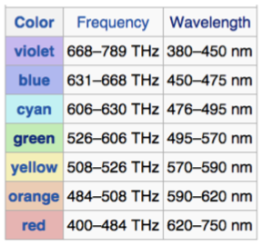m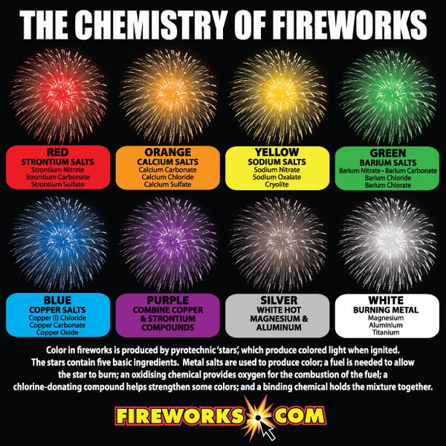
  - 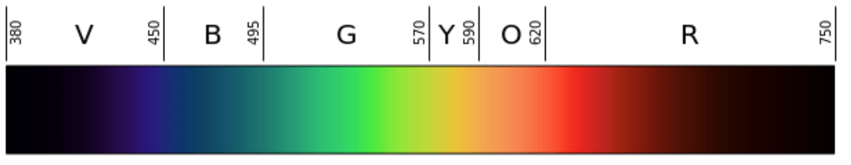

E) TENTATIVE TIMELINE (Keep brief—tables work well for this!)

TIME | ACTIVITY
8:30-9:30 (ALL) | SET UP
9:30-9:45 (Led by Abby C.) | Ice Breaker - Snowball Activity
9:50-10:00 (Led by Eric.) | Engage - Introduce activities for the day and hand out journals.  Tie last week’s activities to this week’s activities in terms of forensics and the final crime scene.
10:00-10:45 (Led by Abby M. and Riley) | Explore: Experiment 1: Dry Ice Bomb Experiment
10:50-11:00  (Distributed by Eric while others set up for activity 2) | SNACK - Bill Nye Video
11:00-12:50 (Led by Jackie and Abby C.) | Explore: Experiment 2: Flame Color Burning Salt Activity
11:50-12:00 (ALL) | Elaborate and Clean Up

F) DESCRIPTION OF YOUR LESSON:
Following a learning cycle approach explain how:
·You will ENGAGE the students into the activities for the day
·The students will EXPLORE the concept through gathering data/investigating/experimenting
·You will support students in making sense of the concepts through forming EXPLANATIONS
·Students will have an opportunity to ELABORATE on what they’ve learned this week

Activity 1:
Engage: | In order to engage students, we will start with a snowball activity. In this activity, students will crumple up a piece of paper with some kind of fact about themselves and throw it in the middle. Once students do this, they will have to pick one up from the middle and figure out which fact matches with which person.  Focus Question: How can an action-reaction activity be used to represent forensics?  Engage 1: Students will have the opportunity to compare the differences of dry ice and regular ice. By doing this, they will have gloves to feel and look at the dry ice while comparing it to holding the regular ice. Students will look at the differences between these two by filling in an anchor chart at the front of the room.
Explore: | Activity 1: Dry Ice Bomb  Before we start this activity, we will need to crush up the dry ice to be able to scoop it out into the bottles. Students will not be conducting this experiment because it would be a safety hazard. They will instead be making predictions and recording the results in their journals. There is just as much to be learned in making observations as well. Three trials will be conducted using three different temperatures of water: boiling, room temperature, and refrigerated. We will need to move outside to a clear area where there will not be many people. Taking the three 2-liter bottles, we will fill each with a scoop of the crushed dry ice. The first trial will be used for the boiling water. One of us will go out into the grassy area and add half of a bottle of water into the 2-liter and place the cap, making sure we run back to the group before the explosion. We will have students timing each explosion to see which explodes the fastest. This experiment will be repeated two more times, once with room temperature water and once with refrigerated water.
Expain: | Per finishing each activity, we will discuss with the students the following questions:  For the first activity, we will discuss…  - How does the carbon dioxide in the bomb cause the explosion? Does the carbon dioxide cause the explosion?  - Why do we use dry ice and not regular ice?  - How might this be useful in forensics?
Activity 2:
Engage: | (Break after snack, use engage 2 to get their attention)  Engage 2: After we finish up this activity, we will move into our initial engage activity. We will ask students to draw their own version of a firework on a piece of paper and color it however they want to. By doing this, we will ask them how they think that these fireworks obtain their color.  In order to focus on the aspects of the final crime scene, we will discuss the importance of the dry ice bomb as well as the flame salt burn. Both of these experiments foreshadow what residue will be found at the crime scene, where students have to figure out what residue comes from a specific material.
Explore: | Activity 2: Flame Color Activity  We will start by introducing the flame colors activity. We will begin by talking about the expectations of flame safety, no loose clothing, wear your goggles at all time and keep your hair away from flames. We will start by telling students we will be rotating stations. Each station will be around 5-6 minutes long and we will rotate clockwise. Each teacher will be at a table and help run it due to fire being used. We will remind the students that the goal of the lab/lesson is to record the colors form each of the station and try to decide which element is present at each station. Students should be observing the colors they are seeing and being respectful of each others opinions. At each station, there is going to be the substance in a dish present. Students should measure out a pinch of each substance and put in their watch glass. Then they will squirt some ethanol from on the solid with a pipet. Students will then hold over bunsen burner to light on fire. Students will know that the color may not change at first, but once the flame hits the solid they will. Students will write down the color that they see in their passport for each station. Students will then compare the color to the wavelengths in nanometers using the handout. Students will then use the information they have been given to make an educated guess about which substance was at which station. Once all students have gone around to each station, we will talk about which substance each group thought was at each table and see if students answers compare to each other. We will then clean up the activity and talk about the explanations part.
Explanations: | For the second activity, we will discuss…  - Why do you think the flames come in different colors? Why might this be useful in forensics?  - How does visible light have a role in this experiment?  - Why do we use salt for this activity?  - How are the electrons acting in this experiment before, during, and after?  After both activities, we will discuss…  - What was challenging about the activities?  - What did you notice that was similar about these activities? What was different?  - Which activity was your favorite, and why?  - Were your predictions correct or incorrect?
Elaborate: | As the end of the day comes close, students will have understood the chemical components of a dry ice bomb and the result of salt and ethanol burning. Students will discuss with each other at the end of the day what they learned about chemical components and how they react with one another. While doing this, students will once again write in their passport journals any questions or comments they have regarding the day's activities.  The residue from each experiment is similar to what can be found in a crime scene, so it will get students very excited about how they will be able to use it for their crime scene in the future class. We can also preview what is happening next week, which is blood typing and cheek cells. We will discuss briefly the importance of this and why it is significant in forensics. We will allow students to share their ideas of how this may be used in a final crime scene as they have already began brainstorming this last session.  For next session, we will set up by placing the butcher paper on the board to use for discussion of the dry ice bomb and its purpose for outside use. This will help students get excited about its outside use and why it is important.

G) How will you determine if your students achieve the objectives for this week?

- Students will achieve these goals by making observations and drawing/writing on their given worksheets throughout the activities.
- We will make sure students have achieved these objectives through discussions throughout and after the activities.
- We will make informal assessments by walking around and monitoring group discussion and providing probing questions to push students to think deeply.
- We will refer to the guiding question throughout the session to ensure students are understanding this concept.
- We will also have a journaling activity for students to do at the end of the lesson. This way students can right down what they have learned as well as their experience from today.
  - What did you learn about today?
  - What can you tell me about visible light?
  - Did you enjoy the activities today?
  - What did you learn from your peers today?
  - What would you like more of next week?
  - What can you tells about the dry ice bomb experiment?

H) PEDAGOGICAL FOCUS:
Our focus for this week is STEM: science, technology, engineering, and mathematics. We dedicated this topic to this week because the activities we chose line up with different elements of STEM. This week we are attacking the topic in many ways.
We plan to incorporate STEM firstly by using the ASSIST method. This method focuses on argument-based inquiry in terms of science. Students will have the opportunity to present their knowledge through conversation, writing, and media. Incorporating STEM into science class means going beyond just teaching science. Students need to be actively engaged. One way of doing so is meshing multiple disciplines into the classroom. We are obviously including science, but even within science we are using forensics alongside chemistry and other types of science. By integrating multiple areas of science into our lesson, we are entertaining a larger audience, essentially. We are keeping more kids engaged based on what interests they might hold. On top of this, we are integrating mathematics concepts by allowing students to measure out quantities of salt. One student may take a liking to math and want to do this step. This student may have previously been uninterested in the experiment, but because we integrated math, he/she is now intrigued. Lastly, we are including technology in the classroom. To our surprise, students began using technology to take photos of their results. We have since encouraged students to do so as this is a great way to record and eventually communicate findings. Also, when timing the dry ice bomb explosions, several students will use their phone stopwatches. This is another use of technology that will be present in the lesson.
Saturday Science Teaching – Fall 2018
Lesson Plan #4

Lesson #4
Grade 5-8

A) LEARNING OBJECTIVES and CRITERIA FOR DETERMINING IF OBJECTIVES ARE MET (minimum of 2/ lesson)

- Students will be able to identify the basic properties of cells in their DNA.
- Students will be able to recognize a strand of cells.
- Students will be able to explain that alcohol precipitates DNA out of the solution as DNA does not dissolve in alcohol.
- Students will be able to touch on the idea in explanation that red blood cells carry chemicals called antigens which are used in blood typing.
- Students will be able to explain that the antibodies a person has goes against the blood type they do not have.
Criteria:
- Students will demonstrate mastery of the above topics by speaking in whole group discussion about their findings as well as in small groups in their pods. Teachers will monitor that students understand these concepts by asking guiding questions to each group. We will also review their journal entries to see what concepts they grasped and which they perhaps did not. Students will record their results to blood typing on a worksheet that will also be evaluated to inform teachers of student understanding. Students will demonstrate cheek cell knowledge by talking with teachers as we pause the experimentation to explain the science behind each step. They will also write in their journals about what scientific processes are occuring as we experiment.

B) TEACHER CONTENT KNOWLEDGE (Describe what your teams needs to know regarding the science concepts you’ve identified for each learning objective above)

- Teachers need to be able to explain and understand that DNA is in cells, therefore extracting cheek cells allows us to take a closer look at DNA.
- Teachers need to be able to explain and understand that alcohol does not dissolve DNA due to its properties. When the DNA concentration is high, the ethanol is able to extract a white precipitate immediately. If enough ethanol is added, the electrical attraction between phosphate groups and any positive ions present in solution becomes strong enough to form stable ionic bonds and DNA precipitation.
- Teachers should know that it is the sodium lauryl sulfate in detergent that breaks down the fatty acids and proteins that encase the cell and its DNA, allowing it to eventually be extracted.
- Teachers should know what erythrocytes are red blood cells and there are four blood type groups.
  - Erythrocytes of a human may carry an A antigen, a B antigen, both A and B antigens or no antigens at all. People with type of A blood have A antigens on their red blood cells; type B and B antigens; type AB have both A and B antigens; and type O produce neither A nor B antigens.
- Teachers need to be able to explain that the interaction between antigens and antibodies is responsible for the clumping that allows us to identify blood type.

C) MATERIALS (asterisk (*) = any materials that may be a safety concern)

Blood Testing Kit
- Plastic Gloves (30 sets)
- Plastic Trays (30)
Cheek Cell
- Dixie Cups (60 cups)
- Lemon Gatorade (4 Large Bottles - enough for each student to have a mouthful)
- Dish Soap (1 full bottle - clear if possible)
- Pineapple Juice (1 full bottle)
- Long Wood Skewers (30)
- Alcohol (1 full bottle)
- Test tubes and stoppers (30)
- Tiny take home jars (30)

D) REFERENCES (list ALL references that you borrowed ideas from to develop this lesson – including any handouts you may distribute)

- Cheek Cell
  - https://www.livescience.com/37252-dna-science-experiment.html
- Handouts:
  - In blood testing kit - all ready

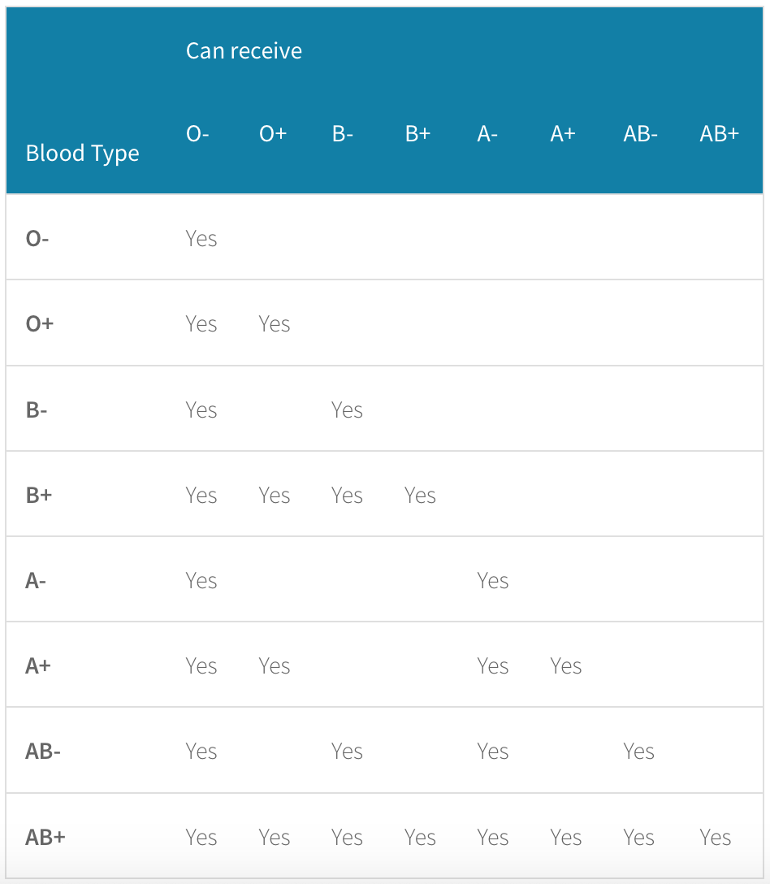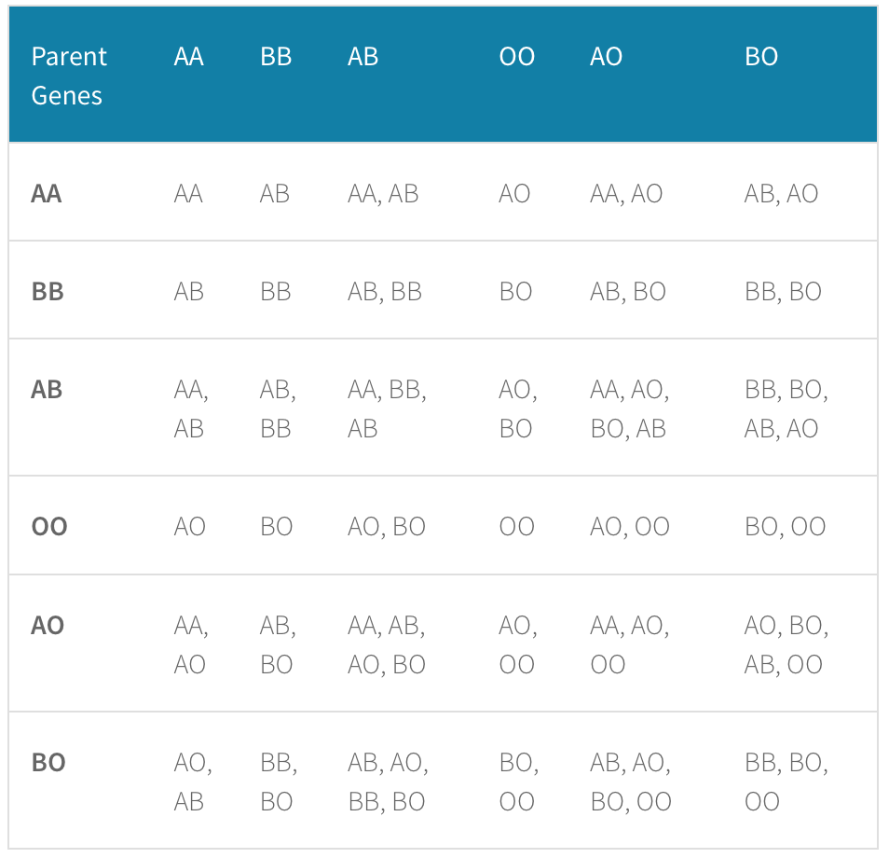
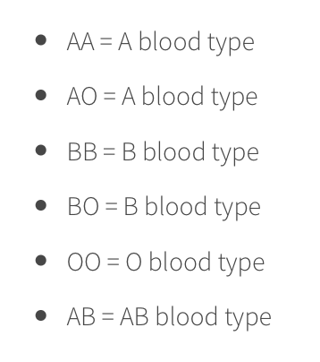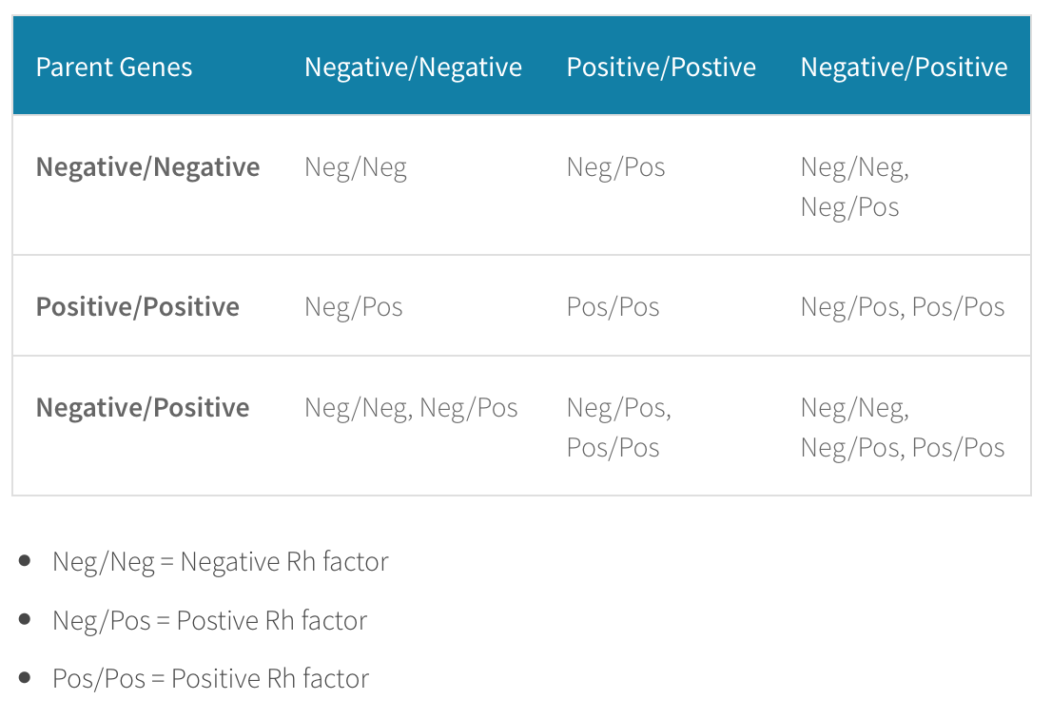

E) TENTATIVE TIMELINE (Keep brief—tables work well for this!)

TIME | ACTIVITY
8:30-9:30 (ALL) | SET UP
9:40-9:50 (Led by Eric.) | Engage - Introduce activities for the day and hand out journals.  Tie last week’s activities to this week’s activities in terms of forensics and the final crime scene. This will be the final day before our crime scene.
9:50-10:40 (Led by Abby C. and Riley) | Explore: Experiment 1: Cheek Cell Extraction
10:45-11:00  (Distributed by Eric while others set up for activity 2) | SNACK - Bill Nye Video - Genes Episode 28
11:00-12:50 (Led by Jackie and Abby M.) | Explore: Experiment 2: Blood Testing
11:50-12:00 (ALL) | Elaborate and Clean Up

F) DESCRIPTION OF YOUR LESSON:
Following a learning cycle approach explain how:
·You will ENGAGE the students into the activities for the day
·The students will EXPLORE the concept through gathering data/investigating/experimenting
·You will support students in making sense of the concepts through forming EXPLANATIONS
·Students will have an opportunity to ELABORATE on what they’ve learned this week

Activity 1:
Engage: | In order to engage students, we will start with by talking about internal identification. We want students to see what they can come up with for how we can use forensics to test the body inside. We will make a list on chart paper.  Focus Question: How can internal identification assist us in forensic testing?  Engage 1: To engage the students, we will ask students to see if they know what type of blood they have. Here we can have them write it down and then talk about how they get this specific blood type from their parents. We will pull up a chart that will help students see this. Also we will see if students can guess what the most popular type of blood is in the US.  - O Positive blood – 38%  - O Negative blood – 7%  - A Positive blood – 34%  - A Negative blood – 6%  - B Positive blood – 9%  - B Negative blood – 2%  - AB Positive blood – 3%  - AB Negative blood​ – 1%
Explore: | Activity 1: Blood Test Kit  To begin this activity, we will provide the students with a vial of blue-colored Anti-A simulated serum and a vial of yellow Anti-B simulated serum. We will also have a vial of each of the four simulated blood types: A, B, AB, and O.  Each team of two students should have four Slide Guides marking them in pencil as follows: 1-Type A, 2-Type B, 3-Type AB, 4-Type O. They should also have four blue mixing spatulas and four yellow mixing spatulas.  Students will:  - Each team should carefully place 1-2 drops of Type A blood in each circle of the Slide-Guide marked as 1-Type A.  - Repeat for Slide-Guide marked 2-Type B using Type B blood.  - Repeat for Slide-Guide marked 3-Type AB using Type AB blood.  - Repeat for Slide-Guide marked 4-Type O using Type O blood.  - Now, add 1-2 drops of simulated Anti-A Sera in the circle marked Anti-A of each of the four Slide-Guides next to the drop of simulated blood and 1-2 drops of the Anti-B sera in each circle marked anti-B next to the drop of simulated blood.  - Using a separate blue mixing spatula for each Slide-Guide mixture in the circles marked Anti-A, gently stir the two drops for about 20-30 seconds and observe for “agglutination”.  - Using a separate yellow mixing spatula for each Slide-Guide mixture in the circles marked Anti-B, gently stir in the two drops for about 20-30 seconds and observe for “agglutination”  - Using the interpretation of results on the Slide-Guide, have students record their observations on the data chart on their worksheet. A + will indicate a positive result or precipitate being formed. A (-) will indicate a negative result or no precipitate being formed.  Simulated Blood Group Antigens on the red blood cell Reactions with: Anti-A Serum Reactions with: Anti-B Serum  A A + -  B B - +  AB AB + +  O none - -
Explain: | Per finishing each activity, we will discuss with the students the following questions:  For the first activity, we will discuss…  - What was the final blood type that you and your partner had?  - Based on your results, what type of antigens were in your blood?  - What antibody is present in the serum from type A blood?  - What antibody is present in the serum from type B blood?  - What antibody is present in the serum from type AB blood?  - What antibody is present in the serum from type O blood?
Activity 2:
Engage: | (Break after snack, use engage 2 to get their attention)  https://video.search.yahoo.com/search/video;_ylt=AwrJ61QB0dhbwaAAjWhXNyoA;_ylu=X3oDMTB0N2Noc21lBGNvbG8DYmYxBHBvcwMxBHZ0aWQDBHNlYwNwaXZz?p=cheek+cell+videos&fr2=piv-web&fr=mcafee#id=57&vid=4e7a536d86db71114a1caca35feca6b7&action=view  Engage 2: For this next activity, we will ask students to draw how they think their cheek cell with look under a microscope. We will ask them to add as much detail as possible. By doing this, students will be able to compare to their actual one after they are able to extra the cell.  In order to focus on the aspects of the final crime scene, we will discuss the importance how internal identification assist us in forensic testing. Cells tell us lots of information about who a person is and makes it easy for people to connect and find people. Both of these experiments foreshadow what residue will be found at the crime scene, where students have to figure out what blood type and other internal testing is used.
Explore: | Activity 2: Cheek Cell Testing  We will start by introducing the cheek cell testing experiment. 24 hours before we start, we need to put the alcohol in the kitchen freezer. It won’t freeze, but it should be ice cold. Next the students will get a sports drink that is light color or colorless provided to them. Next they will take a good mouthful of sports drink and vigorously swish it around in their mouth like mouthwash. Go for at least 2 minutes. This takes some stamina and students will scrape the insides of your cheeks a little with their teeth. NO BLOOD. We will remind them that we are after the DNA from their cheek cells, not their blood type! We will then ask they spit the sports drink and cheek cell solution into a small paper cup. They will then pour it into their test tube until it is about one-third full. Students will then add liquid dish soap until their container is about half full. They will then put the lid on and mix the contents by rocking the container and turning it upside down several times. Remind them to be gentle, their goal is to mix the contents but to avoid causing bubbles from the soap. Students will then add a few drops of pineapple juice. Repeat the gentle mixing and gently add alcohol to the solution. Now teachers will get the icy cold alcohol out of the freezer. Take the lid off of your cheek cell solution and tilt the container in one hand. Students will use their other hand to very gently trickle a small amount of alcohol down the inside of the jar so that the alcohol forms a layer floating on top of the cell solution. Return the container to its upright position and set it aside for 1 minute. After a minute, students need to look carefully at the place where the alcohol makes a layer floating on top of the cheek cell solution. Students should see a band of white gooey material suspended between the liquid layers. Then gently put the skewer down into the container so that the tip touches this material. Carefully twirl the skewer in one direction only; if they are lucky the stuff will wind around the skewer so that they can lift it out through the alcohol layer to look more closely.  Behold their own DNA!
Explanations: | For the second activity, we will discuss…  - Why did they have to swish around their mouth for so long?  - Why did they have to use soap?  - Why does the alcohol have to be ice cold?  - What other sources of DNA could you use? (Please avoid taking samples from the family pet or from your little brother!)  - Do you get more DNA from using your cheeks, the fruit, the leaves or the seeds? Why do you think this is so?  - What do you have in common with a banana?  - What happens if the alcohol isn’t cold?  - Are there any steps you can leave out of the procedure and still get results?  After both activities, we will discuss…  - Could a CSI team use this technique to collect DNA for legal purposes?  - What techniques are used for forensic science or medicine?  - How can someone's blood type or cheek cell DNA help another person?
Elaborate: | By the end of the day, students will have learned about the correlation between blood testing and cheek cells in solving crimes and using it as a means for identification. These two activities will help students understand that identification can be used from multiple means other than fingerprinting and describing what people look like on the outside. Students will once again write in their passports about questions they have and how they learned about these concepts.  Blood Typing and swabbing cheek cells are two internal methods of identification for people who are looking for specific indicators in a crime scene, so it directly correlates to the ending lesson to get the students excited for how they will use it. These two activities are used in order to have a more accurate representation of identification compared to physical identification from features of the face, body, etc.  At the end of these activities, we will place butcher paper or poster paper on the board and ask students about the concepts and types of identification and why they are relevant to investigations of the world around them.

G) How will you determine if your students achieve the objectives for this week?

- Students will achieve these goals by making observations and drawing/writing in their science journals.
- We will make sure students have achieved these objectives through discussions throughout and after the activities.
- We will make informal assessments by walking around and monitoring group discussion and providing probing questions to push students to think deeply.
- We will refer to the focus question throughout the lesson to ensure students are understanding the scientific concepts.
- We will also have a final journaling activity for students to do at the end of the lesson. This way students can write down what they have learned as well as their experience from today.
- What did you learn about today?
- What can you tell me about DNA?
- Did you enjoy the activities today? Which one did you enjoy more?
- What did you learn from your peers today?
- What would you like more of next week?
- What part of blood testing did you find the most important? What does this tell you about forensic science?

H) PEDAGOGICAL FOCUS:

The pedagogical focus for this week is pertaining to ELL students in the design and implementation of our lesson. We will do this by completing the activities in a step-by-step manner for the students. Students that are in the ELL spectrum need instructions that are very detailed and structured. This layout for students like this helps them understand how to complete a task. There will also be images on the step by step instructions to assist ELL students in interpreting the steps. We plan to draw on the board each step that is occuring as well, erasing and redrawing for each step, in order to make following along with the steps simpler. The journals are always open to drawings, too. This makes it easier for these students. We do not ask for full sentences either, or perfect spelling. We will provide journal prompts for those that need assistance in explaining their thoughts as well.
Saturday Science Teaching – Fall 2018
Lesson Plan #5

Lesson #5
Grade 5-8

A) LEARNING OBJECTIVES and CRITERIA FOR DETERMINING IF OBJECTIVES ARE MET (minimum of 2/ lesson)

- Students will be able to identify the basic properties of cells in their DNA.
- Students will be able to touch on the idea in explanation that red blood cells carry chemicals called antigens which are used in blood typing.
- Students will be able to explain that some wavelengths of light are in the visible light range while others are not.
- Student’s will be able to identify that Newton's third law is: For every action, there is an equal and opposite reaction.
- Students will be able to explain why solids react with liquids because of their specific properties.
- Students will be able to identify similarities and differences between types of liquids.
- Students will be able to explain what density is and how you can accurately measure it. Students will be able to identify the basics properties of an acid.
- Students will be able to explain that fingerprints are unique to each individual and that there are three basic shape categories that all fingerprints fall into.
- Students will be able to explain that fingerprinting and invisible ink are tools and techniques used in forensic sciences.

Criteria:
- Students will demonstrate mastery of the above topics by speaking in whole group discussion about their findings as well as in small groups in their pods. Teachers will monitor that students understand these concepts by asking guiding questions to each group. We will also review their journal entries to see what concepts they grasped and which they perhaps did not.
- Through experimentation, students will come to know the difference between solids and liquids, demonstrate acid knowledge, and demonstrate their understanding of each fingerprint type.
- Through experimentation, students will demonstrate dry ice bomb knowledge by applying the concept we used to what they could do besides the bomb, and they will use the flame colors by exploring the colors they give off and matching to each wavelength to find the solution.
- Through experimentation, students will record their results to blood typing, which will be evaluated to inform teachers of student understanding, and they will demonstrate cheek cell knowledge by talking with teachers about each step.

B) TEACHER CONTENT KNOWLEDGE (Describe what your teams needs to know regarding the science concepts you’ve identified for each learning objective above)

- Teachers should know why certain solids react with liquids.
- Teachers should know what density is and how to measure it.
- Teachers should have a solid foundation regarding the explanation for why the chemical reaction between the lemon juice and the ink occurs that results from the heat.
- Teachers should have a strong grasp on the concept that every person has a different fingertip that is especially unique to them.
- Teachers should know the relationship between gas expansion, temperature, and pressure.
- Teachers should be aware of the electromagnetic spectrum and its basic composition.
- Teachers should be able to explain and understand that DNA is in cells, therefore extracting cheek cells allows us to take a closer look at DNA.
- Teachers should be able to explain that the interaction between antigens and antibodies is responsible for the clumping that allows us to identify blood types.

C) MATERIALS (asterisk (*) = any materials that may be a safety concern

Chemical Analysis
- Baking soda
- Five plates
- Vinegar
- Skeleton
- Gloves (enough for 22 kids)
- Tablecloth
- Pipettes (5)

Fingerprinting
- Cocoa powder
- Clear packing tape
- 3 Clear glasses
- Light colored construction paper

Invisible Ink
- Iron
- 5 pieces of cardstock
- Lemons

Blood Testing
- Blood Test Kits

Colored Flames
- Ethanol
- Boric acid
- Five Small salt dishes
- Five ziploc bags
- lighter

Layering Activity
- 5 Plastic water bottles
- Dish detergent
- Canola Oil

D) REFERENCES (list ALL references that you borrowed ideas from to develop this lesson – including any handouts you may distribute)

- Handouts:
  - In blood testing kit - all ready

Chemical Analysis Activity: https://www.brighthubeducation.com/middle-school-science-lessons/80194-three-forensic-science-activity-ideas/
- Invisible Ink:
  - https://www.education.com/science-fair/article/invisible-ink-oxidation/Invisibleink
- Fingerprints:
  - http://stem-works.com/external/activity/561
  - PST USE ONLY:
Set-up in the Office:

  - Body laying on floor
  - Cup or plate with baking soda (5)
  - Fingerprint on glass (3)
  - Water bottle with canola and detergent (5)
  - (5) premade lemon juice notes saying “No one will ever know”
  - Blood type O spattered on the floor or body
  - Plastic bag of salt mixed with Boric acid (5)

Materials in the Room:

  - Vinegar and cups
  - Cocoa powder and tape
  - Iron
  - Blood typing cards and serums
  - Lighter and salt containers

E) TENTATIVE TIMELINE (Keep brief—tables work well for this!)

TIME | ACTIVITY
8:30-9:30 (ALL) | SET UP
9:40-9:50 (Led by Eric.) | Engage - Introduce activities for the day and hand out journals.  Tie all week’s activities to this week’s activities in terms of forensics and the final crime scene. This will be the final day and crime scene.
9:50-10:40 (Led by Abby C. and Riley) | Explore: Crime Scene Stations
10:45-11:00  (Distributed by Eric while others set up for activity 2) | SNACK - Bill Nye Video - Episode 29
11:00-11:45 (Led by Jackie and Abby M.) | Explore: Crime Scene Stations
11:45-12:00 (ALL) | Elaborate and Clean Up and Thank you’s  Pass back journals

F) DESCRIPTION OF YOUR LESSON:

Activity 1:
Engage: | Crime Scene Exploring  In order to help students be engaged a the very start, we will review all of the chemistry topics that we have talked about so far. To do this, we will review the topics and then watch a short video about the analysis of a crime science. This video will help students understand what the steps are in completing an investigation. We will talk about the chart we made last and talk about the different techniques we can use.  Focus Question: How do different aspects of chemistry work together to create a cohesive environment for scientists?  The second part of the engage is to actually show the students the crime scene. When the students get finished with the review and the video, they will be able to see the crime scene that they have been waiting for the whole session. We will take the students to the office to show them the crime scene so that they can begin cracking the activities.
Explore: | Station 1: Blood Testing  - Students will gather a blood sample from the crime scene and bring it back to their station. They will then use the blood test kits to decide what blood type it is. Students will take drops of simulated blood and put it onto their Slide Guide. Then they will use the anti-A sera and the anti-B sera to determine what the blood type is.  Station 2: Invisible Ink  - Students at this station will be given pieces of paper with invisible ink messages already on them. Having a teacher’s help, they will use an iron to oxidize the lemon juice and reveal the message. They will use the message to eliminate suspects.  Station 3: Chemical Analysis  - Students will collect the powder from the crime scene and bring it back to the room. They will mix it with vinegar or water to determine what it might be. They will see that the baking soda will react with the vinegar and hopefully it will spark their memory of our first week’s activities.  Station 4: Fingerprinting  - For this activity, students will have a glass that they find next to the victim with a taped off fingerprint. By looking at this fingerprint, students will compare the different types of fingerprints to the suspects. By doing this, students will be able to eliminate suspects.  Station 5: Colored Flames  - For this activity, we will complete a similar experiment to what we did in class a couple of weeks ago. We will put the alcohol and the salt in a plastic bag to lay out at the crime scene. Students will light it with our help to figure out the color to eliminate the suspects.  Station 6: Layering Liquid  - Students will have the opportunity to see a water bottle next to the victim with different layers of materials in them. There will be 3-4 water bottles filled with the materials so that each group has an opportunity to look at them without waiting for a prolonged amount of time. They again will be able to eliminate suspects by determining the different material in the bottles.
Explain: | After each station, we can ask students to write down one thing in their journal that they want to share with their classmates.  Once the class has been through all the stations, we will ask students  - Who did it?  - How did each station lead you to a conclusion?  - What was your conclusion after each station?  - What did you do at each station?  In their journals, we will ask students to write about their Saturday Science experience and what they learned. We will then ask students to share their thoughts.
Elaborate: | At the end of the day, students will have understood the chemical components of the science activities we have focused on for the past five weeks. From working on internal and external identification, they will understand the connection between chemistry and forensic science and how one subject can be used to further simplify and/or understand the other. Students will discuss with one another which station they enjoyed the most and which one they felt was the most beneficial for realistic criminal investigation. This will be their final journal entry for Saturday Science, along with any concluding questions or comments they have regarding this year’s science program. When students journal, they will be able to organize their thoughts and bring all of the activities together and understand why they are important. If some students feel they were not being challenged enough or have any additional suggestions for next year’s Saturday Science, they will be able to either write these in their journals or tell us in person.

G) How will you determine if your students achieve the objectives for this week?

- Students will achieve these goals by making observations and drawing/writing in their science journals.
- We will make sure students have achieved these objectives through discussions throughout and after the activities.
- We will make informal assessments by walking around and monitoring group discussion and providing probing questions to push students to think deeply.
- We will refer to the focus question throughout the lesson to ensure students are understanding the scientific concepts.
- We will also have a final journaling activity for students to do at the end of the lesson. This way students can write down what they have learned as well as their experience from today.
- Students will be able to take their passports home with them when we are finished with the day

H) PEDAGOGICAL FOCUS:

The pedagogical focus for this week is pertaining to the nature of science. The nature of science is a multifaceted concept that defies simple definition. Science educators have identified three domains of science that are critical to developing scientific literacy. The first of these is the body of scientific knowledge. Of the three, this is the most familiar and concrete domain, and includes the scientific facts, concepts, theories, and law. Tentativeness is all scientific knowledge is subject to change in light of new evidence and new ways of thinking— even scientific laws change. New ideas in science are often received with a degree of skepticism, especially if they are contrary to well-established scientific concepts. Empirical evidence is scientific knowledge relies heavily upon empirical evidence. Empirical refers to both quantitative and qualitative data. Observation and inference is science involves more than the accumulation of countless observations—rather, it is derived from a combination of observation and inference. Observation refers to using the five senses to gather information. Scientific laws and theories in science, a law is a succinct description of relationships or patterns in nature consistently observed in nature. Laws are often expressed in mathematical terms. A scientific theory is a well-supported
explanation of natural phenomena. Scientific methods is no single universal scientific
method. Scientists employ a wide variety of approaches to generate scientific knowledge, including observation, inference, experimentation, and even chance discovery. Creativity is a source of innovation and inspiration in science. Scientists use creativity and imagination throughout their investigations. Objectivity and subjectivity, scientists tend to be skeptical and apply self-checking mechanisms such as peer review in order to improve objectivity. Students will be using all aspect of the Nature of Science during the crime scene activity. We will talk to students about these aspects and how they are used in every experiment and science project. When the lesson is over, we can talk to students about the aspects and how we used them throughout the lesson. The journals are always open for them to take notes too.

