Saturday Science Teaching – Fall 2018
Lesson Plan 1

LESSON 1 Light Interaction
GRADE 3-4
A) LEARNING OBJECTIVES:
- Students will be able to recognize and define how light affects different objects.
- Students will be able to recognize and define how light reacts to different objects.
CRITERIA FOR DETERMINING OBJECTIVES
- The first Criteria for Determining Objectives is that students will demonstrate their knowledge of how light affects different objects by responding in their science journal to the Connecting Question regarding what shadows are and how they are created.
- The second Criteria for Determining Objectives is students’ ability to complete the mirror maze will allow us to see the students demonstrate their knowledge of how light reacts to different objects (how light REFLECTS off a mirror is just one way in which this idea will be demonstrated in this lesson).

B) TEACHER CONTENT KNOWLEDGE (Describe what your teams needs to know
regarding the science concepts you’ve identified for each learning objective above)
We need to know:
- Connection between shadows and puppet shows and how those puppet shows are actually used around the world. (Social Studies connection)
  - There are different cultures that use puppet shows to represent themselves and use as a major form of entertainment. Also, in some religions puppet shows are an integral part.
- How flashlights work
  - Flashlights are usually powered by a battery that provides the power to the rest of the flashlight. When the on button is pushed, it creates a connection between two strips which created the flow of electricity. The electricity from the battery flows through the wires in the flashlight and powers on the light bulb at the end.
- The definition and understanding of refraction and reflection
  - Refraction - a kind of transmission that occurs when light is transmitted from one transparent material to another. The light changes direction and continues on its way. When refraction occurs, there is typically an optical phenomenon. (such as images flipping or appearing to be bent)
  - Reflection - When light bounces off a surface and continues on its way in a completely new direction. Reflection affects color, as colors we see are the colors that an object reflects.
- Understand transparency, translucency, and opacity and how light ties into these topics
  - Transparency - when light can pass through an object fully
  - Translucency - when light can pass through an object partially
  - Opacity - when light cannot pass through an object
  - There are many different materials that light passes through and knowing the difference between them can help you make decisions about what kind of material to use for different projects. Depending on the material, different amounts of light can pass through the surface. Example of transparent would be plastic, translucent would be tissue paper, and opaque would be black construction paper.
- Understand how and why shadows are created
  - Shadows are created when something blocks the light from passing through. This can happen with opaque items and translucent items, creating shadows of different levels of darkness.

C) MATERIALS (asterisk (*) = any materials that may be a safety concern)

Flashlights (12 )~
Small mirrors (36)
Sheet or screen for puppet show (1)
Black construction paper (1 pack) ~
Rainbow construction paper (1 pack) ~
White paper (1 pack) ~
Plastic wrap (1 roll) ~
Tin foil (1 roll) ~
Clear plastic cups - 9 oz (6)
Clear plastic cups 18 oz (30)
Clear plastic cups 24 oz (6)
Clear plastic cups 32 oz (6)
Vegetable oil (1 large bottle)
Dish Soap (1 large bottle) ~
Hand sanitizer (1 large bottle)

D) REFERENCES (list ALL references that you borrowed ideas from to develop this lesson – including any handouts you may distribute)
- https://www.pbslearningmedia.org/resource/lsps07.sci.phys.energy.lplightmoves/how-light-moves/#.W4XGHdhKiHo (Shadow Walk)
- https://gosciencegirls.com/refraction-light-glass-water-play-steam-kids/ (Refraction of light)
- https://docs.google.com/file/d/0B6SAhfoYQVIuNVliY1k0Yklia1U/edit (Reflection)

E) TENTATIVE TIMELINE

Puppet show | 5 minutes → 9:35 AM
Icebreaker | 15 minutes → 9:50 AM
Shadow walk → Finger puppets | 15 minutes → 10:05 AM
Testing materials with how light passes through | 30 minutes → 10:35 AM
Explanation | 10 minutes → 10:45 AM
Snack | 15 minutes → 11:00 AM
Reflection (mirror maze + worksheet) | 20 minutes → 11:20 AM
Refraction (different liquids) | 20 minutes → 11:40 AM
Discussion | 10 minutes → 11:50 AM
Science Notebook | 10 minutes → 12:00 PM

F) DESCRIPTION OF YOUR LESSON:
- Engage:
  - Puppet Show: we will produce a puppet show for the students to watch when they come in. The specific show we are going to perform is Three Little Pigs! With the shadow performance, we are going to incorporate the Social Studies content. Though we wanted to bring into a multicultural aspect with the actual show, however for convenience sake, we are just going to use the show and explain the relevance as this is a form of entertainment in different parts of the world. Actually, this is a way some people practice parts of their religious beliefs. Super cool way to to integrate world-wide knowledge with science.
    - This will be a fun a humerus way to show the students how shadows can be produced and peak their interest in the topic before the explore it on their own.
    - It is also important to remember that this ties into one of our Criteria to meet Objectives. The students throughout the lesson will be observing, experimenting, engaging, and learning about how light affects and reacts objects.
    - At the end of the entire day, the students will be asked to make connections based on all of their activities. This one in specific is something that people encounter every single day (shadows).
  - Shadow walk outside: we will take the students outside to begin their shadow walk but once we get outside we will ask them to put down what they have and participate in a touch middle activity as an ice breaker.
    - The students will explore the idea of shadows with natural light and man made light. This allows for the students to get engaged with the activity on their own terms before they begin to explore it through the activities we planned.
- Explore:
  - Testing different materials: For this activity, we are having the students explore how light can pass through different objects. The students will be given flashlights and explore how the light will pass through each one. The materials they are observing how light passes through are, tin foil, white paper, black paper, plastic wrap. The students will have a worksheet that they will fill out predictions of what they think will happen when they shine the flashlight through the materials listed above. Then they will test each materials and see how the light shines through each one. This will bring up the conversation about what transparent, translucent, and opaque means.
  - Mirror Maze Activity: For this activity, the students are going to be experimenting with how light can reflect off of mirrors and be sent back to a certain location. The students will be given and obstacle on their tables, one flashflight (source of light), and 6 mirrors. They will then have to figure out how to use those 6 mirrors to get their light to reach the end of the obstacle course. This allows for the students to see how reflection works.
  - Liquid activity: The students will draw a picture on a piece of paper and then they will be given water in 4 different sized cups, that are listed in the materials list, and be instructed to see how their image changes when placed behind each cup. This part of the experiment will show the students how refraction works. The students will then take their same drawing and place it behind different liquids and see how that changes their image. They will be given a worksheet to write predictions and what observations of what happens.
- Explain:
  - Testing Different Materials: For this activity, we will explain what transparent, translucent, and opaque means by having the students complete the experiment and try to formulate definitions for these terms. After they come up with definitions for the terms they will share and compare ideas with one another and then with the whole class.
    - Questions to ask:
      - How did the light pass through the tin foil? Black paper? White paper? Plastic wrap? What does this mean?
      - For each material the light passed through how did the light look?
      - How could we label each of these terms for how the light passed through?
  - Mirror Activity: For this activity, we are looking at how reflection works. Through this experiment, we want to students to see how light can be bounce off different objects (the mirrors) to be reflected onto a different object. We want the students to come up with a definition on their own with their groups before sharing with the whole class.
    - Questions to ask:
      - How did the light travel?
      - Was it hard to make it get to the final location?
      - What strategies did you use to get the light to through the maze?
  - Liquid Activity: For this activity, we will be explain how refraction works. The students will be able to see how it works through looking at their drawings in the different sized cups and the different liquids.
    - Questions to ask:
      - Why to you think the image changes when placed behind the different sized cups?
      - What do you think is causing this change?
      - Would putting it behind different liquids cause the image to change even if it has the same amount in them?
      - What happened to your image when you placed it behind the different liquids?
- Elaborate:
  - Full class discussion over Material Experiment where the students get to share their thoughts and tell us why they think the experiment went they way it did.
  - Full class discussion over Mirror Maze where the students get to share their thoughts and tell us why they think the experiment went they way it did.
  - Full class discussion over Liquid Activity where the students get to share their thoughts and tell us why they think the experiment went they way it did.
- Evaluate:
  - Participation during discussion using the open ended questions above will help us decide if the students are grasping the concepts through the experiments. We will ask the probing questions to not only get their minds working but also to push them to the conclusions we have designed the activities around. We also have worksheets that they will be completing with the activities to show their understanding. As teachers we will be walking around during the experiments making sure they are on the right track to find the conclusion and asking them more questions to push their understanding. There will also be the science notebook for them to fill out at the end of each day that asks questions about the topics covered.

G) How will you determine if your students achieve the objectives for this week?
- We will have constant checkins when they are conducting the experiments and participating in the activities to make sure they have a full understanding of light and how it interacts. We will also be giving out science notebooks that ask questions about the activities that we did while they were here. The notebook will stay in the classroom and give us an opportunity to look over their answers to the reflecting questions we have written.

H) PEDAGOGICAL FOCUS:
-State the focus for the week - Productive discussions
-Explain how you are trying to incorporate this into your practice in this week’s lesson
- Throughout the activities, we will have whole group discussions. Through these whole group discussions we will promote the students to engage in a further understanding of the activities by asking them questions that promote higher thinking.
- We will also monitor the students throughout the activities to decide which students should share first. This will allow students to build on what others say as well as connect their ideas to those that shared before them.

Saturday Science Teaching – Fall 2018
Lesson Plan 2

LESSON 2 See in the Dark
GRADE LEVELS 3-4
Focus Question: What role do the different parts of our eye play in perceiving light/dark?
- The focus question will be put in big letters on the board at the front of the room for the class to continuously be brought back to the goal of the lesson.

A) LEARNING OBJECTIVES and CRITERIA FOR DETERMINING IF OBJECTIVES ARE MET (minimum of 2/ lesson)
OBJECTIVES:
Students will know the different components of the eye and their purposes.
Students will understand how the eye must make adjustments in order to see in the dark.
CRITERIA FOR DETERMINING OBJECTIVES
- The first Criteria for Determining Objectives is that students will demonstrate their knowledge of the different parts of the eye by labeling their diagram of the eye and being able to create the 3D model of the eye.
- The second criteria for determining objectives is that the students will be able to demonstrate knowledge of how the eye adjusts to being in the dark by filling out questions and through them sharing through the class discussion.

B) TEACHER CONTENT KNOWLEDGE (Describe what your teams needs to know
regarding the science concepts you’ve identified for each learning objective above)
Pirate Activity:
- Story of the PIRATES
- Eyes make adjustments so that you can see in the dark
Pupil dilation Activity:
- Pupils change size to allow in more or less light
- The wider the pupil the more light the eye lets in
- Pupil gets smaller to block out more light
- The pupil is black because it absorbs all light
- The pupil changes size with the help of the muscles in the iris
- Too much light makes it hard to see (glare, pain, damage to lens/retina)
- Letting in more light makes it easier to see in the dark
How our eyes perceive color activity
- Light receptors in the eye transmit messages to the brain → produces sensations of color
- Color is not inherent in objects → the surface of an object reflects some colors and absorbs all of the other colors.
- We perceive only the reflected colors.
Eye diagram/composition of the eye
- Iris - colored part of the eye that changes the size of the pupil to allow different amounts of light into the eye.
- Pupil - dark hole in the center of the iris that allows light to enter the retina
- Retina - light sensitive inner lining on the back of the eye. The light rays that enter the pupil are focused on the retina by the cornea and lens. The retina produces the image that you see and sends it to the optic nerve for the brain to interpret.
- Sclera - the white of the eye, forms the outer coating of the eye.

Macula - the small area at the center of the retina responsible for what we see straight in front of us, at the centre of our field of vision. The macula is very important as it gives us the vision needed for detailed activities such as reading and writing, and the ability to appreciate color

Cornea - the transparent membrane which forms the outer coating at the front of the eyeball and covers the iris and pupil. It also focuses light on the retina.
- Lens - The lens is a transparent structure behind the iris, the coloured part of the eye. The lens bends light rays so that they form a clear image at the back of the eye – on the retina. As the lens is elastic, it can change shape, getting fatter to focus close objects and thinner for distant objects.
- Rods - used for low light / night vision. They only need a few photons to be activated. Rods don't help with color vision, which is why we see in grayscale at night. The human eye has over 100 million rod cells. Located on the sides of the retina.
- Cones - require more light to be activated. Used to see color. We have blue, red, and green cones. The human eye has about 6 million cones. Located in the center of the retina.
Pupil card

C) MATERIALS (asterisk (*) = any materials that may be a safety concern)

- Eye patches
- Candle*
- Worksheets
- Markers
- Pencils
- Science notebooks
- Crayons
- Cardstock
- Chart paper (the big stuff)

D) REFERENCES (list ALL references that you borrowed ideas from to develop this lesson – including any handouts you may distribute)
- https://mysteryscience.com/print/preview/g/10hAQUMPUZ-t0eyFB4ajP9eU-CELBGaHo_jJdz6yrEqc/presentation/1N1G18g-ifoJvJUr42yxr4rZJ21CHeR55KMFS3FV1C4I/presentation
- https://mysteryscience.com/print/preview/g/1Rl3XhzZXC_op6M0x3ZIM-md-ug4EoV3TqCPRXwpVnow/presentation/13AJTGvHDKMFxQ-AWXoW4fVaVIzu-hglMpjKlSzont64/presentation#
- http://www.metrofamilymagazine.com/June-2014/Simple-Science-Experiment-How-Our-Eyes-Perceive-Color/
- https://thevisibleworld.weebly.com/the-internal-structure.html
- https://lookafteryoureyes.org/how-your-eyes-work/parts-of-the-eye/
- https://askabiologist.asu.edu/rods-and-cones

E) TENTATIVE TIMELINE

GO OVER EXPECTATIONS | 9:30-9:45
Bingo Icebreaker | 9:45-9:55
Pirate Activity / Exploration (Mary) | 9:55-10:15
Pupil Dilation (Sarah) | 10:15-10:20
Discussion | 10:15-10:25
How our eyes perceive color activity (Halle) | 10:25-10:55
Snack | 10:55-11:15
Eye diagram / teach about composition of eye (Justice) | 11:15-11:25
Pupil Card (Sarah) | 11:25-11:45
Science Journal | 11:45-12

F) DESCRIPTION OF YOUR LESSON:
Following a learning cycle approach explain how:
ENGAGE
- We are beginning our day with expectations. This will be the introduction to our day, as we have determined it is needed from last week. We will also begin with a fun story about pirates and introduce the idea of seeing in the dark, and how pirates use their eye patches to help their eyes adjust to the dark.
  - Questions to think about:
    - What is the importance of having expectations?
    - Why are we taking time from our lesson to talk about expectations?
    - Why does it take time for our eyes to adjust from a well-lit room or the daytime to a dark room or night time?
    - Why did/ do pirates wear eye patches?
EXPLORE
- Students will be doing a pupil dilation activity to explore the way in which the eye adjusts to the light. They will be in partners, and one student will start as the observer and one as the eye closer. One student will close their eyes tightly for 20 seconds, and then open their eyes. The other student will look at the pupils of their partner and make observations and inferences about what they see happen. They can do this multiple times, and will switch roles each time.
  - Questions to ask:
    - What do you think is causing the pupil to dilate?
    - What else do you notice?
    - Why does the pupil dilate?
EXPLANATIONS
- Students will learn about the different parts of the eye and have an activity sheet to fill out. Parts of the eye covered will be the pupil, iris, lens, and sclera. We will also talk about rods and cones and how they help us perceive different types of light.
  - Questions to ask:
    - (before the explanation, based on their previous activities) Why is it important that the pupil can get bigger and smaller?
      - When does this happen?
      - How does this happen?
      - Do all eyed-organisms experience this dilation?
ELABORATE

G) How will you determine if your students achieve the objectives for this week?

- We will have full class discussion pre/post an activity to discuss the specific activity at hand. During this time, the students will be asked specific questions that are for their activity, but they will also be asked throughout the lesson on multiple cases why that is important for us to know in order to answer the focus question ijjjin full.
- We will have constant checkins when they are conducting the experiments and participating in the activities to make sure they have a full understanding of concepts for the day.
- We will also be giving out science notebooks that ask questions about the activities that we did while they were here. The notebook will stay in the classroom and give us an opportunity to look over their answers to the reflecting questions we have written.

H) PEDAGOGICAL FOCUS:
-State the focus for the week
- Assessing for learning
-Explain how you are trying to incorporate this into your practice in this week’s lesson
- To assess student learning this week, we want to focus on the 3 Cs: clarity, coherence, and causality. To check for clarity, we will determine if students state their ideas in ways that make sense to their classmates and use everyday language or that the scientific language they use is known by other students. To check for coherence, we will determine if student responses make sense based on the things that they have already learned. To check for causality, we can see if students are creating a link between their ideas in terms of cause and effect.

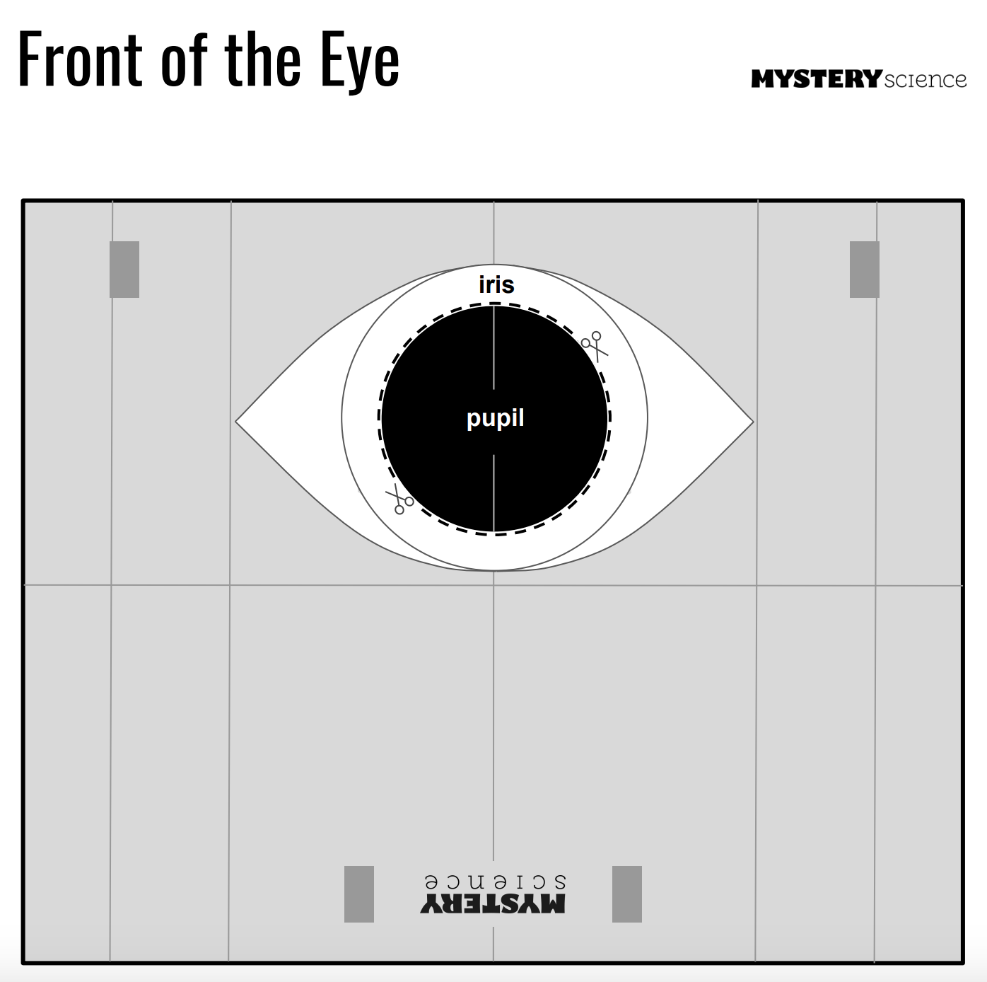
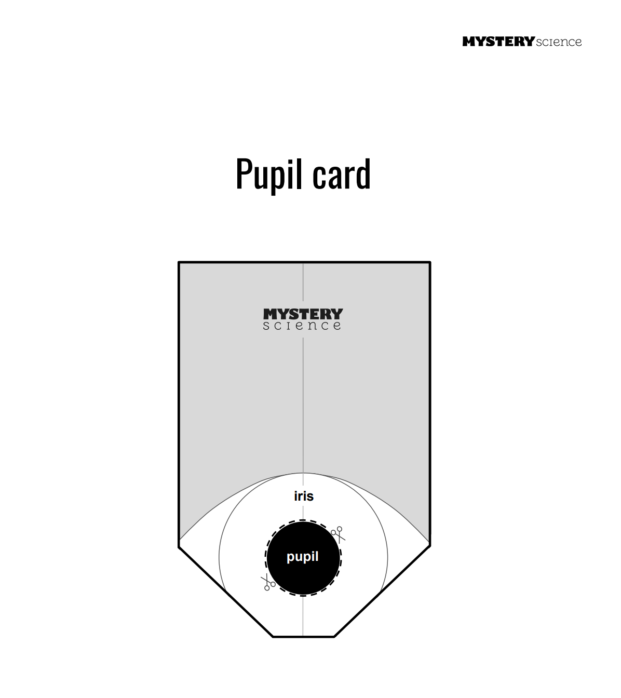

** Not for Students**

Simple Science Experiment: How are eyes perceive color

Materials:
- A drawing of an object (a star, a heart, etc) that has a yellow border, a green interior, and a black dot in the center.
- You will also need blank white sheets of paper and markers/paint to make your own illusions.

Procedure:
- Using the photo of the yellow and green star, stare at the image and focus on the black dot in its center for at least 20 seconds without blinking.
- Immediately look over at the blank side of the image and focus on the black dot there.
- Describe what you see.
- Look at the border and the interior of the image and describe their colors. Why do you think this happened?
- What colors does the human brain group together?

Explanation:
When you look at the blank side of the paper after staring at the image, you notice different colors. The border is now blue and the interior is now red. So bizarre!
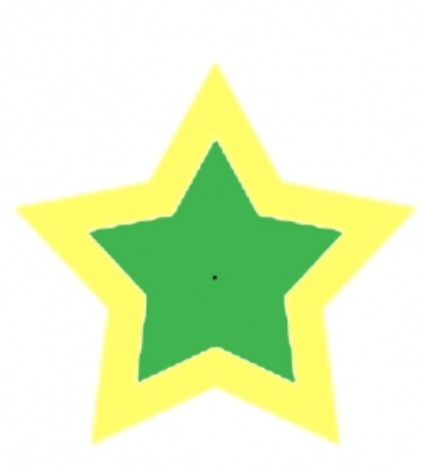
The human eye is really an amazing organ. We have depth perception, we can focus on things close or far away, and we can tell colors apart. There is a part of your eye called the retina that absorbs the light. Other segments of the eye decode colors. These “cones” can decode only certain colors, and red and green are paired, as are yellow and blue and black and white. When you stare at an image like this for a while, you temporarily make an impression that stays on your retina. However, when you stare at a certain color tends to bleach out the color pair in your cones and triggers the other color.

**NOT FOR STUDENTS**

EYE ANATOMY
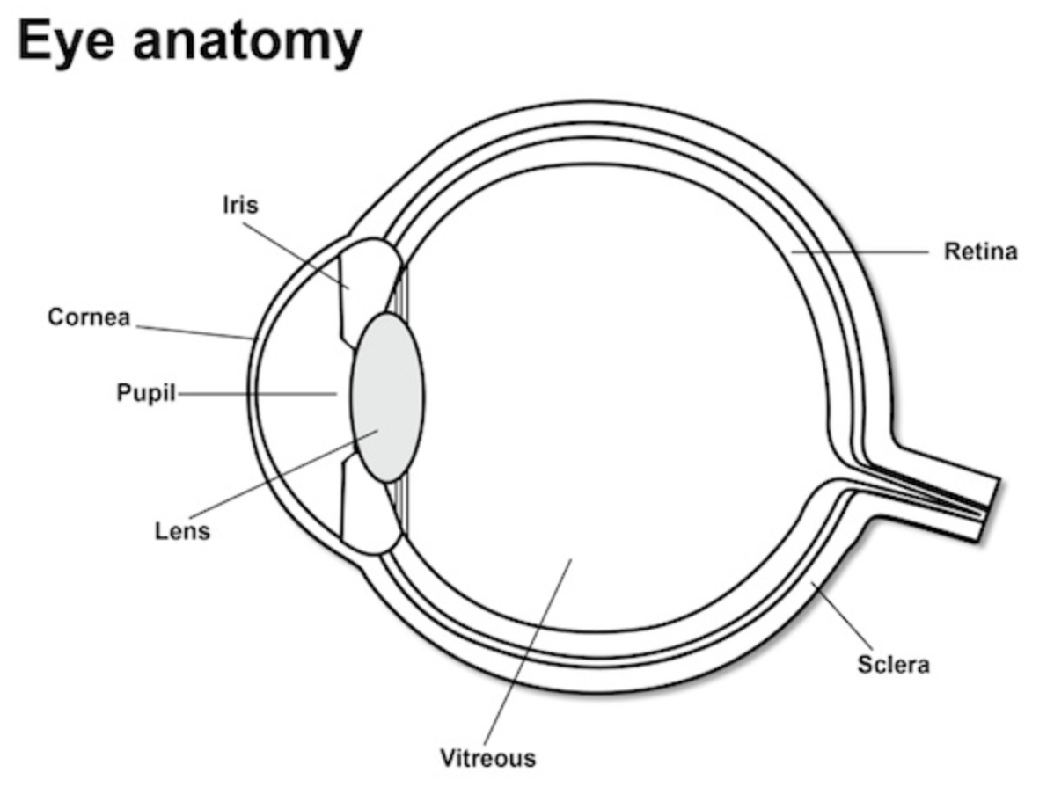

Cornea
The cornea is the transparent membrane which forms the outer coating at the front of the eyeball and covers the iris and pupil. It also focuses light on the retina.

Iris
The iris is the coloured circle surrounding the pupil. It changes the size of the pupil and allows different amounts of light to enter the eye. When people ask you what colour your eyes are, they mean what is the colour of your iris. The majority of the outer surface of everyone’s eye is white! (This is the sclera).

Lens
The lens is a transparent structure behind the iris, the coloured part of the eye. The lens bends light rays so that they form a clear image at the back of the eye – on the retina. As the lens is elastic, it can change shape, getting fatter to focus close objects and thinner for distant objects.

Pupil
The pupil is the dark circular hole in the centre of the iris which allows light to enter the retina.

Retina
The retina is the light-sensitive inner lining of the back of the eye. Imagine that the eye is like a non-digital camera, and the retina is the film. Rays of light enter the eye and are focused on the retina by the cornea and lens. The retina produces an image which is sent along the optic nerve for the brain to interpret, rather like developing a camera film.

**NOT FOR STUDENTS**

Rods and Cones of the Human Eye

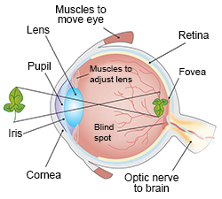

The anatomy of the human eye. Click to enlarge and for more information.

You can see in the drawing on the left that the back of the eye is lined with a thin layer called the retina. This is where the photoreceptors are located. If you think of the eye as a camera, the retina would be the film. The retina also contains the nerves that tell the brain what the photoreceptors are "seeing."

There are two types of photoreceptors involved in sight: rods and cones.

Rods work at very low levels of light. We use these for night vision because only a few bits of light (photons) can activate a rod. Rods don't help with color vision, which is why at night, we see everything in a gray scale. The human eye has over 100 million rod cells.

Cones require a lot more light and they are used to see color. We have three types of cones: blue, green, and red. The human eye only has about 6 million cones. Many of these are packed into the fovea, a small pit in the back of the eye that helps with the sharpness or detail of images.

Other animals have different numbers of each cell type. Animals that have to see in the dark have many more rods than humans have.

Take a close look at the photoreceptors in the drawings above and below. The disks in the outer segments (to the right) are where photoreceptor proteins are held and light is absorbed. Rods have a protein called rhodopsin and cones have photopsins. But wait...these are stuck in the back of the retina. That means that the light is absorbed closer to the outside of the eye. Aren't these setup backwards? What is going on here?

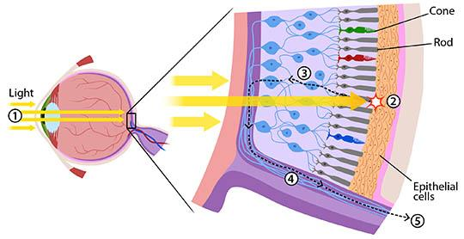

Light moves through the eye and is absorbed by rods and cones at the back of the eye. Click for more information.

The "backwards" organization of rods and cones is helpful for a few different reasons.

Cell orientation makes it easier to recycle parts. Image by HuBoro.

First of all, the discs containing rhodopsin or photopsin are constantly recycled to keep your visual system healthy. By having the discs right next to the epithelial cells (retinal pigmented epithelium: RPE) at the back of the eye, parts of the old discs can be carried away by cells in the RPE.

Another benefit to this layout is that the RPE can absorb scattered light. This means that your vision is a lot clearer. Light can also have damaging effects, so this set up also helps protect your rods and cones from unnecessary damage.

While there are many other reasons having the discs close to the RPE is helpful, we will only mention one more. Think about someone who is running a marathon. In order to keep muscles in the body working, the runner needs to eat special nutrients or molecules during the race. Rods and cones are similar, but instead of running, they are constantly sending signals. This requires the movement of lots of molecules, which they need to replenish to keep working. Because the RPE is right next to the discs, it can easily help reload photoreceptor cells and discs with the molecules they need to keep sending signals.

Now that we know how these photoreceptor cells work, how do we use them to see different colors?

We have three types of cones. If you look at the graph below, you can see each cone is able to detect a range of colors. Even though each cone is most sensitive to a specific color of light (where the line peaks), they also can detect other colors (shown by the stretch of each curve).

Since the three types of cones are commonly labeled by the color at which they are most sensitive (blue, green and red) you might think other colors are not possible. But it is the overlap of the cones and how the brain integrates the signals sent from them that allows us to see millions of colors. For example, the color yellow results from green and red cones being stimulated while the blue cones have no stimulation.

How Do We See the Color White?
Our eyes are detectors. Cones that are stimulated by light send signals to the brain. The brain is the actual interpreter of color. When all the cones are stimulated equally the brain perceives the color as white. We also perceive the color white when our rods are stimulated. Unlike cones, rods are able to detect light at a much lower level. This is why we see only black and white in dimly lighted rooms or while out viewing a star-filled night sky.

Are Carrots Good for Your Eyes?
Let's take a minute to talk about vitamins. The pigment molecule attached to the proteins in photoreceptors is called retinal. When retinal absorbs photons, it gets destroyed in the process. In order to regenerate more retinal, your body needs Vitamin A. Carrots are one food that is high in Vitamin A. This makes them good for your eyes, but don't think they will make your eyesight better. While carrots are good for the health of your eyes, they won't make you see better or let you ditch your glasses or stop wearing your contact lenses.

Saturday Science Teaching – Fall 2018
Lesson Plan

LESSON # 3 Color
GRADE LEVELS 3-4

Focus Question:What is the color spectrum and how is it composed?
A) LEARNING OBJECTIVES and CRITERIA FOR DETERMINING IF OBJECTIVES ARE MET (minimum of 2/ lesson)
LEARNING OBJECTIVES:
- Students will be able to understand why we see color.
- Students will experience different ways to see color.
- Students will be able to explain why we see color utilizing examples from activities that we did in class.
- Students will be able to create, experience, and explain the bending of light.
CRITERIA FOR DETERMINING IF OBJECTIVES ARE MET:
- A Criteria for Determining Objectives is that students will demonstrate their knowledge of seeing in color by participating in whole group discussions.
- A Criteria for Determining Objectives is that students will demonstrate their knowledge of experiencing color by making a kaleidoscopes.
- A Criteria for Determining Objectives is that students will demonstrate their knowledge of experiencing color by utilizing spectostropes and observing what happens.
- A Criteria for Determining Objectives is that students will demonstrate their knowledge of creating, experiencing, and explaining the bending of light by making their magnifying glass and observing and further discussing it.
- A Criteria for Determining Objectives is that students will demonstrate their knowledge of seeing in color by completing their science journal.

B) TEACHER CONTENT KNOWLEDGE (Describe what your teams needs to know
regarding the science concepts you’ve identified for each learning objective above)
- TEAM KNOWLEDGE:
  - How the eyes see color ( review of last week ) → cones
  - Why light bends
  - When light bends
  - What bending light looks like
  - Kaleidoscopes → a toy consisting of a tube containing mirrors and pieces of colored glass or paper, whose reflections produce changing patterns that are visible through an eyehole when the tube is rotated
  - Diffraction Grating → is a piece that splits and diffracts light into several beams travelling in different directions
    - Spectroscopes

C) MATERIALS (asterisk (*) = any materials that may be a safety concern)
- Poem about significance of light ( we have )
- Spectostrope
  - Candle flame
  - Regular light bulb
  - Flashlight
  - White Computer Screen (we have)
  - String Lights (we have)
  - Fancy lights from Alex’s brother
- Kaleidoscope
  - Mylar → about 3’ ( enough to put three separate strips in each roll)
  - Toilet Paper Rolls → 24
  - Cardostock
  - Straws
  - Markers
  - Tape

D) REFERENCES (list ALL references that you borrowed ideas from to develop this lesson – including any handouts you may distribute)
https://www.youtube.com/watch?v=YAxLueEKqmU
https://buggyandbuddy.com/science-for-kids-how-to-make-a-kaleidoscope/

E) TENTATIVE TIMELINE

STILL STROLLING IN | 9:30-9:35
Quick Expectations (Halle) | 9:35-9:45
Read Aloud (Mary) | 9:45-9:55
Kaleidoscopes (Justice) | 9:55-10:40
Discussion about colors (Justice) | 10:40-10:50
Snack (watch color video) (THE SJMH TEAM) | 10:40-11:00
Spectroscopes (Sarah) | 11:00-11:30
Spectroscope Discussions (Mary) | 11:30 - 11:45
Science Journals (THE SJMH TEAM) | 11:45-12

F) DESCRIPTION OF LESSON:
Following a learning cycle approach explain how:
- PRE-ENGAGE
  - EXPECTATIONS → We are going to review expectations that we created together as a class last week for two reasons: not everyone was present and our friends need to be reminded that we have to follow directions the first time in order to do fun things.
  - Our management is not bad by any means, the students are very eager to learn and create as well as goof around.
- ENGAGE
  - To engage students we will do a read aloud of the book All Colors of the Rainbow to introduce topics for the day. This will get them thinking and get them ready for the explore phase of the lesson. We will ask students questions in order to connect to previous lessons and to get them ready for today’s lesson. The questions are as follows:
    - What do we remember from last week about how our eyes help us see color?
    - What parts of the eye help us see color?
    - What other than our eyes makes us able to see color? (light)
    - What else do you know about color?
    - What do you want to learn about color today?
- EXPLORE
  - Kaleidoscopes
    - Teachers will break students into four separate groups to go through the directions for actually making the kaleidoscopes.
      - Decorate the tube
      - Cut three mylar strips to fit into the tube
      - Organize these into a triangle prism and tape together (shiny side down)
      - Cut bendy end off of straw and tape to tube with the bendy end hanging off the end
      - Cut out circles in the cardstock
      - Poke a hole in the center with a pencil
      - Decorate the circle with different designs on different sections of the circle
      - Attach the circle by putting the straw through the hole
    - By doing this activity the students will be observing how the shape of their mylar will recreate the light spectrum and their image they draw within their kaleidoscope. This will only partially
  - Spectroscopes
    - There will be 6 stations with different light sources at each. There will be: candles, flashlights, string lights, fancy lights from Alex’s brother
  - EXPLANATIONS
  - We will be doing discussions throughout the activities, which is where most of the explanation for the day will occur.
  - After the kaleidoscope activity we will ask questions to ensure that the students understand how they work and how light is important to the process. Specific questions follow:
    - What pieces of the kaleidoscope are making the colors change?
    - What pieces are creating the images that you are seeing?
    - Why are you seeing different shapes?
    - Did you enjoy this activity?
  - After the spectroscope activity we will also have guiding questions for the students to lead the discussion and ensure that important topics get covered. Specific questions follow:
    - What do you think is happening with the spectroscope?
    - Why are you seeing the rainbow when looking at white light?
    - What parts of the spectroscope cause the light to be seperated?
  - Discussions following every activity yes, but at the end of the entire lesson, we discuss what we learned and address terms and concepts that the students will find useful when referring to the content and experiments that they are working with:
    - What are some important terms that we discussed today?
    - Can you describe those terms using an example from what we did today or what you can associate it with outside of the classroom?
    - Where does this content affect you outside of the classroom?
    - Why is it important to understand the color spectrum?
    - How is the color spectrum composed?
    - What makes the composition of the color spectrum important to you?
- ELABORATE
  - The elaboration portion follows in line with the explanations in that as our conversations with the students about their creations and discoveries tends to lead to questions from the students. I think we have done a great job getting as much extra information on the subjects that we are presenting that we have been able to share and continue to help students theorize and question what they are finding.
  - The activities we are doing are quite fun and interesting. That being said, we are incorporating some of the topics that we have covered in the first two weeks. This will give the students the opportunity to continue to make connections as well as further develop their understandings of light and how it affects what we see including but not limited to how we see shapes and colors and how we process those visions in our head. The goal is that as we continue to move through the weeks, the students are finding more understanding and interests in the topics at hands. There should be questions and there should still be wonders by the end of the lesson, and hopefully we can address most of those questions and inquiries in class.
  - Most of our assessment comes down to the conversations we have with the students during the lessons while they are interacting with different materials/ activities. But we also have incorporated our science journal which allows us to keep documented forms of learnings, understandings/ misunderstandings, and remaining questions.

G) How will you determine if your students achieve the objectives for this week?
- In creating the kaleidoscopes, the students are going to have the opportunity to individually encounter a “disorienting” experience by playing with different colors, different shapes, and light.
  - Something that we have noticed is that when the students have to create things ( because they have a difficult time focussing during the directions) they have to talk with each other. They end up discussing and the conversation ends up being beneficial in that they explain what they are seeing to one another rather than just doing it as an individual. That way the students are articulating their observations with peers, then we can group back together as a class and discuss the main purpose of the activity.
- When going through the different light sources, the students are going
- Throughout the lesson, we are going to incorporate small group and full class discussions to briefly assess what the students are gaining from their inquiries and activities. Too, the students will be creating many things, so as they are creating we are going to walk around and informally assessing with probing questions and just interacting with their process of thinking. By chatting with the students and hearing their observations along with their personal understandings and having the opportunity to hear the other ideas of other students they will continue to grow their learnings (that is if the student is willing to be open to listening and a different perspective).
- In addition to discussions and personal chatting, we are going to complete the science journal at the end of the session to assess what they learn. They are answering questions that connect information as well as having the opportunity to discuss something that they personally connected to and discuss what they learned from that activity.

H) PEDAGOGICAL FOCUS:
-State the focus for the week:
- Nature of Science
-Explain how you are trying to incorporate this into your practice in this week’s lesson
- First and foremost, it is important to remember that we have included the “ways” of the Natures of Science in every week. The past two weeks, we have not only introduced new concepts and topics of light and color to the students, but we have also made it a point to incorporate their previous knowledge in order to make those connections with the students so that the information does retain better. That being said, the students are being exposed to the new information through investigation, observation, experimentation, classification, and anything else that allows the students to put in the work and come up with their own conclusions about the situation at hand. This way, all of the knowledge (not necessarily referring to the actual scientific definition or terminology, rather just the knowledge of understanding and experiencing what is happening in their own words) that the students are gaining is based on evidence that they were able to provide/ come up with on their own.
- That being said, throughout our discussions, we are specifically going to incorporate the ideas of Nature of Science: the items listed below. These properties are going to be written on the board next to the focus question so that students will have a reference to look at while we discuss what we learned focussing on those specific properties and how they all affect us and our knowledge base.
  - Tentativeness: Subject to change
  - Empirical Evidence: Evidence
  - Observation and Inference: Combination of both; Obser- using 5 senses to gather info; Infer- developing explanations from observations
  - Scientific Laws and Theories
  - Scientific MethodS - not just one
  - Creativity- source of innovation and inspiration
  - Objectivity and subjectivity - Objectivity (peer review) as subjectivity is never not there

Saturday Science Teaching – Fall 2018
Lesson Plan 4

LESSON 4: Color - Light vs Pigment

GRADE LEVELS 3-4

What are different types of color, and what makes them different?

A) LEARNING OBJECTIVES
- Students will be able to personally interact with different forms of color (light and pigment) to make observations and inferences.
- Students will be able to apply their previous knowledge of how we perceive light and see color to their experiments with color.
- Students will be able to understand and explain the different frequencies of different colors.
CRITERIA FOR DETERMINING IF OBJECTIVES ARE MET
- Students will state at least one observation and one inference that they discover after they complete their explorations with color.
- Students will either state in their response to a discussion question a piece of information that relates to past weeks lessons, write in their science notebook a piece of information that relates to past weeks lessons, or demonstrate during their experimentation something that shows to us that they are pulling from information learned in past weeks lessons.
- Students will accurately state information that they learned about the different frequencies of color either in their science notebooks or during discussion - small or whole group.

B) TEACHER CONTENT KNOWLEDGE (Describe what your teams needs to know
regarding the science concepts you’ve identified for each learning objective above)
- How people see
  - Thinking about the rods and the cones. Rods work at very low levels of light. The human eye has over 100 million rod cells. Cones require a lot more light and they are used to see color.
- How people see color
  - Bringing in information from the previous lessons just in case students need to be refreshed on how the eyes work. Light receptors within the eye transmit messages to the brain, which produces the familiar sensations of color. Color is not inherent in objects. Rather, the surface of an object reflects some colors and absorbs all the others. We perceive only the reflected colors.
- How people perceive different things
  - Color Blindness (there is a video that is going to be shown during snack to explain to the students about color blindness and actual blindness. This will hopefully open their minds up to the concept that not everyone sees in the same way. Too, color blindness and actual blindness are different.)
- Understand the different frequencies of different colors (the images below)

Color | Wavelength | Frequency
Green | 495–570 nm | 526–606 THz
Yellow | 570–590 nm | 508–526 THz
Orange | 590–620 nm | 484–508 THz
Red | 620–750 nm | 400–484 THz

  - Answer why questions when talking about different frequencies of different colors
    - Red waves have a relatively long wavelength, and violet waves are much shorter (almost half of red). Because violet waves have the shortest wavelength of the visible light spectrum, they carry the most energy.
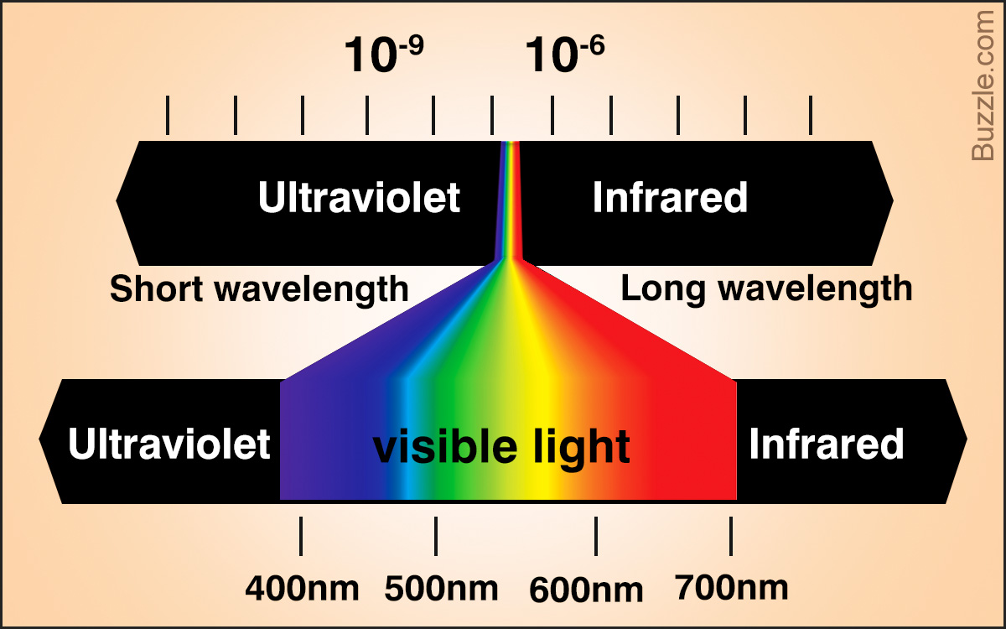
  - Primary Colors of Light: Red Green and Blue
    - Mixed together = WHITE LIGHT
  - Primary Colors of Pigment: Cyan, Magenta, Yellow
    - Mixed together = BLACK
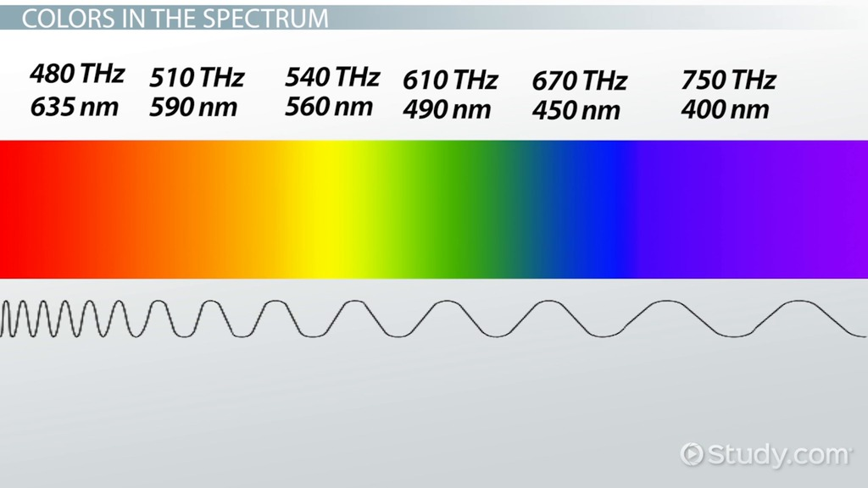

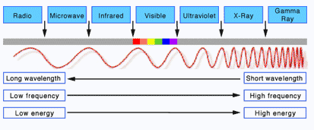

C) MATERIALS (asterisk (*) = any materials that may be a safety concern)
- Black felt tip markers (24)
- Black Crayola washable markers (12)
- Black Sharpies (12)
- Black Rose Art washable markers (12)
- Tie Dye kits
- White bandanas (24)
- Plastic cups (48)
- Food coloring (red,yellow,blue)(6 of each if possible)
- Pencils
- Markers

D) REFERENCES (list ALL references that you borrowed ideas from to develop this lesson – including any handouts you may distribute)
- http://www.open.edu/openlearn/science-maths-technology/science/chemistry/separate-coloured-ink-experiment
- https://www.youtube.com/watch?v=k8YtroKjVxo
- http://learn.leighcotnoir.com/artspeak/elements-color/primary-colors/

E) TENTATIVE TIMELINE

Expectations | 9:45-9:50
Color mixing (Sarah) | 9:50-10:00
Color walk (Halle) | 10:00-10:10
Extract color from black marker (Justice) | 10:10-10:25
Color Discussion so far (Group) | 10:25-10:30
Snack  https://www.youtube.com/watch?v=VN3U1MWJsdo  https://www.youtube.com/watch?v=GCQE1U2EQ_4 | 10:30-10:45
Observations of the paper towels (Color Walk) (Halle) | 10:45-10:55
Tie dye (Justice / Sarah) | 10:55-11:30
Overall color discussion (Group) | 11:30-11:45
Science notebook | 11:45-12

F) DESCRIPTION OF YOUR LESSON:
ENGAGE
- To engage the students, we are going to begin our lesson by presenting each table with food coloring and a cup full of water. The students are going to have time to interact with the different food colorings by mixing different colors.
  - This particular activity will be student led in that there are limited directions: mix and match colors keeping in mind which colors make different colors.
  - Before we start the activity, students will be reminded of expectations. When working with food coloring, we need to remember that it can stain our hands, our clothes, and the tables. Even though the tables are black, they can still be stained and rub off on someone else.
  - Students will be working in pairs.
  - Students will be given the four food colors and two cups of clear water. The students will be given about 7 minutes to mix and match colors and come up with some theories on mixing colors.
  - Students will have the chance to ask questions and bring up things they wonder about to get them excited about the lesson.
EXPLORE
- Before we start the activity, the students are going to be brought back together as a class and talk about predictions.
  - We will ask the students what they think will happen to the water in each cup.
  - We will ask the students what they think will happen to the colors.
  - We will ask the students what they think will happen to the paper towels.
- To explore the color walk, students will be seeing how the different primary colors combine to form the secondary colors. The following instructions will occur at every table. The students will start by placing 7 cups on their table in a row. Every other cup will be filled with water, starting with the first cup and ending with the last cup. The first cup will get 3 drop of red food coloring, the next cup of water will get 3 drops of yellow food coloring, then next cup, the 5th cup, will get 3 drops of blue food coloring. The last cup will also get three drops of red food coloring. Then a paper towel will be folded into thirds and placed from cup one to cup two, then another paper towel from cup two to three, then again until it reaches the last cup. Then over the course of an hour the students will make observations about how the primary colors are combining to make the secondary color.
- Next students will experiment with separating the different colors from different types of black markers. This will reinforce the idea that when colors of pigment mix together they create black. Students will be making observations and coming to conclusions about what they are seeing, and they will be able to relate it back to their engage. The different kinds of markers will have different combinations of pigment, which means that the result for each of the color extractions will be different. This will really get students thinking and create good discussions about what they are seeing.
  - To complete this activity, students will be getting a strip of coffee filter. Students will label the top of the strip with what marker will be used so that they can remember during discussion. They will attach this to a pencil so that it can be put into a cup and have the pencil hold it up. On one end of the paper, students will put a blob with their marker on the filter and go over it several times so that it is saturated. We will then add water so that it just touches the bottom of the filter. After a few minutes students will begin to see colors being seperated.
- Next, to further reinforce what students have learned about mixing pigments, students will be tie dying. This will help students see that color and how it interacts is part of normal daily life. This will be a really fun activity for the students that will get them excited about science and have them see that science is all around us even when they are not fully aware of it. We will have discussions with the students throughout the activity to ensure that they are understanding the concepts of pigment mixing. We will then have a full group discussion to bring together the ideas that we learned during this activity and to address any questions that students may have.

EXPLANATIONS
- After we put together the color walk with the cups at each table, the activity has to sit for about an hour and a half. That being said, near the end of the lesson after the students can see the results of the project, we will observe what we see. Too, we will try to explain what happened with the water, with the colors, and with the paper towels.
  - The students will have to utilize their past knowledge on how water is composed and how it moves to explain the transfer of water into cups that originally had none.
  - The students will have to utilize their knowledge that they had previously or learned throughout the lesson/s in order to explain the color changes. They will be able to talk about the difference between the fact that we are using the understanding and furth discussion on the difference between pigment and light.
- To bring in the difference between light and pigment, we will be showing students how the primary colors of light mix using a light color mixing device. This will project the colors of light on a display, and allow us to show students how the different colors of light interact, and that when they are all mixed together they make white light. This will draw on previous lessons where students used spectroscopes to see how light gets seperated into the different colors of the spectrum. Students will be able to ask questions and make observations about the difference between light and pigment, and will give students a very clear demonstration that there are differences, as many students will probably not yet be aware of this.

ELABORATE
- To elaborate, we will be having whole group discussions with students after each exploration that they complete. This will be to ensure that they are meeting all of the objectives that we have set for them, as well as give students to ask questions and dig deeper into the material. At this point, if time allows and if we determine that students need to be challenged further or provided with more material we can go more in depth into the different topics. For example, we will potentially go more in depth into the frequencies and wavelengths for each color and explain more deeply about why different frequencies put off different colors for our eyes to see. This is just one example, and we can elaborate on any of the topics covered during the lesson as we will be prepared to do so from gathering our content knowledge listed at the beginning of the lesson.

G) How will you determine if your students achieve the objectives for this week?
- As with past weeks, their science notebook will be a main source of determining if students have met the objectives that we set for them, as the questions that they are expected to answer correlate with them. Beyond this, students will be doing experiments and engaging in discussions with small and large group. During these discussions, we will be able to get a sense for if the students are on track with the objectives, or if there are things that we need to discuss further or teach in a different way. We will also be going around to check in with students as they work. This will allow us to differentiate for specific students - be it us giving them additional support or challenging them with more in depth questions and points to think about. We want to help students be successful and meet the objectives, but we also understand that some students will need more support and we intend on giving them the support that they need be it re-teaching or different explanations or different representations of the material.

H) PEDAGOGICAL FOCUS:
-State the focus for the week: Science for all: ELL and Special Education
-Explain how you are trying to incorporate this into your practice in this week’s lesson
- As with every week, the students science notebook will offer them multiple ways to express their learning to us. There are lines so students can write their responses if they feel comfortable doing that, as well as boxes so that the students can draw if they would feel more comfortable and be more successful in communicating their ideas in that way. Throughout the lesson, there will be lots of visuals and hands on experiments that will be modeled for students. This will allow those who do not do well with verbal instructions to get a grasp of the lesson ideas and allow them to continue to learn even if they can not yet be successful from oral instruction. Students are always encouraged to share their thoughts and ideas in any way that they need to be successful, so throughout the day and not just with their science notebooks, they will be able to communicate with the teachers in multiple ways. During discussions, they can describe their findings, thoughts, and ideas to us and they can also demonstrate what they found to us with the materials that they have.
- Another thing that we could do support all learners is provide sentence or idea starters for them that they can use to help formulate and articulate their ideas in a successful way. This will be helpful for students who have the ideas that they want to convey in their heads, but just need help figuring out how to put those ideas down on paper or in a discussion with their peers.

Saturday Science Teaching – Fall 2018
Lesson Plan

LESSON 5: Production of Light
GRADES 3-4
Focus Question: How can we make the light bulb light?

A) LEARNING OBJECTIVES
- The students will be able to understand how light can be produced through electricity in multiple ways.
- The students will be able to create circuits using different materials including batteries, potatoes, and lemons along with wires and light bulbs, and understand how circuits create light.
- The students will be able to apply previous knowledge that we have learned about light ( how we see: thinking of eyes and how we interact with light) to knowing how to create circuits.
- The students will be able to apply previous knowledge that we have learned about light ( how we see: thinking of eyes and how we interact with light) to knowing why circuits work.
CRITERIA FOR DETERMINING IF OBJECTIVES ARE MET
- Students will demonstrate their working circuits made with the battery, potato, and lemon and explain how light is being produced from each.
- Students will show their working circuits to the teacher.
- Students will connect and relate their explanations of circuits to previous weeks lessons in a way that makes sense given the context that they provide.
- Students will connect and relate their explanations to previous weeks lessons in a way that makes sense given the context that they provide.

B) TEACHER CONTENT KNOWLEDGE
- Teachers must know how to create simple circuits utilizing light bulb, wire, and battery.
- Teachers must know what a circuit needs in order to work: energy source, conductor, and something to power.
- Teachers must know what is traveling through the wire (energy) and why (conduction) it powers something (in this case, the energy from the battery is traveling through a wire to power a light bulb).
- Teachers must know previous knowledge from lessons to facilitate a review on what we have learned over the course of these five weeks: shadows and interaction with light, how we see color, the color spectrum and its composition, the different types of color, and production of light.
- Teachers must know how energy is created and transferred through the different materials that we will be using to create the circuits as well as which one is preferable or most effective.
  - A potato battery is an electrochemical battery, otherwise known as an electrochemical cell. An electrochemical cell is a cell in which chemical energy is converted to electric energy by a spontaneous electron transfer. In the case of the potato, the zinc in the nail reacts with the copper wire. The potato acts as a sort of buffer between the zinc ions and the copper ions. The zinc and copper ions would still react if they touched within the potato but they would only generate heat. Since the potato keeps them apart, the electron transfer has to take place over the copper wires of the circuit, which channels the energy.
  - A lemon battery is made with a lemon and two metallic electrodes of different metals such as a copper penny or wire and a galvanized (zinc coated) nail.
The energy for the battery does not come from the lemon, but rather the chemical change in zinc (or other metal). The zinc is oxidized inside the lemon, exchanging some of its electrons in order to reach a lower energy state, and the energy released provides the power. The lemon merely provides an environment where this can happen, but they are not used up in the process.
Assuming that zinc and copper electrodes are used (such as a copper coin and a zinc plated nail) then a single lemon could generate approximately 0.9 Volts. To the left a series circuit of lemons shows 3.41 volts being produced.
NOTE: Potatoes, apples, sauerkraut, or any other fruit or vegetable containing acid or other electrolyte can be used, but lemons are preferred because of their higher acidity. In potatoes, for instance, the electrolyte is phosphoric acid, while in lemons it is citric acid.

C) MATERIALS (asterisk (*) = any materials that may be a safety concern)
- Batteries (24)
- Wires (48)
- Battery holders (24)
- Light bulbs (24)
- Large Potatoes (30)
- Lemons (30)
- LED bulbs (30)
- Pennies (48)
- Copper wire (64)
- Zinc/galvanized plated nails (48)

D) REFERENCES (list ALL references that you borrowed ideas from to develop this lesson – including any handouts you may distribute)
- https://science.howstuffworks.com/innovation/everyday-innovations/how-to-make-potato-powered-light-bulb.htm
- https://blog.connectionsacademy.com/kitchen-science-for-kids-making-a-battery-out-of-a-lemon/
- https://www.youtube.com/watch?v=DtRrvraDkLI
- https://www.kidzworld.com/article/4726-how-potato-batteries-work
- https://www.edinformatics.com/math_science/how_does_a_battery_work.htm

E) TENTATIVE TIMELINE

Students still arriving | 9:30-9:40
Expectations | 9:40-9:45
Circuit activity - phase 1, 2 (Sarah, Justice) | 9:45-10:30
Discuss (Group) | 10:30-10:45
Snack | 10:45-11:00
POTATO LIGHTS / LEMON LIGHTS (Mary, Halle) | 11:00-11:45
Discuss/Compare/Science Notebooks | 11:45-12:00

F) DESCRIPTION OF YOUR LESSON:
ENGAGE:
- Begin class by going over what we have learned so far in saturday science. This particular activity is going to be a full group discussion where all students are going to be held accountable to respond to the questions. How this particular discussion is going to go is the questions will be asked in class or written down depending if the students arrive on time. The students will be asked singular questions at a time, then will be instructed to turn and talk to table mates before we discuss each question as a whole group. Each question will be addressed in this way. This will allow all students to engage with each question even if they do not speak out loud during the whole discussion.
  - Shadows and light interactions (refraction, reflection, transparency, translucency, opacity)
  - How we see light and color (anatomy of the eye)
  - How light and color interact (white light is all lights together)
  - How pigment and color happens (primary colors, secondary colors, all colors make black)
- Explain that none of this can happen without light, in general. Ask students “Where does light come from?” Again, this is going to be a whole class discussion for students to think and consider. Time will be given for the students to turn and talk and address each question, then we will talk as a whole group.
  - Have students share different ways of producing light both naturally and manufactured (fire, sun, bioluminescence, electricity)
EXPLORE
- Circuits:
  - The students will first be given a battery, one wire, and a light bulb. They will be given the task to figure out how to make the light bulb light up without any help from the teachers. The correct way is to place one end of the wire on one end of the battery and the other end of the wire to the other side of the battery. Then you must place the light bulb on top of one end of the battery.
  - Once the students figure out how to create light with the bare minium they will be given a more complex circuit to work with. For the second circuit the students will be given two wires, a battery, battery holder, a light, and light holder. They will then be told to create light without any help from the teachers once again.
  - For this one the correct way for the students to form the circuit is to place the battery in the battery holder and then connect a wire to each end of the battery holder. The light bulb must be placed in the light bulb holder, you then connect each wire to a part of the light bulb holder.
- Lemon v potato: students will have the opportunity to explore different ways to create circuits to create light. They will all be creating both a potato and lemon light so that they have first hand experience creating the circuit to promote more in depth discussion. This will bring up a conversation about why this works and how it differs from the circuits we used in the beginning of class.
  - Potato light:
  - Cut the potato in half, then cut a small slit into each half, large enough to slide a penny inside.
  - Wrap some copper wire around each penny a few times. Use a different piece of wire for each penny.
  - Stick the pennies in the slits you cut into the potato halves.
  - Wrap some of the third copper wire around one of the zinc-plated nails and stick the nail into one of the potato halves.
  - Take the wire connected to the penny in the half of potato with the nail and wrap some of it around the second nail. Stick that second nail into the other potato half.
  - When you connect the two loose ends of the copper wires to the light bulb or LED it will light up
  - Lemon light:
  - Press down (gently) on your lemon and roll it around on a table to get the juices flowing inside it. You want it to be soft, but you don’t want to break the skin.
  - Insert both nails into the lemon, about 2 inches apart. Be sure they aren’t touching each other, and don’t let them puncture through the other side of your lemon.
  - Remove the insulation from around the holiday light’s lead, exposing the bare wire beneath.
  - Wrap the exposed wire around both the copper nail and zinc nail, and ta-da! Your holiday bulb will light up.

EXPLANATIONS
- During this phase of our lesson we will have students discuss which circuit and power source worked the best.
- For the circuit their will be discussion after every phase of building. This will help the students learn that the electricity from the battery travels through the wire to connect with the light bulb turn it on. The students will learn that the light bulb needs both the energy from the negative and positive side of the battery in order for it to turn on.
  - For the first phase, where the students need to create the light with the bare minimum the teachers should ask questions to get them thinking on the right path to lead to to the creation of their light. Question to ask:
    - Does the battery matter how it is positioned?
    - How do you think light is created at your home, at school, at the store?
    - What parts do you think need to be touching?
    - Does the light need to go on a certain side of the battery?
    - Why do you think connecting your parts in this manor turns on the light bulb?
  - For the second phase the students should be able to figure out how to connect the circuit more quickly because they already have figured out how with the simple form but there are questions to ask like why they set it up the way they did, or why it works. Questions to ask:
    - How does this circuit differ from the one we had earlier?
    - Is this one more complex?
    - How does this one work compared to the other circuit?
    - What strategies did you use to figure out how to make this one work?
ELABORATE
- If time allows, we will discuss parallel and series circuits with the students to further their understanding of how circuits work. This will show students that there are multiple ways of creating a circuit. Students will then be able to discuss which type of circuit they think would be best for different uses, bringing in a real life aspect to the lesson.

G) How will you determine if your students achieve the objectives for this week?
- First and foremost, we are going to be walking around through discussions (when students are talking at their tables) to hear the conversations. This will give us an accurate representation of where students stand in regards to their knowledge that they have learned from previous lessons o

H) PEDAGOGICAL FOCUS:
- The pedagogical focus for this week is STEM.
- We are integrating STEM by having students working with creating the circuits.

