Baxter International Foundation 2023 Year End Report
Project Title: 2023 Baxter STEM Education Initiative
Organization: Indiana University School of Education
Due to the Covid-19 pandemic and subsequent restrictions preventing K-12 students from coming to Indiana University - and after consulting with our project partners at Baxter Biopharma Solutions - we pivoted from planning in-person student summer STEM academies to developing online STEM education modules. Since that time, we have been engaged in co-designing a series of “Baxter Online STEM Challenges” in partnership with Baxter Biopharma Solutions (now Simtra Biopharma Solutions). These challenges are designed to foster interactive learning for underserved students who are interested in STEM but may not have opportunities to engage in activities that support their career interests. This project was developed to increase interest and engagement by providing authentic Baxter-led STEM learning challenges and feedback from professionals at Baxter Biopharma Solutions, providing connections and role models for college and career trajectories. Ultimately, we aim to create learning experiences that will engender deeper interest and commitment to pursuing STEM-related career pathways and help address the issue of underrepresentation in STEM career fields.
To date, we have developed three online video modules that feature five Baxter STEM professional volunteers. Each online video module challenges students to solve some of Baxter Biopharma Solutions’ most vexing problems including optimizing the procedure for safely reconstituting medicines and improving processes for maintaining sterile environments. Videos that discuss career opportunities and pathways at Baxter Biopharma Solutions are also being developed along with other STEM challenge videos that include the topics of pharmaceutical safety and shelf-life prediction and effectively transporting medicines. Each video module has been professionally recorded and edited at Indiana University School of Education’s state-of-the-art media laboratory. The scripts for each online video module are co-written by Baxter STEM (now Simtra STEM) professional volunteers. Upon completion, the videos are uploaded to the Indiana University School of Education website: https://education.indiana.edu/community/pk-12-school-initiatives/baxter-stem-challenges/index.html where they are disseminated to science teachers for use in their classrooms along with resources necessary to implement the modules.

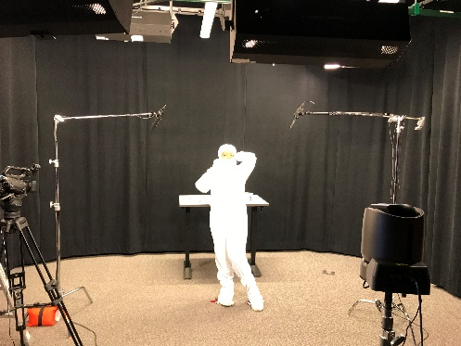
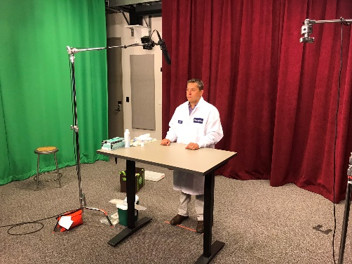

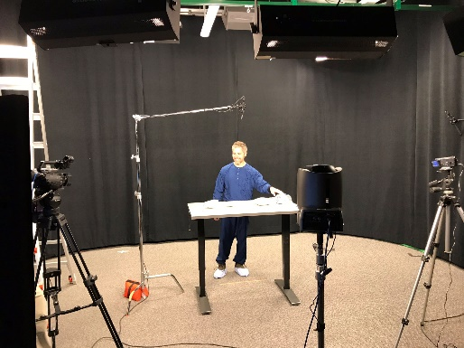
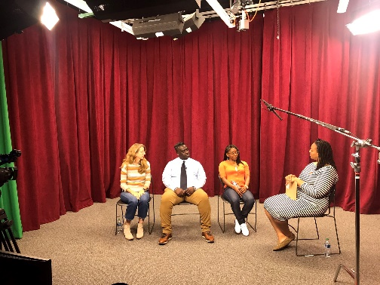

The images above are from creating the Baxter Online STEM Modules in the Indiana University School of Education Media Laboratory with STEM professional volunteers from Baxter Biopharma Solutions.

Each of the online modules have been developed using participatory co-design, a process in which educators actively engage in the instructional design process in ways that benefit them and their students. Having science teachers participate in the process at its very initial stages has helped to ensure that the project addresses the participating teachers’ needs and the needs of their students by helping to produce content-specific, grade-level and culturally appropriate, educational resources. Initially, the online STEM modules were co-designed with two high school science teachers and subsequently tested in their classrooms. In fall 2023, we provided a professional development workshop for seven additional middle and high school science co-design teachers to learn about the project and provide feedback for improvement and optimization.

To date, the project has reached 9 classrooms and more than 900 students. Furthermore, many of the teachers who have implemented the project have been visited by Baxter STEM (now Simtra STEM) professional volunteers.

The costs to produce the online STEM modules and host them on the Indiana University School of Education website have been provided in-kind. Therefore, in fall 2023, we requested a no-cost-extension from Baxter International Foundation which was granted in November 2023. We intend to use the remaining project funds during 2024 to increase the project's reach by hosting more teacher professional development workshops. These workshops will provide more science teachers with all the resources and materials necessary to implement the modules in their classrooms.

We greatly appreciate the support of Baxter International Foundation to help advance STEM teaching and learning. For more information about the Baxter Online STEM Challenges, please contact Dr. J. Adam Scribner at jascrib@iu.edu.

